## Changing from the Adobe Forms Package to the Activant Forms Package

When you elected to switch from the Adobe Forms Package to the Activant Forms Package, you received this e-mail, with the following included files:

* This documentation
* **P21CrystalIntegrationSetup.msi** – Installation for Crystal forms integration software
* **CR0CR000001.SQL** – Enables the new Activant Forms Package
* **FormsIntegration.zip** – .xsd and .rpt files you need for the Forms Design Package (only sent if you have purchased the Forms Design Package)
* **CF0F000XXX.SQL** – Script that licenses Forms Design Package (only sent if you have purchased the Forms Design Package)

When you change from the Adobe Forms Package to the Activant Forms Package, there are several steps you must take.

* Run the P21CrystalIntegrationSetup.msi installation for each client where Prophet 21 is installed (see *Installing the MSI File* on page 1 for instructions)
* Run a SQL script that turns on the new forms package (see *Enabling the New Activant Forms Package* on page 5 for instructions)
* If you had old customizations, re-apply them in the new forms, or engage Professional Services to re-customize for you; to do this, you will need the files in the FormsIntegration.zip package (see the *Forms Design Guide* for more information on customization)
* If you purchased the Forms Design Package, run the licensing SQL script (see *Run the Licensing Script for the Forms Design Package* on page 7 for instructions)

##### Installing the MSI File

The P21CrystalIntegrationSetup.msi file will install the integration software you need to use Crystal Reports to print your forms.

Use the following instructions to run the P21CrystalIntegrationSetup.msi installation. Callouts in **blue** contain steps you must take to complete the installation, and callouts in **red** contain optional steps or helpful information.

Double-click the msi file to start the installation. The following window opens.

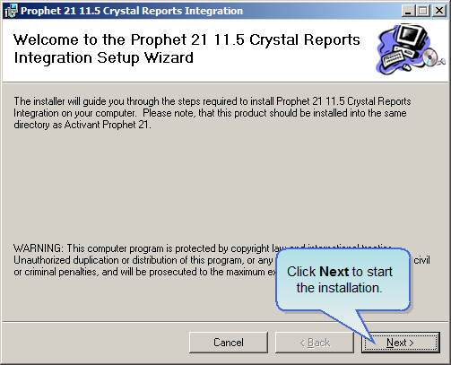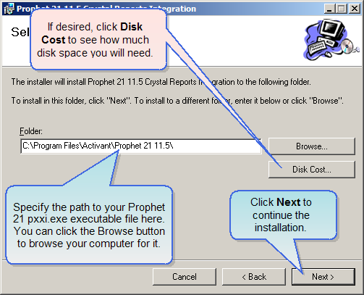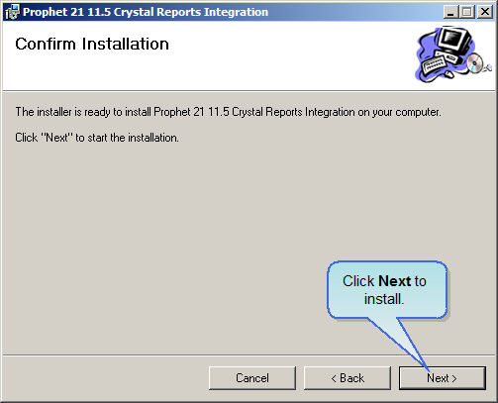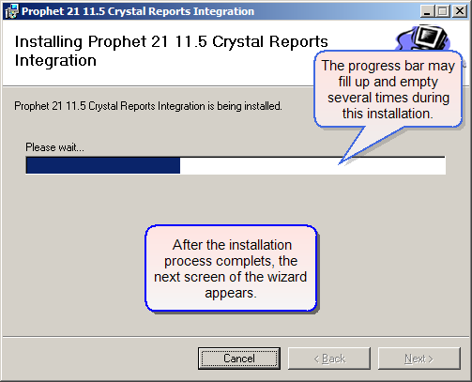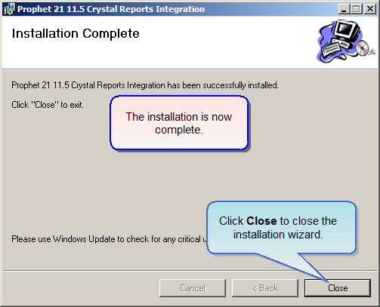

##### Enabling the New Activant Forms Package

You must run the CR0CR000001.SQL script against your Prophet 21 database to enable the new forms package. Note that you only have to run it against your database; you do **not** have to run it for each Prophet 21 application installation.

Use the following instructions to run the script against your Prophet 21 database.

1. First, save the CR0CR000001.SQL file to your database server. Remember where you saved it, because you will need to find it later.
2. Find SQL32.exe in the folder where you have Prophet 21 installed (by default, this is C:\Program Files\Activant\Prophet 21 11.5\).
3. Double-click SQL32.exe to run SQL32.
4. A dialog box will appear when SQL32 starts. You will be able to select a database profile from the drop-down field. Each Profile points to a server and database. Select the profile that points to the database you want to update (Activant recommends that you update a play database prior to your production database, so that you can ensure you will not have any problems with the update before applying it in your production environment).
5. Then either type in the system administrator password for this server, or login using Windows Authentication, and click **OK**.
6. Windows authentication will only allow you to login if your Windows Authenticated login has SA privileges. For more on Windows Authentication, see your Windows and SQL Server documentation.
7. A browse window appears. Use the browse window to locate the directory where you saved CR0CR000001.SQL at the start of these instructions.
8. Select the directory and click the **OK** button.
9. Click **OK** to begin upgrading your database. Wait until this process is done.
10. After the update is successful, close the SQL32 window.

##### Run the Licensing Script for the Forms Design Package

If you have purchased the Forms Design Package, you must run the CF0F000XXX.SQL script against your Prophet 21 database to enable forms customization. Note that you only have to run it against your database; you do **not** have to run it for each Prophet 21 application installation.

Use the same instructions as above in *Enabling the New Activant Forms Package* starting on page 5 to run the script; simply replace that script with the CF0F000XXX.SQL script.