Once in the report, click the selection expert icon.

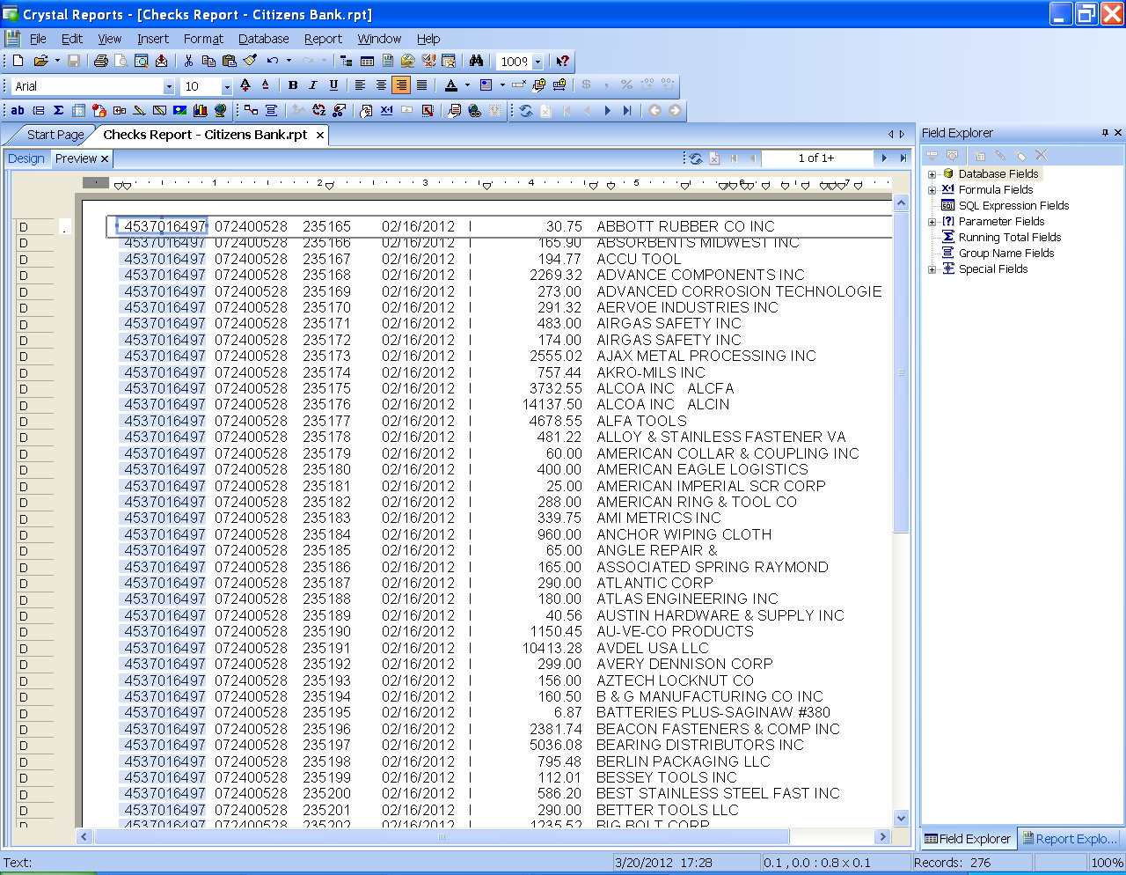

Click the “payments.check_date” tab, enter the start and end date & time, and click ok.

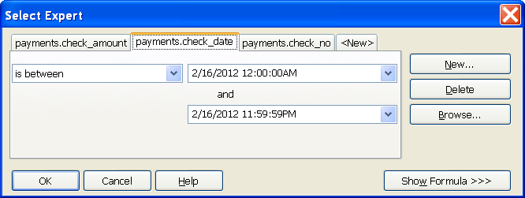

Click Refresh Data

