

Type here

|  |  |  |  |  |  |
| --- | --- | --- | --- | --- | --- |
| Saginaw, MI  800-324-3233 | Lansing, MI  800-569-6122 | Gaylord, MI  800-528-2448 | Shelby Twp., MI  877-970-7377 | Statesville, NC  800-222-1416 | Niles, MI  800-684-8636 |

**mid-states**

**bolt & screw co.**

*The dedicated fastener people.*

**P.O. Box 2050**

**Flint, MI 48501**

**Watts: (800) 482-0867**

**Phone: (810) 744-0123**

**Fax: (810) 744-3505**

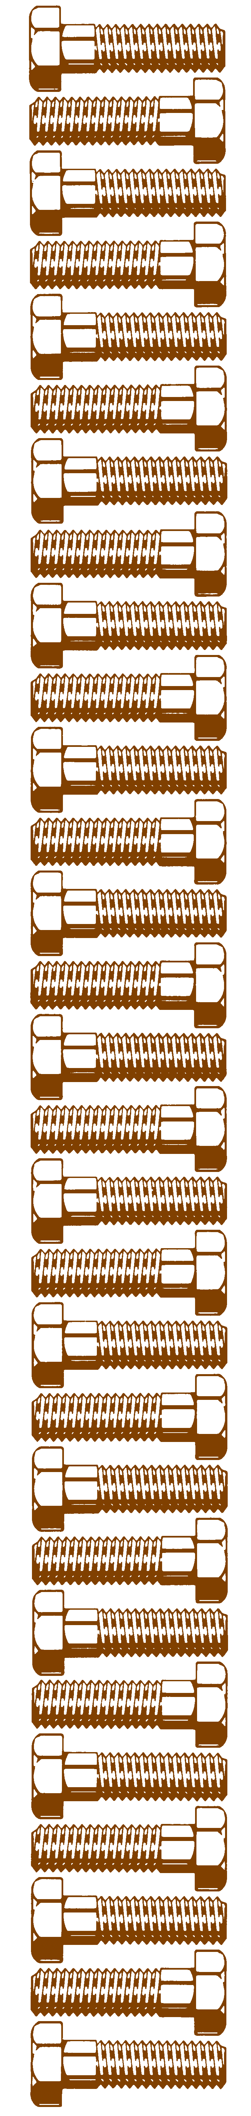

**mid-states**

**bolt & screw co.**