Headquarters
770 S Adams Rd  Suite 300  Birmingham, MI 48009  NMLS #3038  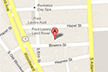 | 825 Bowers St  Birmingham, MI 48009  NMLS #250790  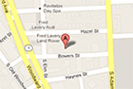 | 555 S Adams Rd  Suite 200  Birmingham, MI 48009  NMLS #21482  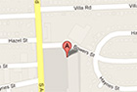 | 3270 W Big Beaver Rd  Troy, MI 48084  NMLS #3038  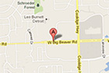

Accent Florist in Troy
Tiffany Florist in Birmingham
Della’s Maple Lane in Troy

