ABC Analysis and Cycle Counting

The purpose of the Cycle Counting module is to aid in counting inventory on a regular-basis, to keep track of what was counted and when, and very importantly, to prioritize which inventory should be counted. The Cycle Counting module consists of two screens, ABC Analysis and Cycle Count.

In the ABC Analysis screen, historical data of items OR bins can be analyzed four different ways:
- Number of Issues: determines rate of issues.
- Total items issued (Issues x Pkg Qty): determines rate of usage.
- Avg Value of Inventory: determines value of unconsumed inventory (qty * Unit Price).
- Total value of total items issued (Issues x Pkg Qty x Unit Price): determines value of consumed inventory.
These analysis types are used to derive values that are then compared against a user-defined set of criteria, or Classes. The Classes can range from A through F, hence the title ABC Analysis. The items or bins that meet the criteria of the classes can then be set with a counting frequency, thus prioritizing the order of classes of items or bins to count. The results of the Analysis can be viewed in the "# of Items" column, as well as in the Cycle Count screen, where additional filters and count physicals can be performed.

Select Transactions > Cycle Counting > ABC Analysis

The ABC Analysis screen requires 7 steps:
- Select Item or Bin for the ABC Analysis.
- Select the appropriate Analysis Type.
- Select a Look Back Period for the system to analyze historical data.
- Type in values to define the ABC Class criteria.
- Type in values to set the Count Frequency of each class.
- Click on the appropriate box to choose to reassign the class for all or just items or bins that do not yet have a class.
- Finally, click on the "Run Analysis" button.

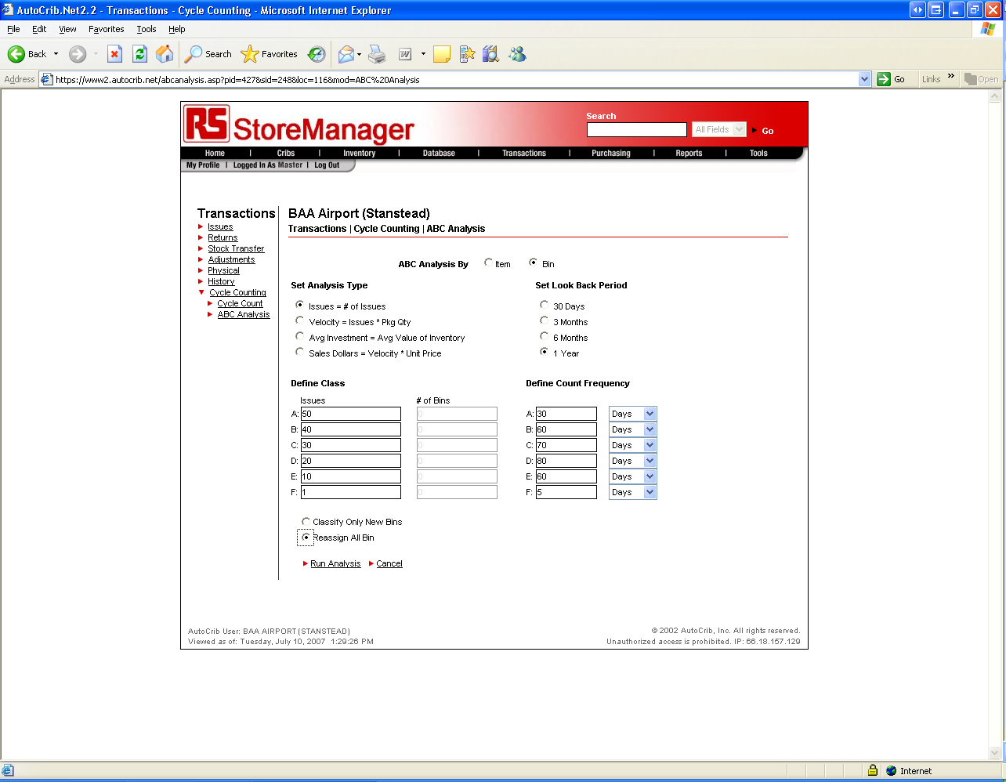
- Once the ABC Analysis is performed, select the Cycle Count link
- Enable ‘Lock ABC Analysis – Cycle Count in Progress’. The ABC Analysis must be locked until the cycle counting is complete. This is to ensure that all items or bins are counted before Classes can be reassigned.
- Select the crib in which you want to count the inventory. All cribs can be counted as well.
- Select the class of items or bins to count. All classes can be counted.
- Select a method for the cycle count. Items or bins that have passed their next count date can be selected or all can be counted.
- Click on the ‘Go’ button to produce the cycle count list.
- Print the report and perform a physical count.

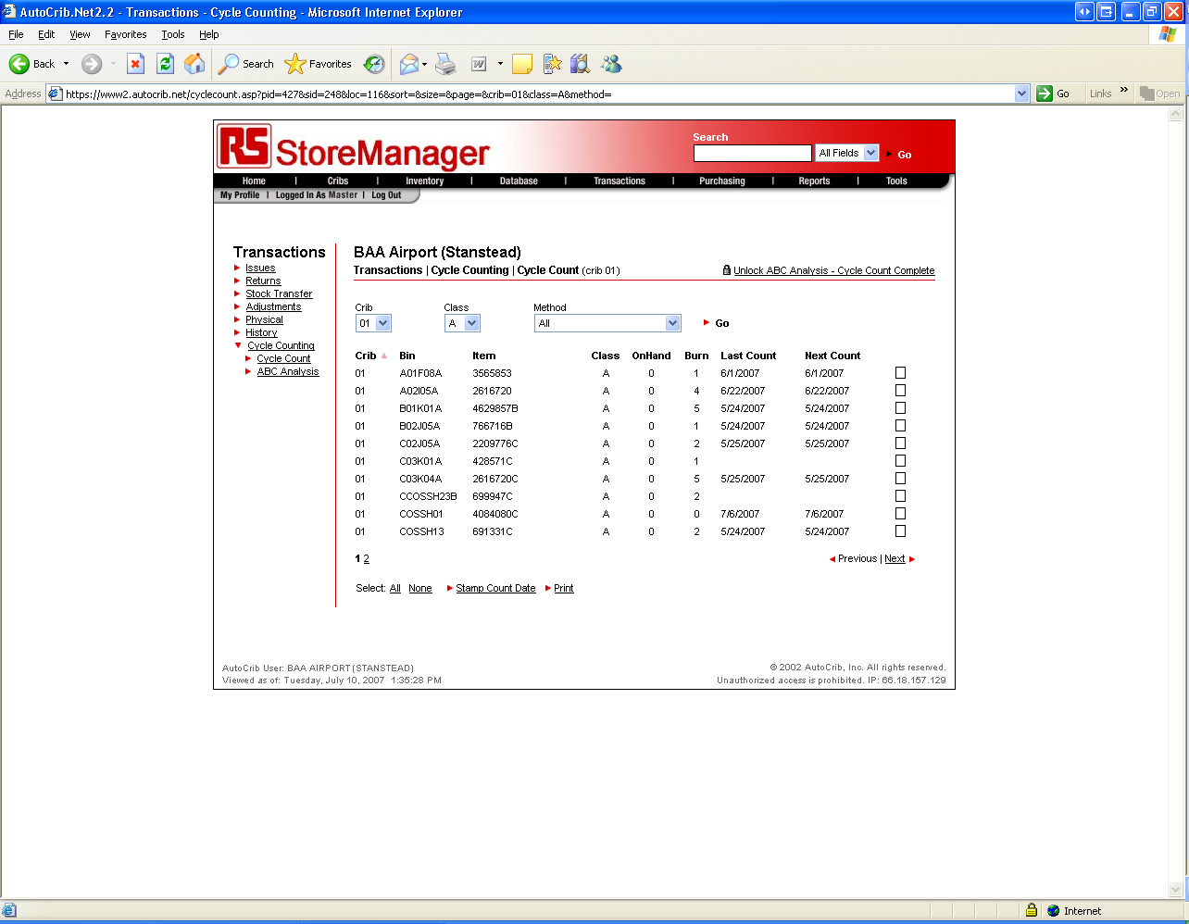

The software allows you to physical each bin in the Cycle Count screen. Simply, select the select the bin and insert the on hand and burn quantity currently in the bin.

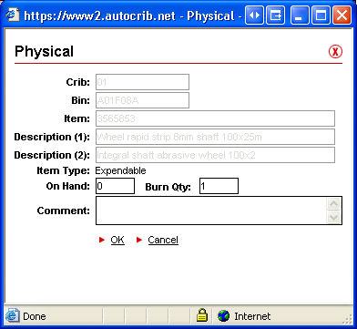

Once counting is complete, select the ‘Stamp Count Date’ button. This will stamp the bins or items with a last count date which then creates a next count date. The next time cycle count is to be performed, the Method drop down allows a user to quickly produce a list of items that have passed their next count date.

