Creating Access Controls for Autocrib.Net

You can limit the amount of an item used by an employee by following the steps below.

Select Cribs>Tool Cribs

Select the crib that needs access limits. Click ‘Edit’ and enable ‘Emp Access’. Then, select the ‘Save’ button.

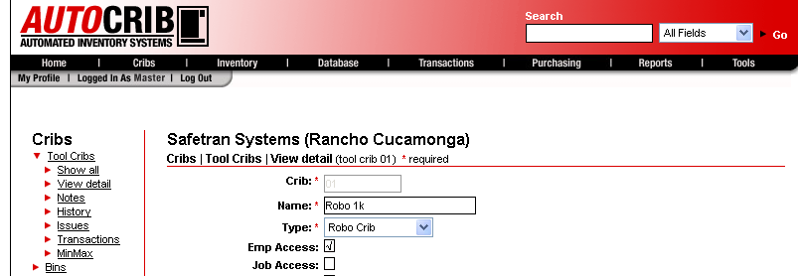

Select Tools>Options>Defaults

Click ‘Edit’ and enable ‘Unlimited Access’ under the System Wide menu. Then, select the ‘Save’ button.

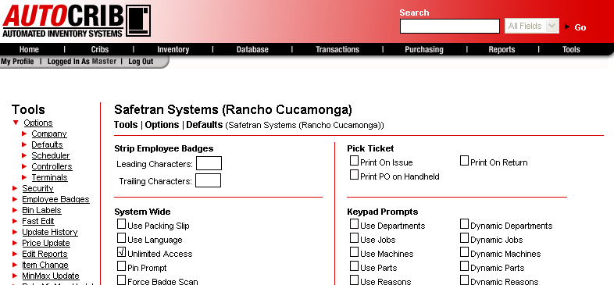

Select Cribs>Access

Under the Select Employees menu, click ‘Insert’ and select the employees that need access restrictions. The menu also gives the option to ‘Select All’ employees.

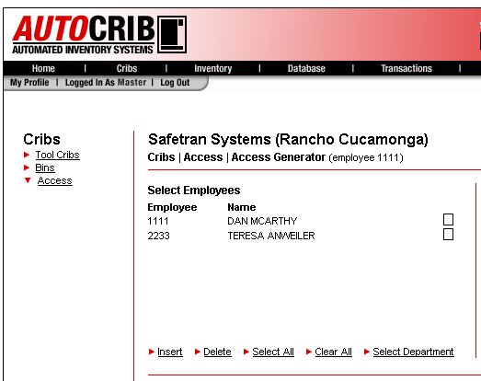

Under the Select Items menu, click ‘Insert’ and select the items that need to be restricted.

Update the Max and Frequency for each item. Then, select ‘Update Max/Freq’
Max = the maximum number of pieces allowed to be issued within the frequency

Frequency = the number of days before access is reset

Example = If the Max=5 and Frequency=7, the employees would be allowed to issue 5 pieces of the item every 7 days.

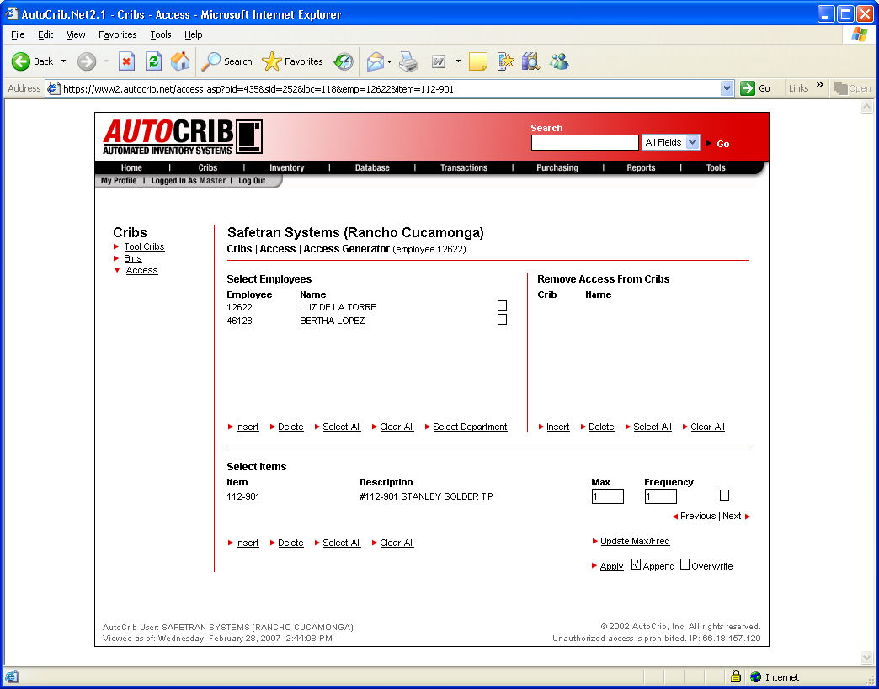

If this is the first time Access Controls are being setup, the ‘Overwrite’ option should be enabled. However, if the Access Controls are being appended, the ‘Append’ option should be enabled. Then, select ‘Apply’.

