AutoCrib Training – Tutorial Series

Access Controls:

The Access module provides the ability to limit access to item(s) by a specific employee, group of employees or all employees. Additionally you may also remove an employee(s) rights to use an entire crib with the Remove Access from Cribs section of the screen.

*For example: The administrator wants to give access to all employees for 1 pair of safety glasses per week, regardless of what crib they use; or would like for only employees that work in the machine shop to have access to the dispensing machine in that department. This can be accomplished through the Access Control Module.

As this is an essential element of the software, there must be an advance as well as ongoing assessment of which employees should have access to which items. This information is imperative for a successful access control program.

Access Control Module:

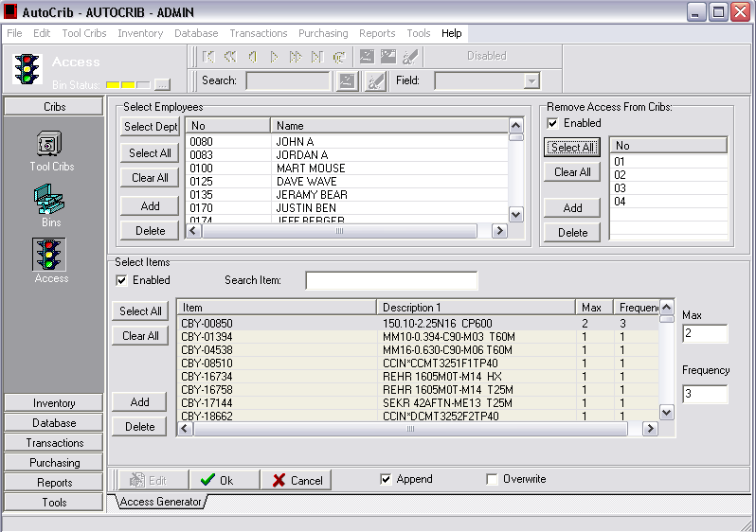
Max Item Select
&
Frequency Select Area
Crib Access Area
Item Selection Area

Employee(s) or Dept
Selection Area

Fig 1.0 – Access Control Module

Setting up Access Controls:

Employee selection - Using the select all or add buttons, choose the employees that you will add, delete, or modify access rights for:  - To Select everyone, click Select All from the employee selection area, and all employees will be selected Fig1.1 | 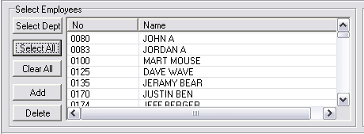  Fig 1.1 – Employee Selection Area

- Selecting one or a group of employees can be done easily by clicking Add ,Fig1.1 and choosing the employee(s) from the Employee Lookup window Fig1.2  Employee selection will look similar to that of Fig1.1. Once the proper employees have been chosen, move to the “Select Items” section of the module. | 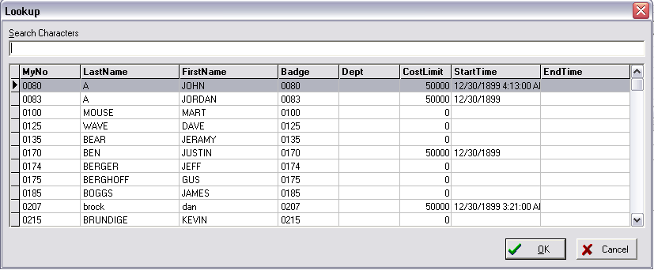  Fig 1.2 – Employee Lookup

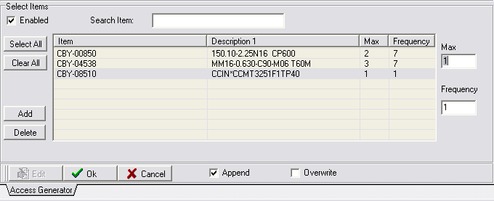  Fig 1.3 – Item Selection Area | Item Selection – To Activate the Item Selection window, click on the Enabled box. Fig 1.3 This will allow you to choose the Item(s) that will be given or removed from the selected employees:  - Picking the Items is identical to the method for selecting employees. All Items can be selected by clicking Select All or click Add to choose the Items individually  - The default for any item selected will be Max 1 and Frequency 1. This means the selected employees will be able to receive the selected item only once a day.  - To increase the max and/or the frequency of a particular item (i.e. 1 per day or 5 per month):  - Highlight the Item  - Change Max quantity (0 - 9999)  - Change Frequency quantity (1 – 365) *number represents days  - Repeat steps for all Items
- To create or modify the access control Click the “Append” or “Overwrite” box when you have finished, Fig 1.3 then Click Ok. Please note, if you are setting up access control for the first time you should use the overwrite option.

* IMPORTANT: In Every instance after the initial setup, you should use the append option.

Enabling Access Controls (Crib):

Crib Activation – To Enable the Crib that will enforce Access, click on the Emp Access checkbox. Fig 1.4 This will allow Access Controls to be enabled per Crib selected. | 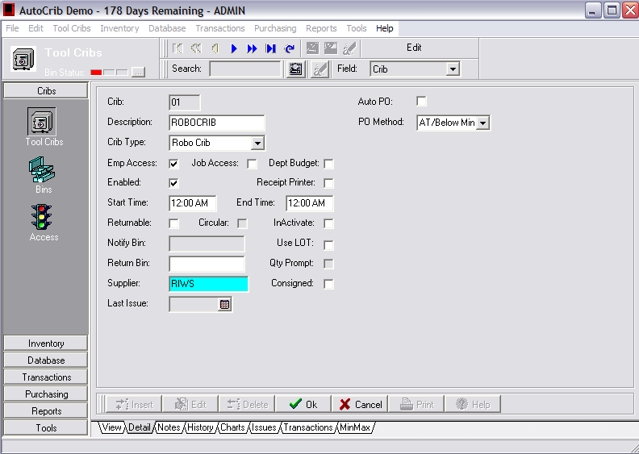  Fig 1.4 – Crib Detail Screen

Enabling Access Controls (System):

System Activation – To Enable the Access Controls to work properly throughout the system, click on the Unlimited Access checkbox. Fig 1.5 This will enable all other employees’ access to the Items that were not restricted. | 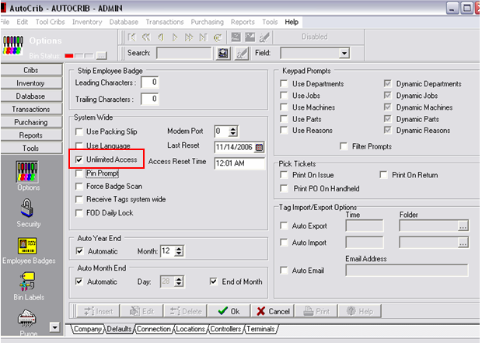  Fig 1.5 – System Detail Screen

