SQL Server Express Agent Installation (only follow if not installed on pc)

      - Using Windows Explorer, navigate to C:\Program Files\Autocrib5.2. Double click on expressagent.exe.
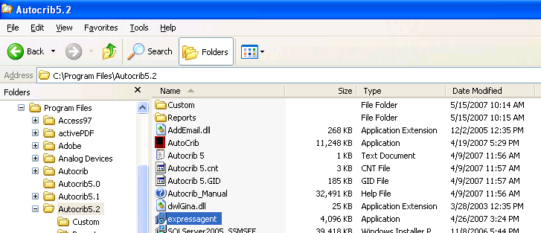

      - Click Next on the Setup Wizard.
      - Select ‘I accept the agreement’. Then, choose Next.
      - In the Select Components screen, select ‘Install the SQL Express Agent and Job Builder utility’. Then, choose Next.
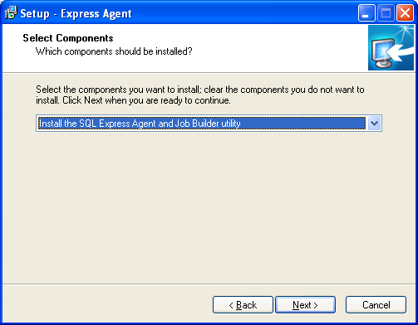

      - In the Additional Tasks screen, enable ‘Create Desktop icon’. Then, choose Next.
      - Choose ‘Install’.

SQL Server Express Agent Configuration

- Open the Express Job Builder located in Start > All Programs > Vale Software > Job Builder > Job Builder.
- Select ‘Create a ‘Backup Database’ Job.
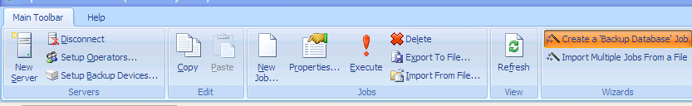

- Select Next on the Backup Wizard.
- Select the ‘autocrib52’ database. Then, click Next.
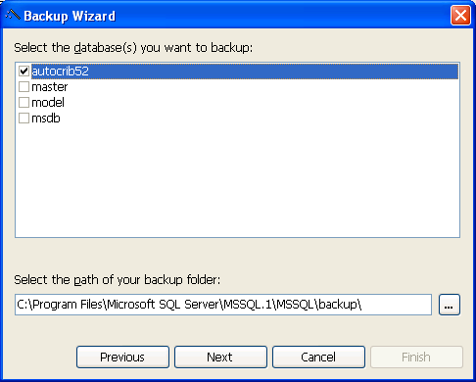

- Enable each day that the backup should be executed. Then, select a time for the backup to be executed. Click Next once the configuration is complete.
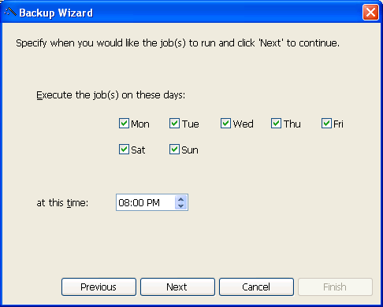

- If you would like the system to notify you when the backup has failed via email, select ‘Edit Operators…’
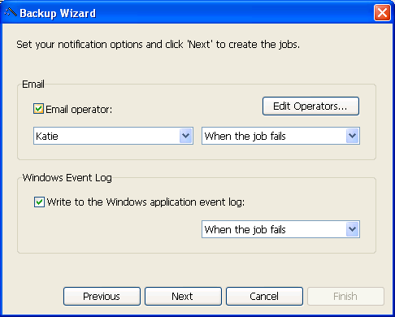

- Select the Add button and insert a name for the new operator and the email address for the notification.
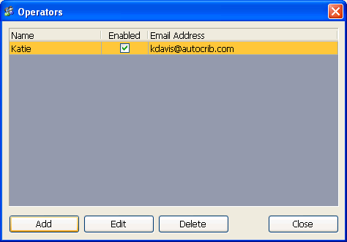

- Under the Email menu, enable ‘Email operator:’ and select the operator name. Then, select ‘When the job fails’. Under the Windows Event Log menu, enable ‘Write to the Windows application event log:’ and select ‘When the job fails’. Click Next once the configuration is complete.

- Select the ‘Finish’ button.
- Go to Start > All Programs > Vale Software > Express Agent > Agent > SQL Express Agent Configuration. Select the ‘Email Settings’ tab. Insert the SMTP Server, Email Address, Username, and Password for the program to email events. Click ‘Apply’.
