Create a backup and backup script in SQL 2005 Express
For Autocrib MGMTSTATION

1) Double click My Computer
2) Double click the C: drive
3) Create a new folder called: “SqlExpressFiles”
4) Logon to your SQL server 2005
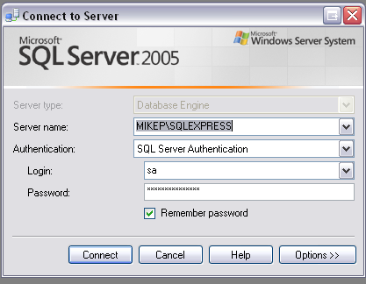

5) Highlight the Autocrib Database.
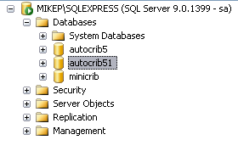
6) Right click the database and select “Tasks”. In the tasks menu, select “Backup”.

7) The following screen should show up.
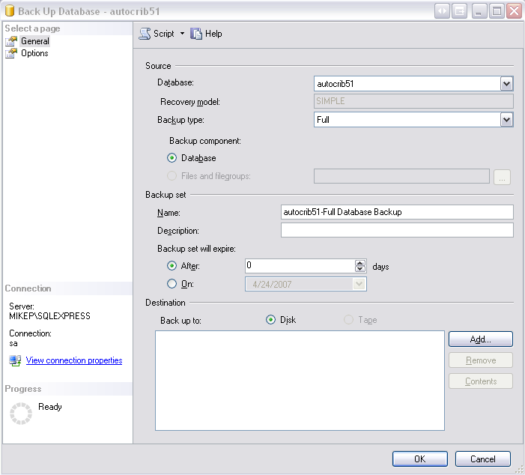

8) Click on

9) Click on the Browse button: on the following screen.

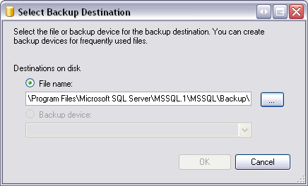

10) It is suggested you backup the database on the secondary drive on your Autocrib Management station. Select the E:\Backup folder and name your backup “autocrib5daily”.
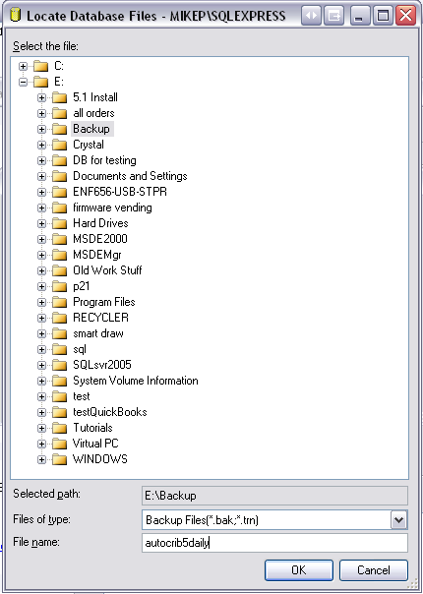
Select “Ok”

11) When the following screen appears, select “Ok”.
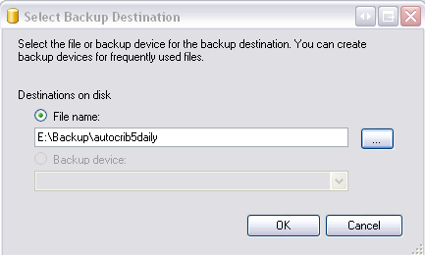

12) On the main screen, select on the left side of the screen.
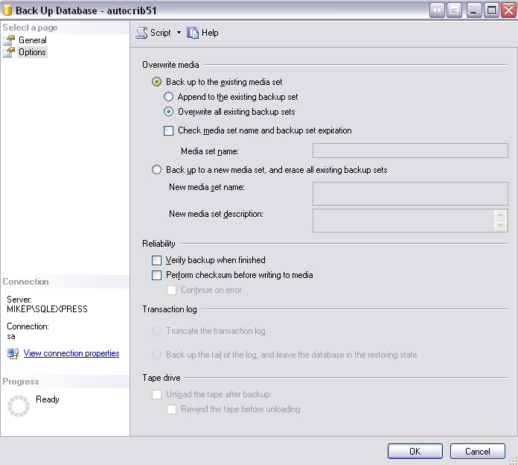
13) Place a check in the “Overwrite all existing backup sets”

14) Click the tab and on the following screen. 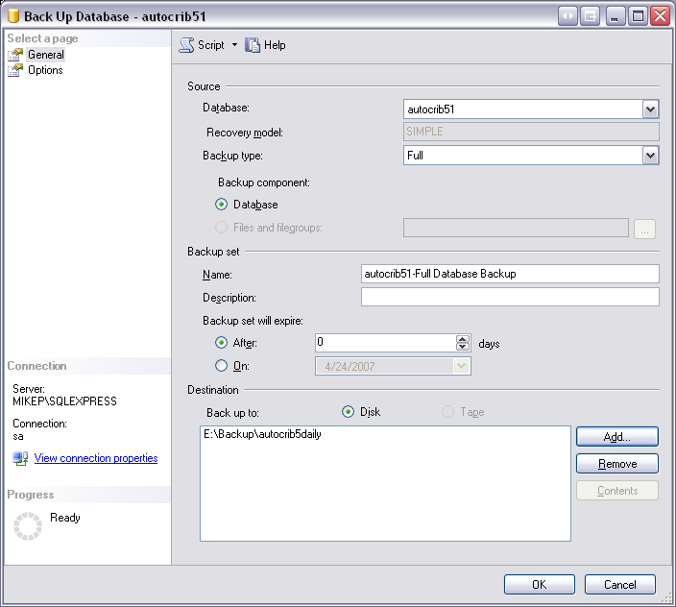

15) Press : Cntrl+Shift+f at the same time

16) Name the file: sqlexpressbackup and save to the folder created in step 3.
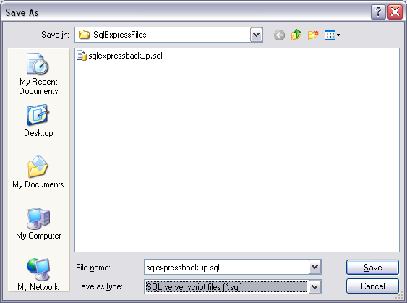

17) Click Save

18) Notice the following in the lower left hand corner.
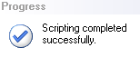

19) Click OK on the following screen.
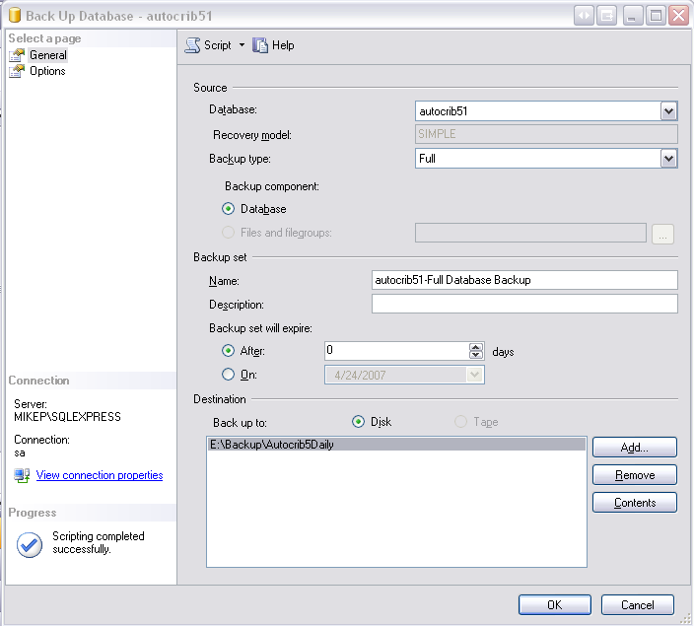

20) You should see the following confirmation
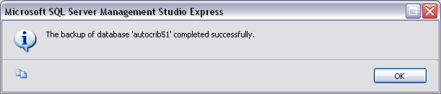

Automate your backup Script

To automate the backup you will need to create a .bat file with the following information:

1) Open a blank notepad file. Copy the following information into notepad:

@echo off
echo.
call sqlcmd.exe -S LOCALHOST\AUTOCRIB -U sa -P AutoCrib2005 -i C:\SqlExpressFiles\sqlexpressbackup.sql
echo.
cls
exit

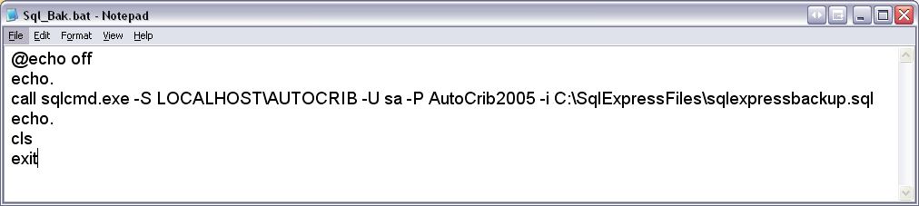

2) Click file>”Save As”.
3) Change the Save as type to “all files”.
4) Name the file Sql_Bak.bat
5) Click Save (Save to the SqlExpressFiles folder you created in step 3)
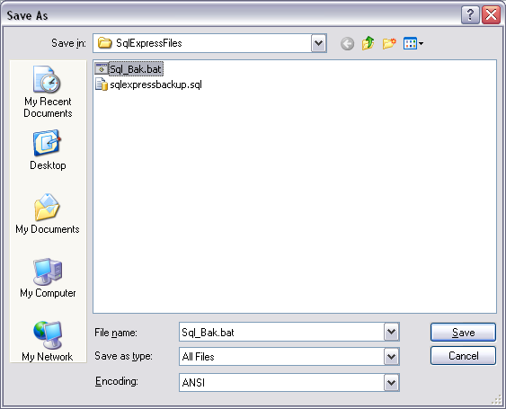

6) Now in windows, click on Start>All Programs>Accessories> System tools> Scheduled Tasks
7) Click the icon.

8) When the wizard pops up, click next.
9) From the following screen click the browse button:
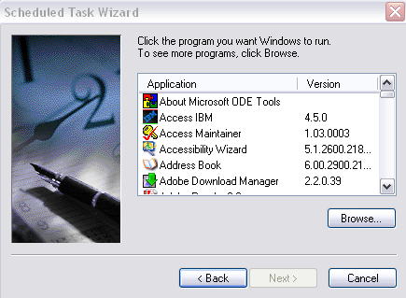

10) Find the Sql_Bak.bat file that you have just created:
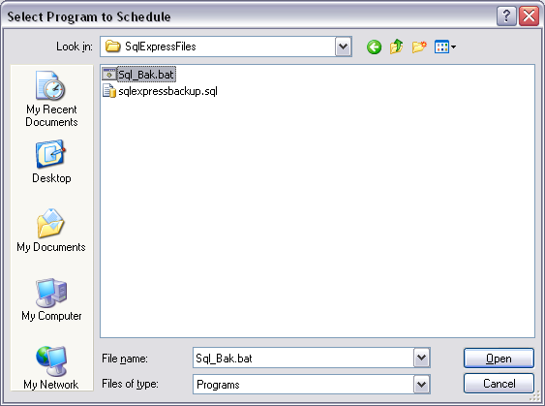

11) Click “Open”

12) Click “Daily”

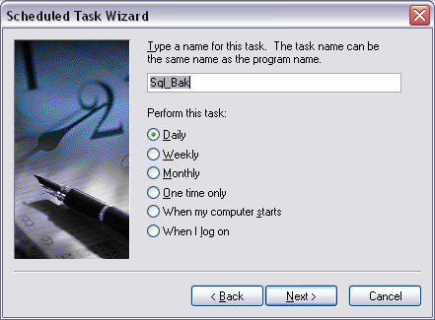

13) Select the backup time and click next

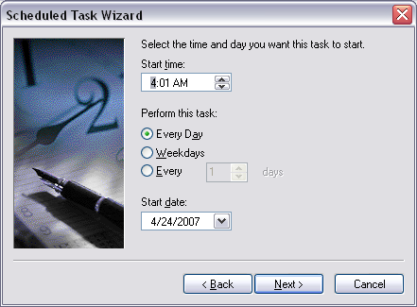

14) Enter the PC username and password:
Un: Autocrib
Pw: password

15) Click finish.
