Changing Bin Assignment

1. Select Tool Cribs> Bins

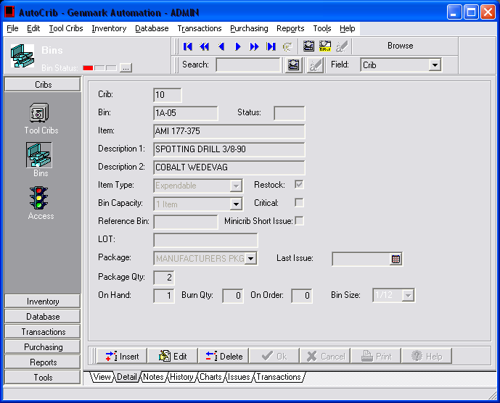

2. Before assigning a new item to a bin, verify the On Hand, Burn Qty, and On Order quantity are ‘0’. Notice below that there is an item On Hand. When we select edit, the option to select a new item for the bin is locked out.

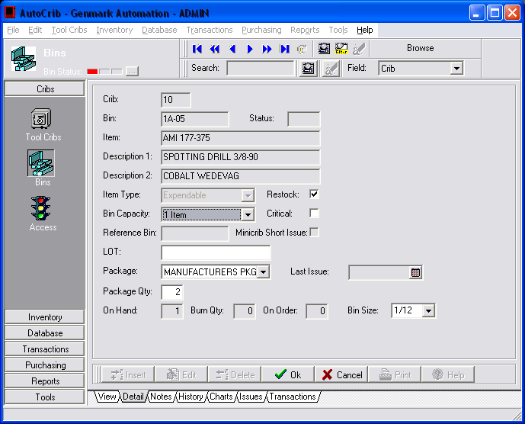

3. To remove the item from On Hand, select Transactions>Physical and highlight the bin location of the item. Press the physical button and change the quantity to 0. (Note that if you have an item on order you will need to remove this item from the Purchase Order.) If the item is located in a RoboCrib, the physical should be performed at the RoboCrib so that the item can be removed from the bin.

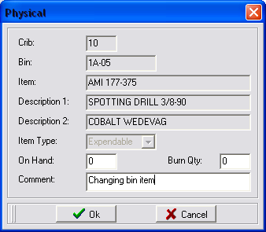

4. Notice that the item field is blue. Double click this field and select the item you want to assign to this bin.

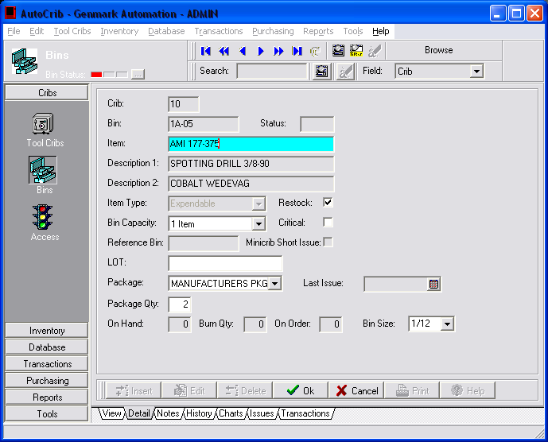

Assigning Open Items for RoboCribs

1. If you do not want to assign anything to the bin you will need to create an “OPEN” item. This item allows the user to know that the bin does not have an item assigned to it and will be reflected in the ‘Open Bin’ reports. Add a new item under Inventory>Items.

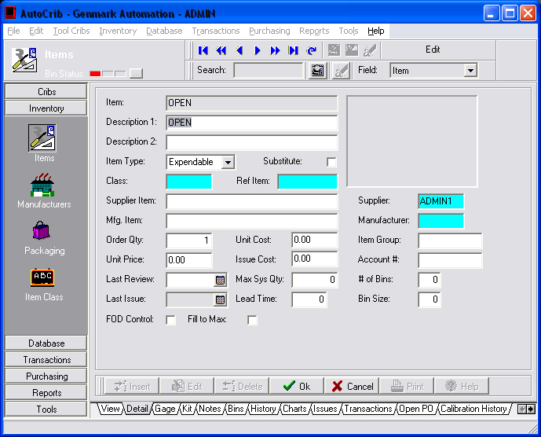

2. Go back to the Bins screen and insert

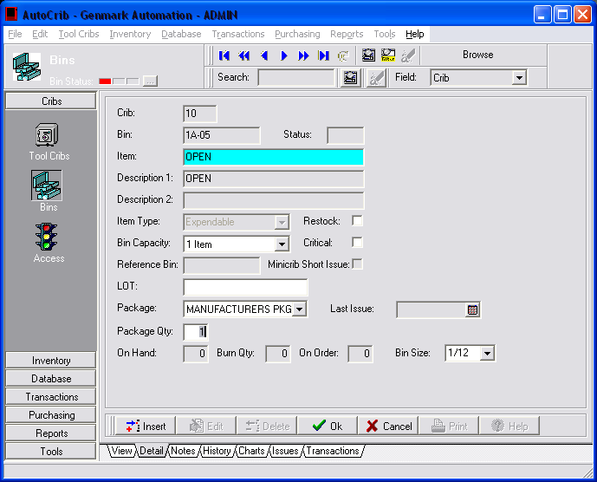

3. When the ‘Robo Open Bins’ report is run, this bin will now appear in the report. The ‘Robo Open Bins’ report can be found under the Standard Reports module in the ‘Inventory’ report category.
