AutoCrib Training – Tutorial Series

Bin Assignment Change & Open Bins:

The intent of this document/tutorial is to explore the complete administration and backup scenarios using MSDE Manager, SQL Server Management Studio Express and the SQL Express agent as the administration tools for the MSDE/Microsoft SQL Server and the AutoCrib databases. The goal is to help train and prepare for the administration of all existing, pending and future installations and to come up with a database backup scheduling routine to successfully restore a database if/when the need arises.

Changing Bin Assignment

1. Select Tool Cribs> Bins

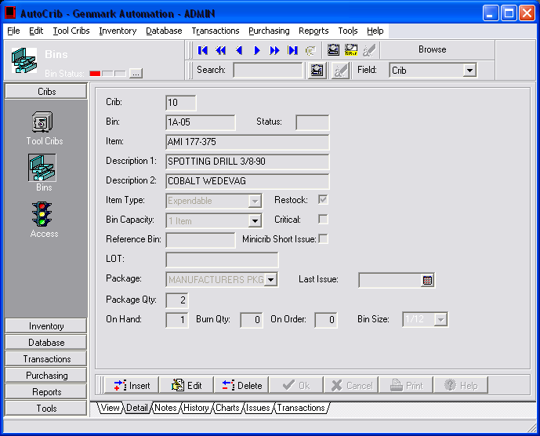

2. When assigning item to existing bins - Verify On Hand, Burn Qty, On Order, Open Issues are ‘0’. Below there is an item On Hand. Selecting edit will not allow the select item box to be enabled

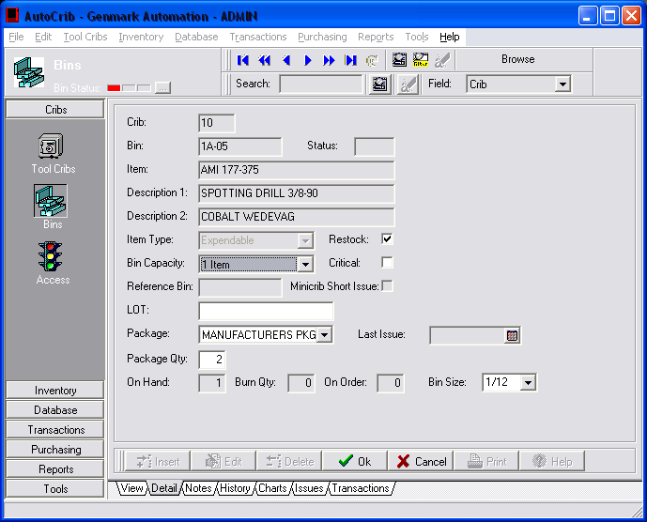

3. To remove On Hand or Burn quantities from any Item

- Select Transactions → Physical
- Highlight the bin location of the item.
- Press the physical button and change the quantities desired to 0. (Note that if you have an item on order you will need to remove this item from the Purchase Order.)
- If the Item is located in a RoboCrib, the physical should be performed at the RoboCrib so that the item can be removed from the bin.

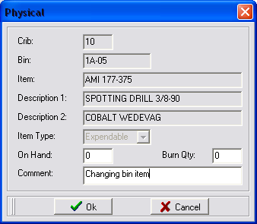

4. Returning to Tool Cribs → Bins - Edit will enable the item field.

- Double click this field and select the item you want to assign to this bin.

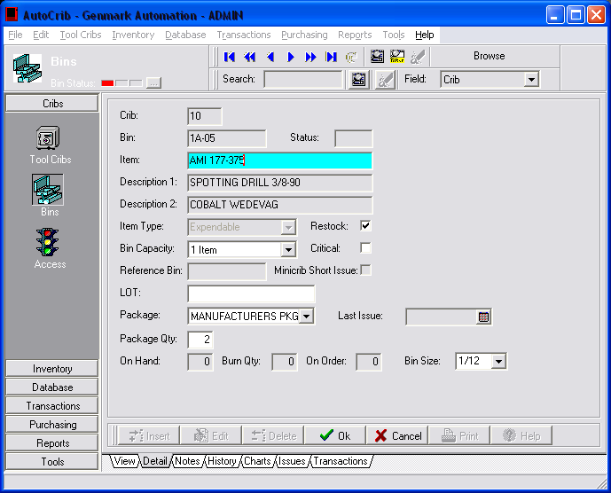

Assigning Open Items for RoboCribs (AutoCrib 4.2)

- Removing an Item from a RoboCrib in version 4.2 required a Bin to be transferred to “OPEN” item. This item allows the user to know that the bin does not have an item assigned to it and will be reflected in the ‘Open Bin’ reports.

- Add a new item under Inventory>Items.

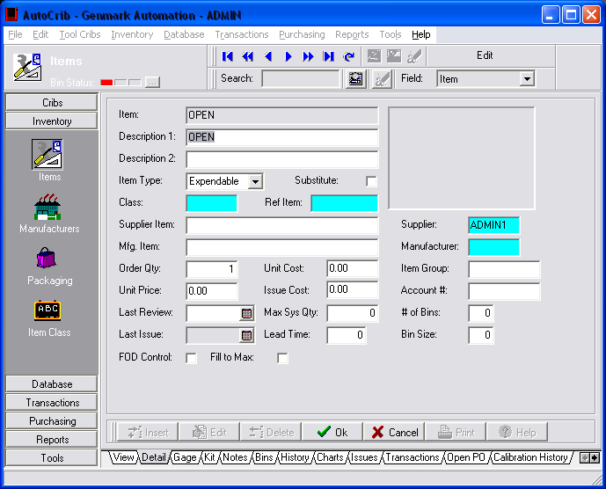

- Go to Tool Cribs → Bins

    - Highlight Bin to adjust
    - Edit Item to Open

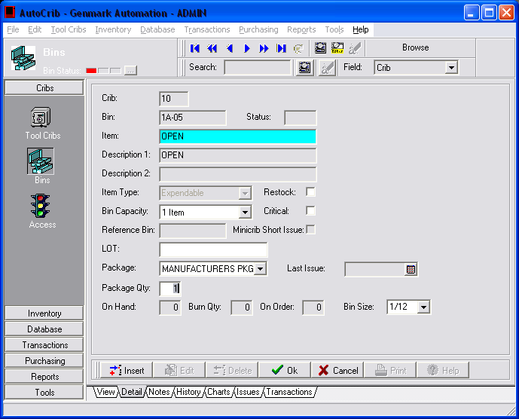

- Go to Reports → Standard → Report Category Inventory

- The ‘Robo Open Bins’ report will now show any and all Open Bins/Items.

