Custom Fields

The Custom Fields module is where user definable fields can be added for Items, Employees, Departments, Jobs, Machines, Parts, and Reasons. For each database type mentioned, up to 12 user-defined fields can be created. Once created, the user-defined fields are visible in the Detail screens of the respective database modules. For Items, under the inventory module there is a separate Custom Fields tab page. These fields are used to set up data tracking elements that are not otherwise available in the software and are user definable.

Example: A user may want to track all machines that a specific item is used on for the purpose of understanding what machines and jobs would be affected by the item becoming obsolete or superseded by a new improved technology. If we create a custom field called ‘Machine’ in the Items module, we could easily generate a report that would show us all machines that a specific item was used on. We can also use these custom fields for further sub-classifying items within their product classes. For instance, you can see the usage on all TIN coated carbide drills.

Select Database > Customs

- Insert an ID Label and description for the custom field.
- Click ‘Save’

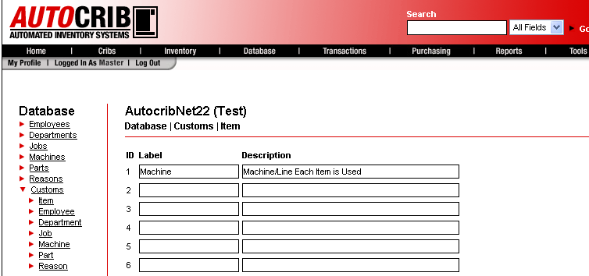

- Go to Inventory > Items. Select ‘Edit’ on an item that needs the custom field populated.

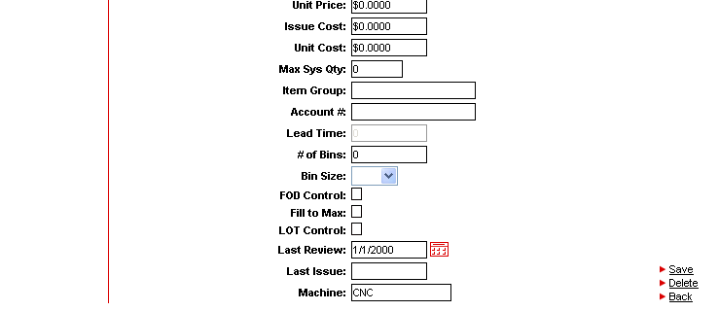

- Insert date for the custom field. Then, click ‘Save’.

