Adding a department to the software

1) Select Database>Departments from the menu
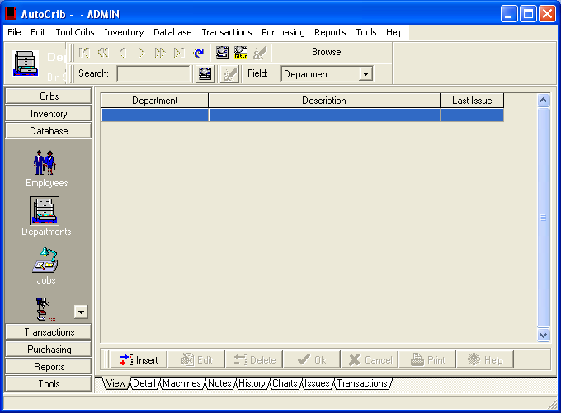

2) Click on the “Insert Button”
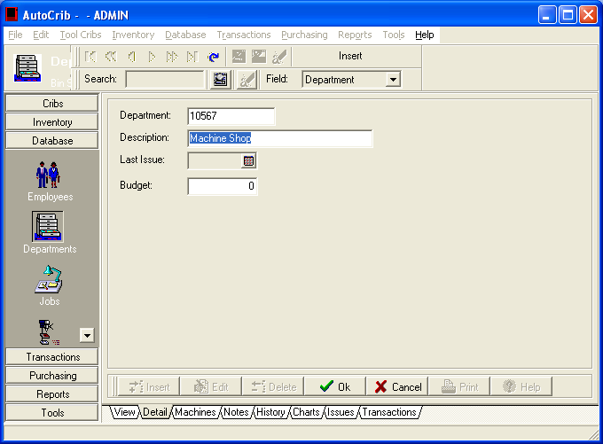

3) Enter the Department number, and a description for that department.
4) Select “Ok”
Assign a department to an employee

Please note: If an employee floats between multiple departments, it is best to leave their department field blank. The Robocrib will prompt the user to enter which department they are using the tool for.

1) Select Database>Employee and highlight the employee you would like to assign to a department

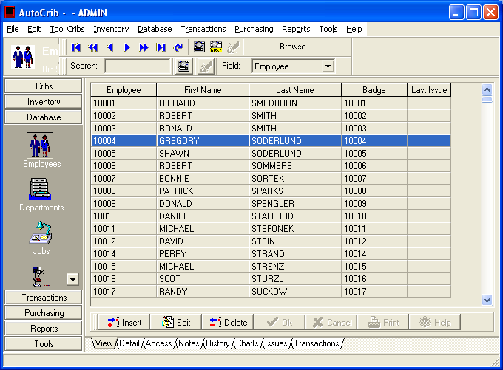

2) Select ‘Edit’
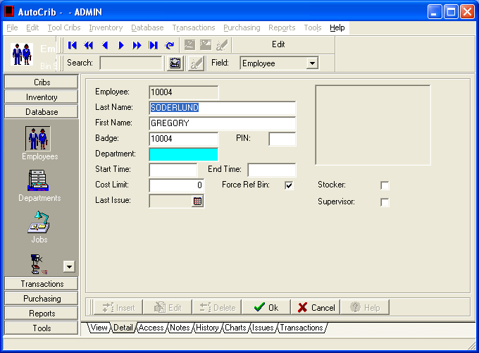
3) In the aqua color “Department” field double click and select the department # of the employee.

4) Select “Ok”

Enable the machine to track by departments

1) Select Tools>Options and then select the Tab labeled “Defaults”

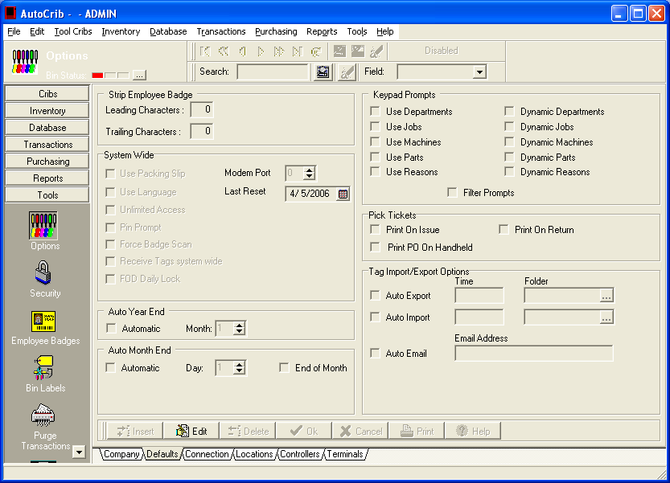

2) Select the “Edit” button and place a check under Keypad Prompts where it says “Use Departments”

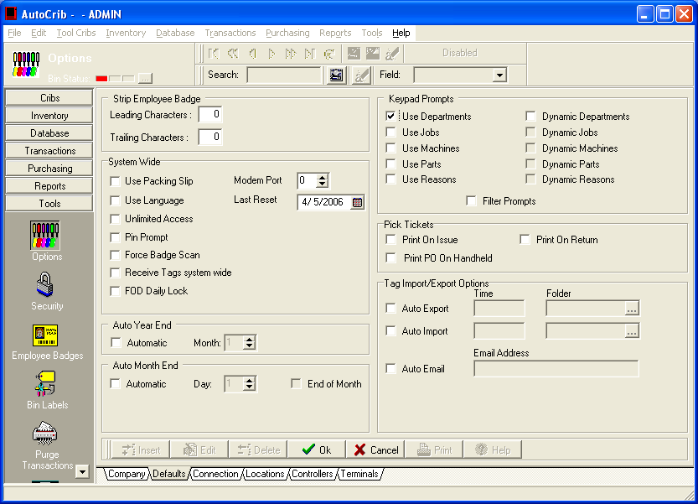

3) Select “OK”
The Robocrib will now track by department usage.

