Employee Interface

- Save the empinterface.exe file into C:\Program Files\Autocrib 5.2.
- Double click on empinterface.exe. An icon will appear in the task tray. Double click on this icon and locate the folder where the flat file containing the complete list of active jobs will be stored.
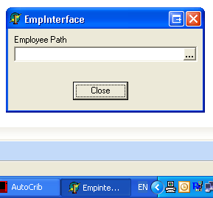

- The Employee Interface should run at all times and will process the CSV or TEXT file as soon as the file has been stored into the specified location.

How the program works:

The customer will produce, on a scheduled basis, a flat file containing the complete list of active employee data, and deposit flat file into a designated shared folder. The interface application will monitor the designated folder for the presence of a new flat file. When one is deposited, the interface will read the flat file records and append new employee data to the Autocrib Employee table. The interface will not create duplicates. The interface will not delete any employees from the Autocrib Employee table although it does not appear in the most recent flat file. Instead, the employee will be set to inactive. Departments included in the employee records of the flat file will be added to the Department table. Currently, no department descriptions can be added through the interface. The interface application will stay running on the AutoCrib computer and monitor for CSV or TXT files in the designated folder. When the file appears, the interface will immediately process the file. Once all records in the flat file are processed, the flat file will be renamed uniquely following a date + time.old naming convention and saved in the designated folder.

Data Sources – Flat File Definition

The flat file must be named jobs.csv. The layout is as follows:

Field | Data Type | Required | Length
Emp_number | alpha numeric | Yes | 12
Badge_number | alpha numeric | Yes | 12
Dept_number | alpha numeric |  | 12
PIN_number | alpha numeric |  | 4
First_name | alpha |  | 20
Last_name | alpha |  | 20
The flat file must include all active employee numbers. The fields must be separated using a comma delimiter. A sample flat file appears below.

A000071,000071,9999,3101,Peter,Smith
A000072,000072,9999,5566,John,Allen
A000073,000073,9999,5432,Jay,Charles
A000074,000074,9999,9009,Mike,Parsons
A000075,000075,9999,5666,Kelly,Slater
A000076,000076,9999,2231,Greg,Finch

If a department, PIN, or name is not available, its position and delimiter must still be retained. For example, a record where first name is not available would appear as follows:

A000071,000071,9999,3101,,Smith

Note that the comma delimiter for first name is retained before the last name.

The update result in the Job table for the first record would be:

Emp.MyNo | A000071
Emp.Badge | 000071
Emp.Dept | 9999
Emp.PIN | 3101
Emp.FirstName | Peter
Emp.LastName | Smith

