Adding Employees to Autocrib.Net

Select Database>Employees

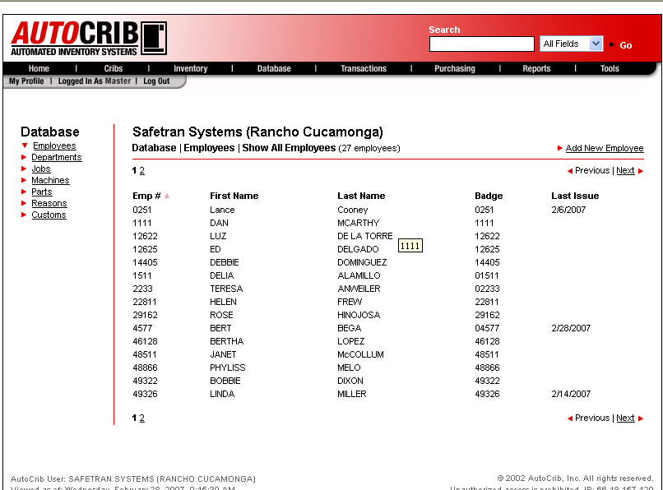

Select ‘Add New Employee’

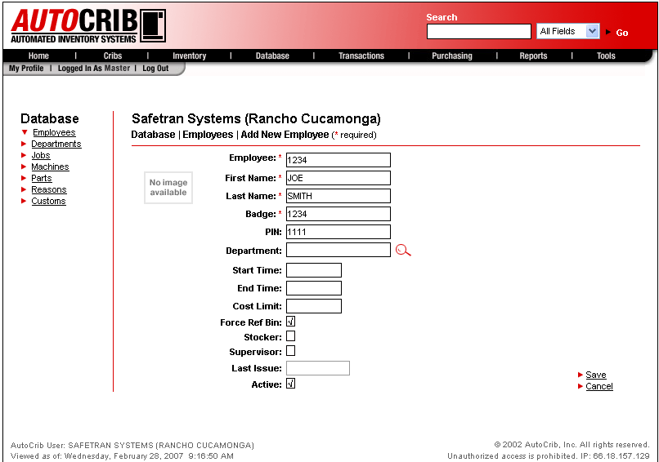

Enter employee Details.

Employee number: A unique number assigned to an employee by the employer, often an employee's Social Security Number. Must be unique for each employee.

Last Name: An employee’s last name.

Badge number: A number assigned to an employee badge by the employer, often the same as an Employee number. Required during Issue and Return operations at a station.

PIN: An employee's Personal Identification Number assigned to an Employee number. Required during Issue and Return operations at a station if the PIN prompt is enabled in Tools > Options > Defaults.

Department code: A company's department/cost center number or code, which has been optionally assigned to an employee. The system will not prompt for a department number, yet it will insert it into the transaction database. This should only be used when an employee will always be issuing and returning items from the same department/cost center.

Start Time: An optional setting of the time an employee's shift is scheduled to begin. Issue and Return operations are restricted for an employee using Start Time or End Time if Access Control is set to ON.
End Time: An optional setting of the time an employee's shift is scheduled to end. Issue and Return operations by an employee are restricted using Start Time and End Time if Access Control is set to ON.

Cost Limit: An optional setting of a monthly dollar allowance which will deny an employee's access when monthly usage has been exceeded. Issue and Return operations by an employee are limited using Cost Limit if Access Control is set ON.

Force Ref Bin: Forces the issue of an item (i.e., regrind item) stored in a Referenced Bin before an employee can access the selected item (i.e., new item). All of the referenced bin’s inventory must be exhausted before the selected bin will begin to dispense. This is a very effective means of cost control.

Supervisor: An optional setting for a specific employee, normally a supervisor, which overrides any and all settings in the access control module. For example, a normal employee is denied access to a specific item the supervisor can issue the item for the employee. The benefit to using this feature is that you do not have to build and maintain access control profiles for those designated as supervisors.

Stocker: An optional setting that allows this specific employee to restock any remote dispensing unit, or crib.

Last Issue: The date the employee last issued an item from any station.

Select “Save”

