The bin designated as the reference bin on a Helix (Vending) machine is forced to deplete its inventory before the requested bin dispenses. This feature is very useful when the user have regrinds or products that should be used before the new gets dispense.

To activate this feature:

- Under Cribs → Bins and highlight the vending machine
- Click on the bin you want to add a reference item to
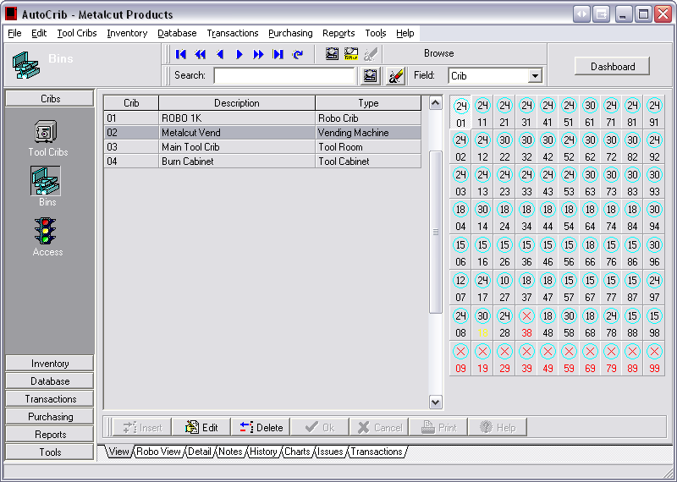
1
2

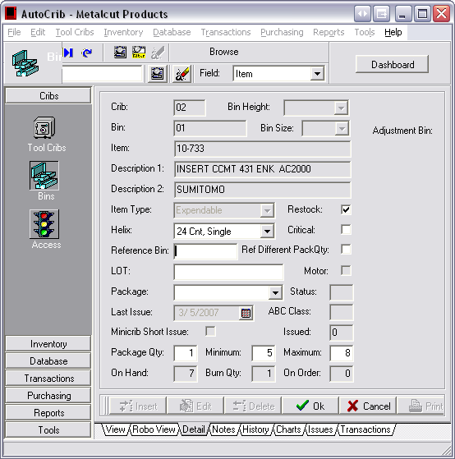
4
- Click on Edit down above the tabs
- Click on the blank field for “Reference Bin”
- Enter the Bin number of the reference item.
- Click OK

