Force Reference Item – How To

The item designated as the reference item on a RoboCrib is forced to deplete its inventory before the requested item is dispensed. This feature is very useful when the user has regrinds or products that should be used before the new tool is dispensed.

To activate this feature:

- Under Items → Inventory, locate the new item that should be referenced
- In the detail screen of the new item, click ‘Edit’.
- Double click the aqua box labeled ‘Ref Item’.
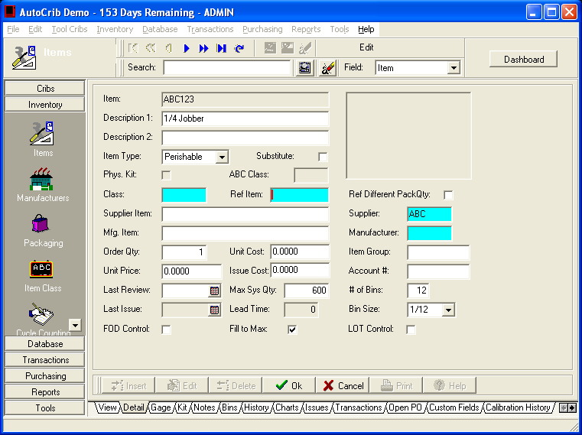

- Select the used item that should be dispensed before the new item. Then, select ‘OK’. (Note: If the regrind item is stocked in a different package quantity than the new item and the regrind item should still be dispensed before the new item, the ‘Ref Different PackQty’ must be enabled.)
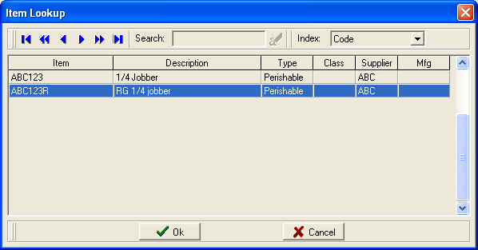

- Under Database > Employees, enable ‘Force Ref Bin’ for each employee where the item reference should be implemented.
