Item Code Change

- Create a text document which includes the current item code and the new item code. The format is as follows.

Item code <tab> new item code

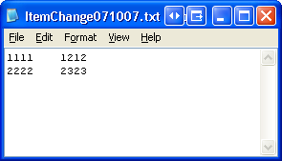

- Save the text file in a folder of your computer.
- Login to the Autocrib.Net website and select Tools > Item Change.
- Select the ‘Upload File’ link. Locate the text file saved in step 2. Then, choose ‘Upload’.
- Select the ‘Proceed’ button.

All item codes will now be changed throughout the database. If any errors occurred during the process, a notification will appear.

