AutoCrib Training – Tutorial Series

Item Interface:

The intent of this document/tutorial is to train on the setup for the Item Interface custom module. The customer will produce, on a scheduled basis, a flat file containing the list of item data that needs to be added or changed, and deposit the flat file into a designated shared folder. The interface application will monitor the designated folder for the presence of a new flat file. When one is deposited, the interface will read the flat file records and append new item data to the Autocrib Item databases, as well as disable items not found on the new file.

The flat file can be .csv or .txt.

The interface will not create duplicates.

The interface will not delete any items from the AutoCrib Item database.

The interface can append or add new items into the database.

Once all records in the flat file are processed, the flat file will be renamed uniquely and saved in the designated “outbox” folder.

Item Interface

- Install the Item Interface
  - Start the ACItemUpdaterInst.msi file.
  - Insert the server name, database name, username, and password.
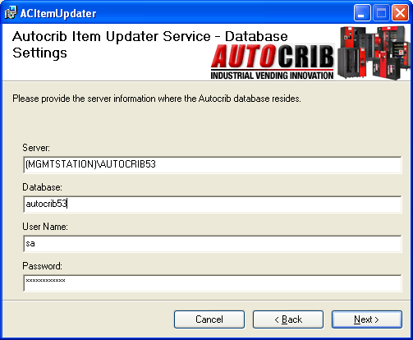
Example:

Server: (MgmtStation)\Autocrib53
Database Name: autocrib53
Username: sa
Password: AutoCrib2005
  - Click “Next”.

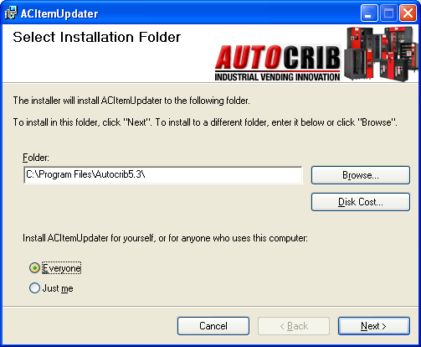
  - Select the folder to install the Item Updater.
Then, select “Next”.

  - Select “Next” again and allow the Item Updater to install. Then, select “Close”.
- Configure the Item Updater software.
  - Open My Computer and navigate to the folder where the Item Updater was installed.
  - Double click the “ACItemUpdaterSvc.exe” file. This application is a service that runs in the background.
  - Double click the “ACItemUpdater.exe” file. This application allows you to configure the flat file location, import interval, file name, delimiter, etc. Once the settings have been configured, select “Save Changes”.

Item Import Interval: number of minutes between the updater looking for a new file.
Inbox Location: Directory where the new flat file will be stored.
Outbox Location: Directory where the processed flat files will be stored.
File Name: Name of flat file, including file
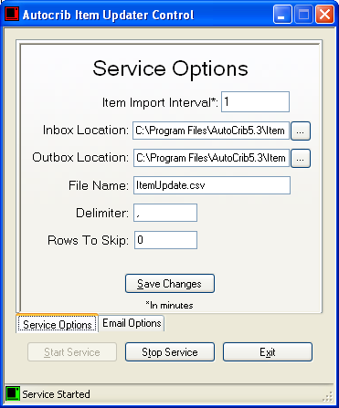
extension, when the flat file is saved in
the Inbox directory.
Delimiter: Character separating each
field within the flat file.
Rows to Skip: Item Updater will not
process the number of records defined
in this field. For example, if there is a
header in the flat file, the system will
not process the first record as long as
the “Rows to Skip” is set to 1.

  - Email Options Tab is used to flag files that did not get imported into the AutoCrib database. If the computer running the Item Updater has email access, you can configure this tab. Otherwise, leave this tab blank. Select the “Save Changes” button.
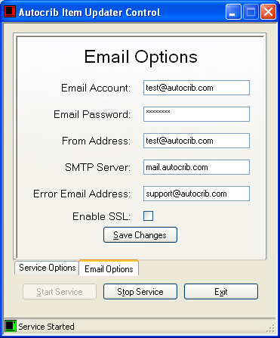
Email Account: Email account name used
by the pc.
Email Password: The password used for
the email account.
From Address: Email address being used to
send the error report.
SMTP Server: SMTP server name
Error Email Address: The email address of
where the error report should be sent.
Enable SSL: If encryption is being used,
check this box.

Data Sources – Flat File Definition
- The flat file must be use the same name inserted in step 2.c. The layout is as follows:

Autocrib Item Field | Item Flat File Position | Required | Type | Max Length | Default | Distinct Values
Code | 1 | Y | Alpha | 30
Description1 | 2 |  | Alpha | 35
Description2 | 3 |  | Alpha | 35
ItemType | 4 | Y | Integer |  |  | 0,1,2,3,4
OrderQty | 5 |  | Integer
AvgUnitCost | 6 |  | Currency
IssueCost | 7 |  | Currency
Cost | 8 |  | Currency
Vendor | 9 | Y | Alpha | 50
VendorItem | 10 |  | Alpha | 30
Mfg | 11 |  | Alpha | 6
MfgItem | 12 |  | Alpha | 30
Class | 13 |  | Alpha | 6
MaxSysQty | 14 |  | Integer
Notes | 15 |  | Alpha | 255
Physical | 16 |  | Boolean | 1 | 0 | T=1, F=0
ItemRef | 17 |  | Alpha | 30
ItemGroup | 18 |  | Alpha | 50
Account# | 19 |  | Alpha | 50
FOD | 20 |  | Boolean | 1 | 0 | T=1, F=0
LotControl | 21 |  | Boolean | 1 | 0 | T=1, F=0
Serialize | 22 |  | Boolean | 1 | 0 | T=1, F=0
Weigh | 23 |  | Boolean | 1 | 0 | T=1, F=0

Type field values are as follows:

0=Expendable
1=Perishable
2=Durable
3=Kit
4=Gage

The fields must be separated using a delimeter. A sample flat file appears below.

ABC123,,0,10,1.25,1.00,1.25,MTS900,,,,,,,,,,,,,,
CNMG0001,1/2 DRILL,,0,5, 1.25,1.00,1.25,VAR100,,,,,,,,,,,,,,

