How to Assign an Image to an Item

- Start the Autocrib software
- Login to the software using the ‘admin’ login
- Go to Inventory > Items

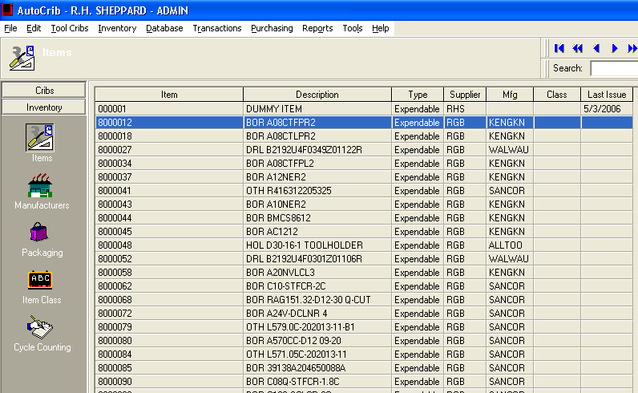

- Click ‘Edit’ on the item you want to assign a picture.
Right click in the image section and select ‘Insert Picture’

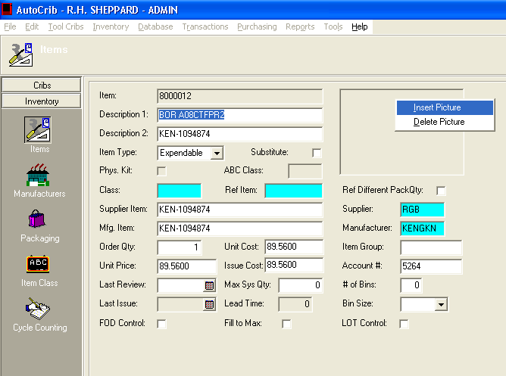

- Locate the image you would like to assign the item. The image should be in a jpeg format and the best resolution to use is 1200 x 900.

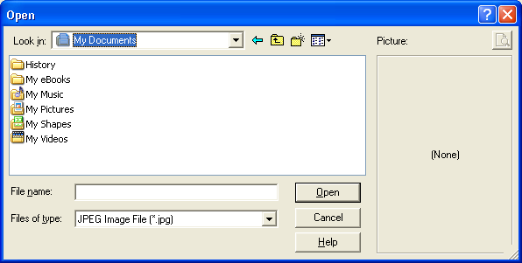

- Click ‘OK’ to save the settings.

