AutoCrib Training – Tutorial Series

How to Assign an Image to Items:

This document/tutorial will help you quickly assign images to the Items listed in the Inventory module. The picture assignment helps the managing attendant, subordernents and the dispensing unit users identify the correct Item not only through the AutoCrib managing software but also through the touch screen interfaces.

How to Assign an Image to an Item

- Start the Autocrib software
- Login to the software
- Go to Inventory → Items

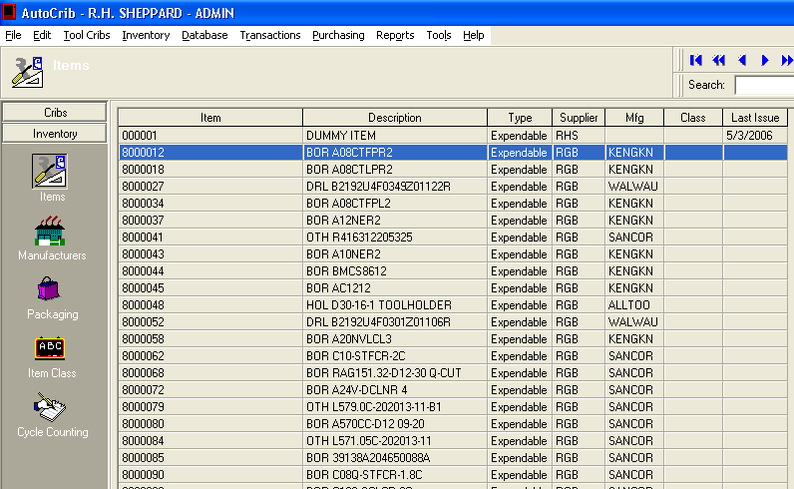

- Click ‘Edit’ on the item you want to assign a picture.
- Right click in the image section and select ‘Insert Picture’

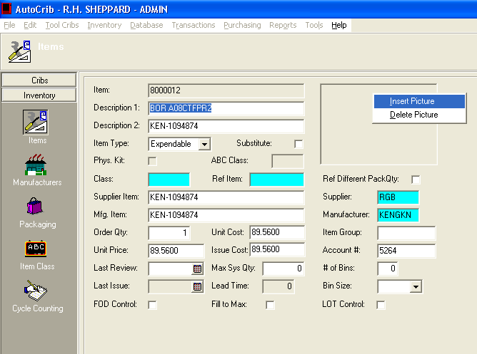

- Locate the image you would like to assign the item.
  - The image should be in a jpeg format and the best resolution to use is 1200 x 900.

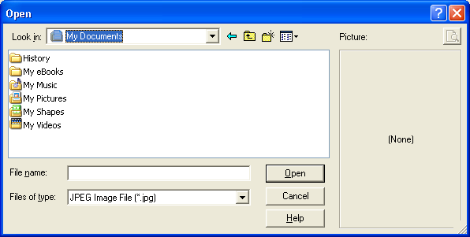

- Click ‘OK’ in the Items Screen to save the settings.

