AutoCrib Training – Tutorial Series

Job Interface:

The intent of this document/tutorial is to train on the setup for the Job Interface custom module. The customer will produce, on a scheduled basis, a flat file containing the complete list of active job data, and deposit flat file into a designated shared folder. The interface application will monitor the designated folder for the presence of a new flat file. When one is deposited, the interface will read the flat file records and append new job data to the Autocrib Job databases, as well as disable jobs not found on the new file.

The interface will not create duplicates.
The interface will not delete any jobs from the AutoCrib Job database.
Once all records in the flat file are processed, the flat file will be renamed uniquely and saved in the designated folder.

Job Interface

- Save the jobinterface.exe file into C:\Program Files\Autocrib 5.1 or C:\Program Files\Autocrib X.XX depending on the software version being used.
- Double click on jobinterface.exe. An icon will appear in the task tray.
- Double click on this icon and locate the folder where the flat file containing the complete list of active jobs will be stored.

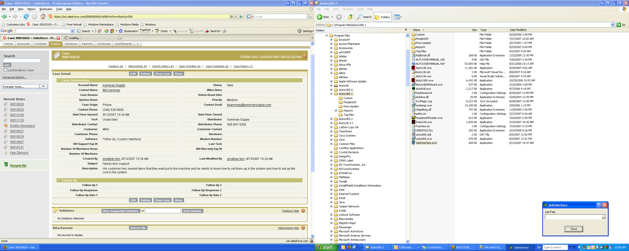

- The Job Interface should run at all times and will process the jobs.csv file as soon as the file has been stored into the specified location.

Data Sources – Flat File Definition
- The flat file must be named jobs.csv. The layout is as follows:

Field | Data Type | Required | Length | Example
job_number | alpha numeric | Yes | 40 | 111112
job_description | alpha numeric | No | 40 | JOB 111112
active | boolean | Yes | 1 | 1=true; 0=false

- The flat file must include all active job numbers.
- The fields must be separated using a tilde “~” delimiter. A sample flat file appears below.
0123~alcoa xxxx~1
0321~trane xxxx~1
0456~northrop xxxx~0
0658~~1
0898~~0
0999~chrysler xxxx~1

- If a description is not available, its position and delimiter must still be retained.
- For example, a record where description is not available would appear as follows:
  - Note that the tilde delimiter for description field is retained before the active field
0658~~1

- The update result in the Job table for the first record would be:

Job.MyNo | 0123
Job.Description | Trane
Job.Active | True

