MinMax Update

The MinMax Update tool allows a text file with Bin Minimum and Maximum levels of all crib types (except RoboCribs), to be used to update the live Bin data. The following script details how to perform this update.

The following screenshot shows Crib 04, bin 01, with item 603193. The Min and Max are 15 and 30 respectively. We are looking to update the min to 8 and the max to 20

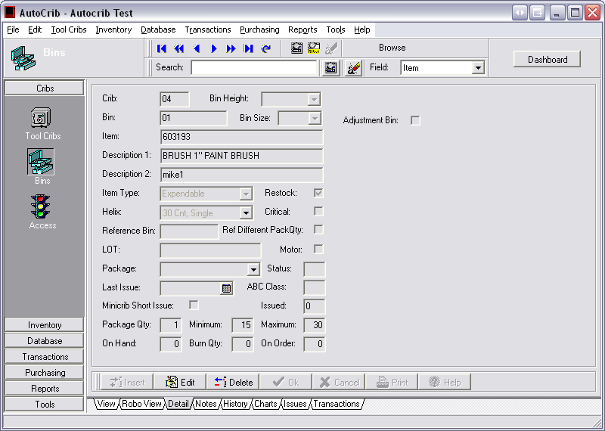

The following screenshot shows Crib 04, bin 11, with item 605071. The Min and Max are 2 and 30 respectively. We are looking to update the min to 15 and the max to 20.

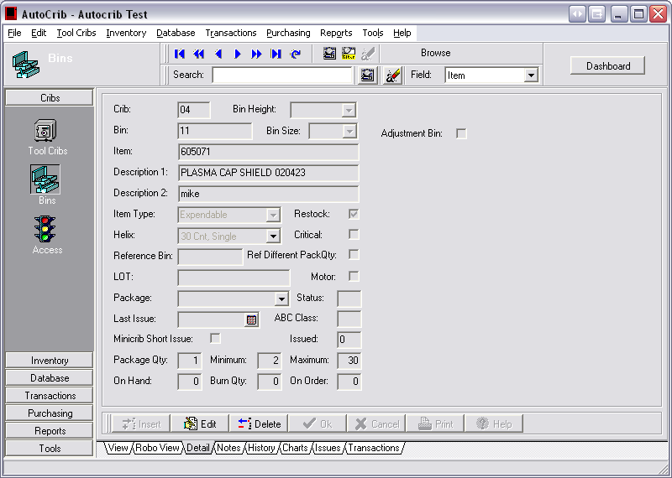

To change these two min/max’s we will need to create a text file in the following format:

Station [Tab] Bin [Tab] Item[Tab] Minimum[TAB] Maximum

For example:
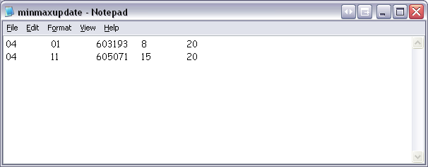

Save the text file to your PC.

Select Tools from the drop down menu, then MinMax Update
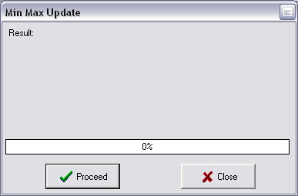

Click the Proceed button and find the text file you just saved.

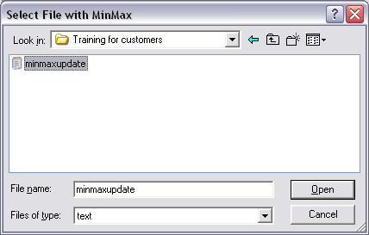

Click Open.

Your Min Max’s should now be updated.
