MobileCrib Troubleshooting

Problem: Unable to start the MobileCrib software

Has the MobileCrib software worked before?
- If the MobileCrib software has worked before, go to the ‘Verify Network Settings are Correct’ step.
- Verify the SQL scripts have been executed on the database.
- Verify Autocrib version 5.1.53.0 or above is being used at the workstations.

Verify Network Settings are Correct

- Verify the Mobile Companion wireless icon arrows do not have an ‘X’ through them. If there is an ‘X’, do the following.
  - Select the Mobile Companion icon on the task tray. Select ‘Find WLANs’.

Mobile
Companion Menu
Mobile
Companion Icon

  - Once a wireless LAN(s) is located, the name will display in the ‘Available WLAN Networks’ list. Highlight the appropriate wireless network and click ‘Connect’.

  - The Mobile Companion Mode tab appears.
    - Select the ‘Mode’ tab.
      - Verify ‘USA’ is selected for Country.
    - Select the ‘Encryption’ tab.
      - Select the appropriate Encryption type. Usually, this will be WEP.
      - Select the KeyLength being used; 40-bit or 128-bit.
      - Insert the access code associated with the wireless access point.
      - Click ‘OK’.

    - Select the IP Config tab.
      - Depending on the configuration, select either DHCP or Static from the IP Type drop down. If ‘Static IP’ is selected, an IP address, subnet mask, gateway, DNS, and WINS will be required.
      - Click ‘OK’.

  - The Mobile Companion wireless status icon should indicate that the MobileCrib is connected to the Access Point. If there is still an ‘X’ through the icon, see the network administrator.
- Verify regulatory settings are correct.
  - Select the Mobile Companion icon on the task tray. Select ‘Wireless’ and then the ‘Options’ selection.
  - Select the Regulatory option.
    - Settings = USA
    - Verify ‘Enable 802.11d’ is disabled.
- Attempt to ping the SQL Server.
  - Tap the Mobile Companion icon on the task tray. Select ‘Status’.

Mobile
Companion Menu
Mobile
Companion Icon

  - Select the ‘Signal’ tab to display a real-time graph of the signal quality to the Access Point.
    - As long as the LED to the right of the graph is green the Access Point association is not jeopardized.
    - If the LED is red, an association with a different Access Point could not be established to improve signal strength.

  - Select the ‘Ping’ tab to determine if the SQL Server is reachable.
    - Enter the IP address of the SQL Server in the IP drop-down list.
    - Select ‘Start Test’.
    - If the ping test is unsuccessful, see the network administrator.
    - If the ping test is successful, press the ‘Stop Test’ option and follow the next steps.

- Access Internet Explorer
  - Go to Start > Programs > Internet Explorer.
  - Once the Internet Explorer screen appears, enter a website in the URL.
  - If you are unable to access a website, verify with the network administrator that Internet access is allowed.
  - If the website loads successfully, follow the next steps.

- Verify the MobileCrib application is named ‘MobileCrib 5.1’
  - Go to Start > Programs > Autocrib.
  - Verify the MobileCrib application is named ‘MobileCrib 5.1’.
  - If the application is not named ‘MobileCrib 5.1’ follow the steps below.
    - Place the MobileCrib on the cradle
    - Once the Active Sync window appears, select the ‘Explore’ button.
    - Double click on ‘My Windows Mobile-Based Device’.
    - Go to Windows > Start Menu > Programs > Autocrib.
    - Right click on the MobileCrib application and choose ‘Cut’.
    - Paste this onto the desktop of the computer.
    - Rename the MobileCrib file to ‘MobileCrib 5.1’.
    - Copy this file from the desktop and paste it into Windows > Start Menu > Programs > Autocrib.
    - Remove the MobileCrib from the cradle and try to start the ‘MobileCrib 5.1’ software.
    - If the software will still not start, follow the steps below.
  - If the application is named ‘MobileCrib 5.1’ follow the next steps.
- Verify the config file is setup correctly.
  - Go to Start > Programs > Autocrib.
  - Click on the ‘config’ file.
  - Verify the format in the config file is as follows.

Server|database name|login|password|crib number

Examples:
(local)|autocrib5|sa|autocrib|01
192.168.168.25|autocrib5|sa|autocrib|01

  - If the format is not correct, follow the steps below.
    - Place the MobileCrib on the cradle.
    - Once the Active Sync window appears, select the ‘Explore’ button.
    - Double click on ‘My Windows Mobile-Based Device’.
    - Go to Windows > Start Menu > Programs > Autocrib.
    - Right click on the ‘config’ and choose ‘Cut’.
    - Paste this onto the desktop of the computer.
    - Open the ‘config’ file in Notepad and edit the format to meet the standards listed above. Then, save the changes.
    - Copy this file from the desktop and paste it into Windows > Start Menu > Programs > Autocrib.
    - Remove the MobileCrib from the cradle and try to start the ‘MobileCrib 5.1’ software.
    - If the software will still not start, follow the steps below.
  - Use the server’s IP address instead of the computer name in the config file. (This can be changed on the MobileCrib itself.)
  - Verify the username and password have proper user permissions to the database. If the database resides on the customer’s SQL Server, the DBA will need to verify this. Otherwise, the standard user should be ‘sa’.
  - If the config file is setup correctly and the user has correct permissions follow the next step.
- Telnet the SQL Server from a workstation.
  - Go to Start > Run
  - Type ‘cmd’ then click ‘OK’.

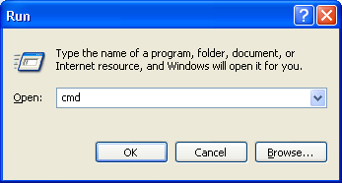

  - Type telnet IP address of the server 1433.
Example: telnet 192.168.168.22 1433
  - If an error “Could not open connection to the host, on port 1433: Connect failed”, port 1433 must be added to the exceptions list. See below.

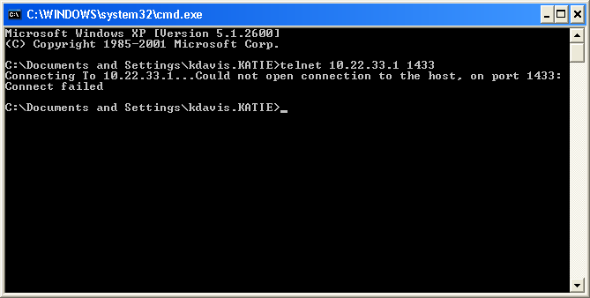

    - Go to Start > Control Panel > Windows Firewall.
    - Select the Exceptions tab.
    - Select ‘Add Port…’
    - Enter ‘SQL Server’ as the Name and ‘1433’ as the Port Number. Select ‘TCP’. Then, click ‘OK’.

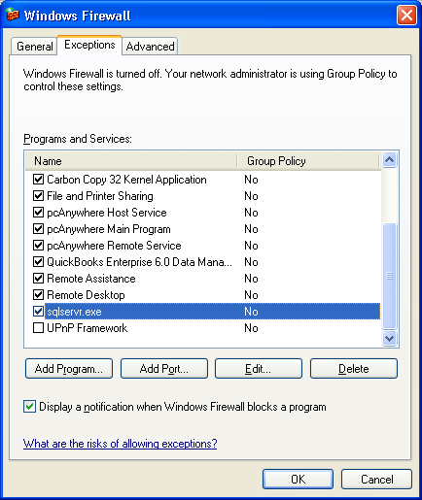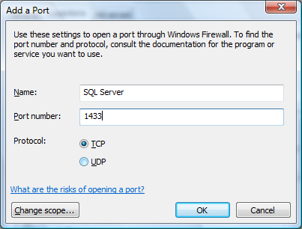

  - The SQL Server application must also be added to the exceptions list.
    - Click ‘Add program…’
    - Select the ‘Browse’ button.
    - Navigate to the C:\Program Files\Microsoft SQL Server\MSSQL\Binn folder and find sqlservr.exe.
    - Click ‘OK’.
    - The sqlservr.exe file should be enabled in the Exceptions list.
    - Attempt to start the MobileCrib software. If an error is still generated follow the steps below.
- Perform a soft reboot on the MobileCrib.
  - Hold the red power button until the message “Releasepower key to warm reboot”.
  - Once the MobileCrib has rebooted, attempt to start the MobileCrib software. If an error is still generated follow the steps below.
- Verify a wireless computer can start the AutoCrib software.
  - Using a wireless computer, start the AutoCrib software.
  - If the Autocrib software starts successfully, the wireless access point is setup correctly.
  - If the Autocrib software does not start, the wireless access point settings need to be checked.
- Turn Windows Firewall off
  - Go to Start > Control Panel > Windows Firewall.
  - Select the ‘Off (not recommended) option. Then, click ‘OK’.

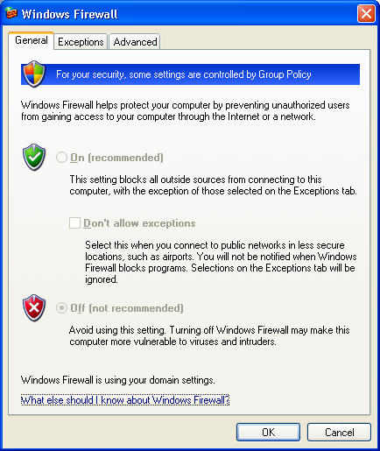

  - Attempt to start the MobileCrib software. If the software will start, follow the steps below.
    - Go to Start > Microsoft SQL Server > Client Network Utility
    - Highlight the TCP protocol and select the ‘Disable’ button. Then, click ‘OK’.

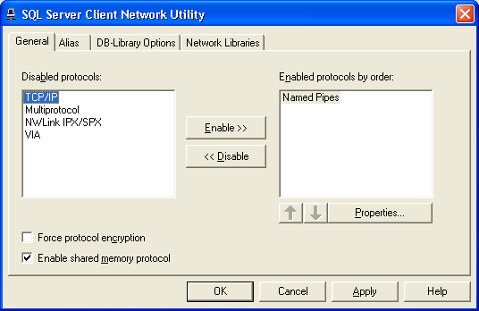

    - Turn off the SQL service by double clicking on the server icon in the task tray and select ‘Stop’. Select ‘Yes’ when prompted to turn stop the SQL Service.

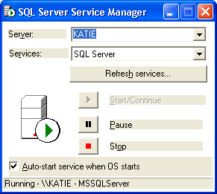
- Reinstall the cab files. Go to Start > Programs > File Explorer > My Device > Applications. Reinstall the following files.
  - Netcf.all.wce4.arm4.cab
  - Sql.wce4.arm4.cab
  - Symbol.all.arm.cab

    - Highlight the TCP/IP Protocol using the Client Network Utility and select the ‘Enable’ button. Then, click ‘OK’.

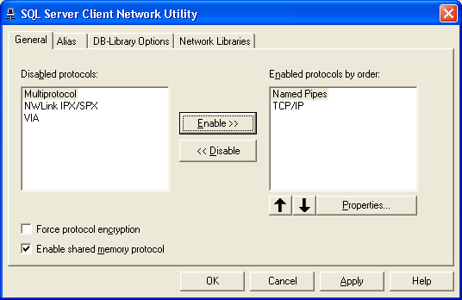

    - Click ‘Start/Continue’ on the SQL Service.

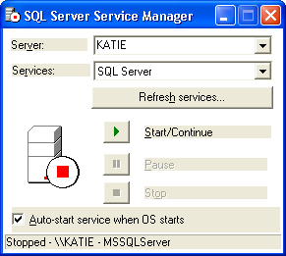

    - Attempt to start the MobileCrib software. If the software still will not start, contact AutoCrib technical support.

