AutoCrib Training – Tutorial Series

This document is a simple walk through setup of AutoCrib’s Commerce Center/P21 client-side and server-side integration. There will be additional settings done through the AutoCrib and P21 software. The configurations for the AutoCrib software are listed below. Changes to the P21 must be arranged by a P21 administrator.

AutoCrib Item Setup:

- Make sure Supplier Item codes are added to each Item  - These Items must match the Items Codes listed on the P21 database | 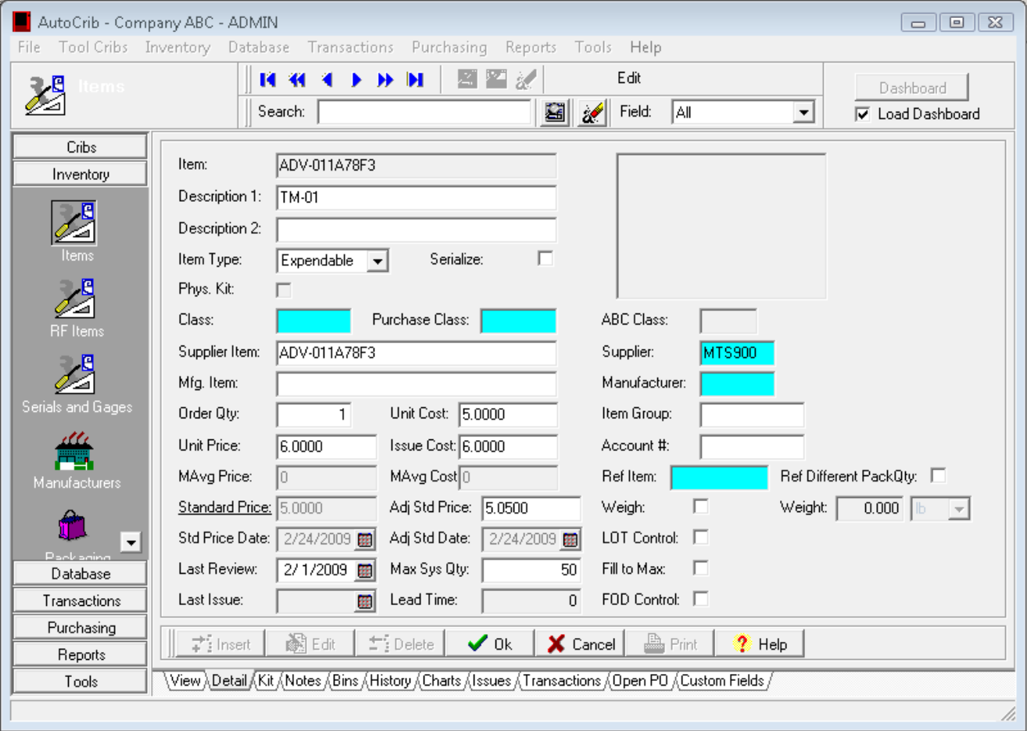  Figure 1
- Add PO Email for P21 receiving inbox  - Enable AutoPO, setup time to create PO and which assigned days to create PO | 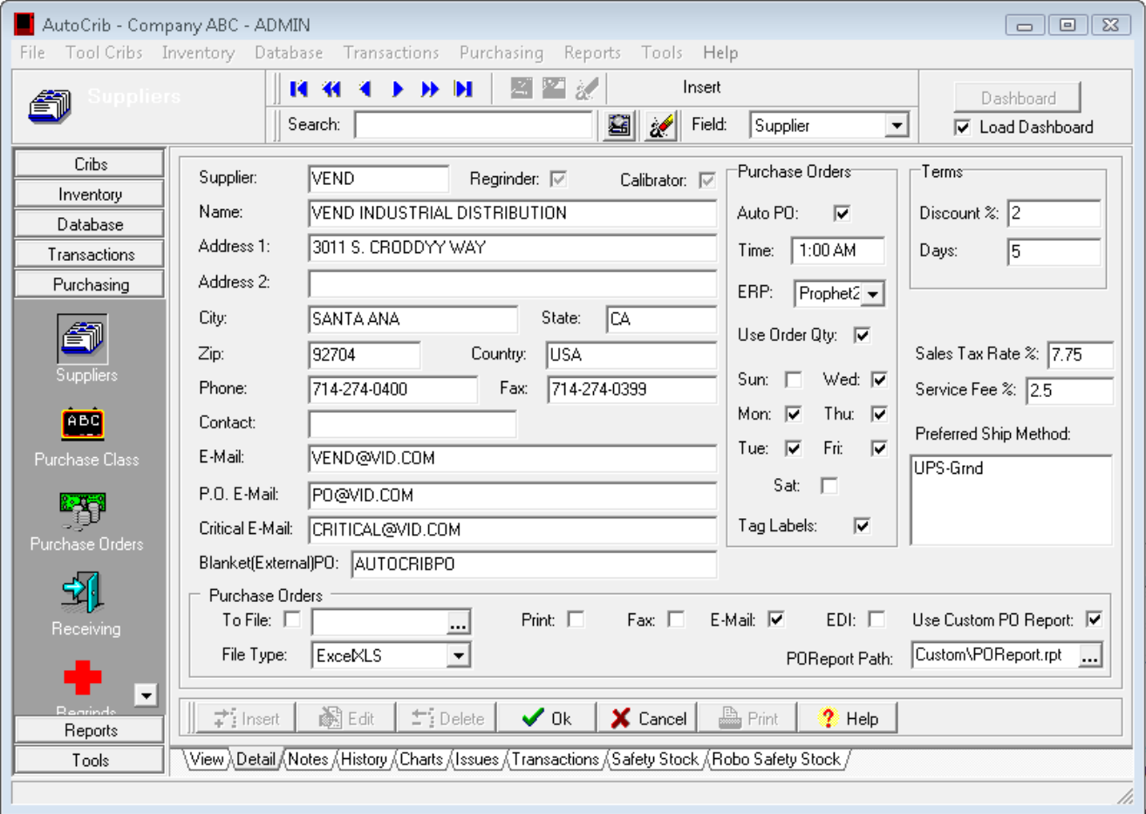  Figure 2

Continue…
- Enable AutoPO for each Crib where Automatic Purchasing will be available  √ AutoPO and select PO Method – Refer to Help Guide for method explanation  - Click OK | 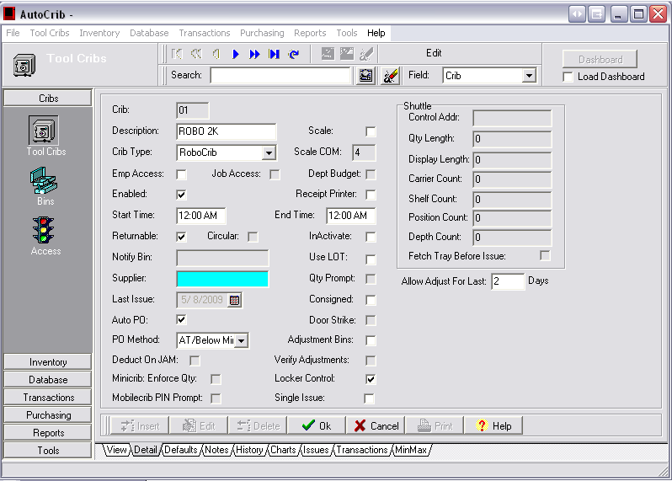  Figure 3
- Understand the package quantity assigned to Items because all Items being brought from P21 must match the Pack Quantity assigned through the AutoCrib software  ◙ This process can not break down package quantity. | 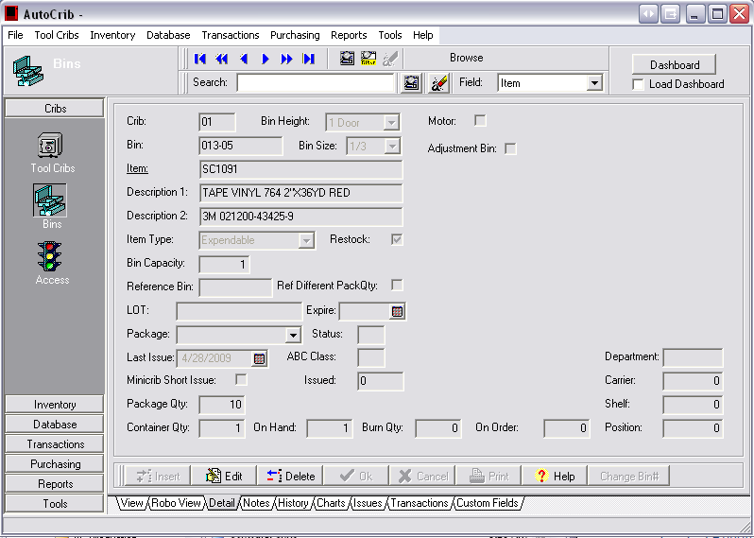  Figure 4
P21 Commerce Center Client Setup:  - Incoming Mail  - Setup incoming mail server  - Outgoing Mail  - Provide outgoing server information with port numbers  - Options  - Create two folder for incoming and outgoing file locations  - After creation: Click browse on each pathway and select the appropriate file locations  - Designate times upon when the system while check for new Purchase Orders for transfer  - Provide the proper P21 Commerce Center information for: (Information is provided by P21 – Consult Commerce Center Help Menu for assistance)  - EDI ID:  - Contact Name  - SalesLocNo:  - Taker  - ContactID:  - CustNo:  - Click Save | 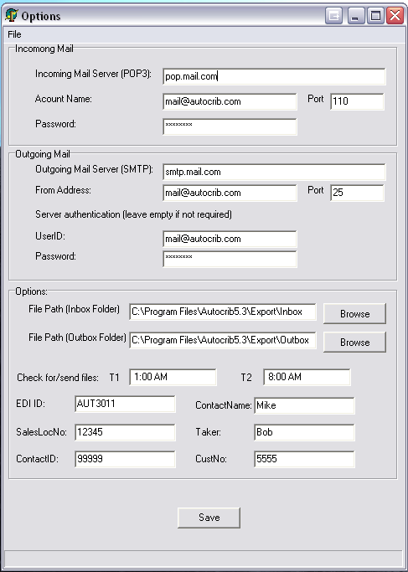  Figure 5
P21 Commerce Center Server Setup:  (Email account should be dedicated to this system as other emails will be read is incoming orders)  - Incoming Mail  - Setup incoming mail server  - Outgoing Mail  - Provide outgoing server information with port numbers  - Options  - Create two folder for incoming and outgoing file locations  - After creation: Click browse on each pathway and select the appropriate file locations  - Designate times frequency for sending mail to client side  - Click Save | 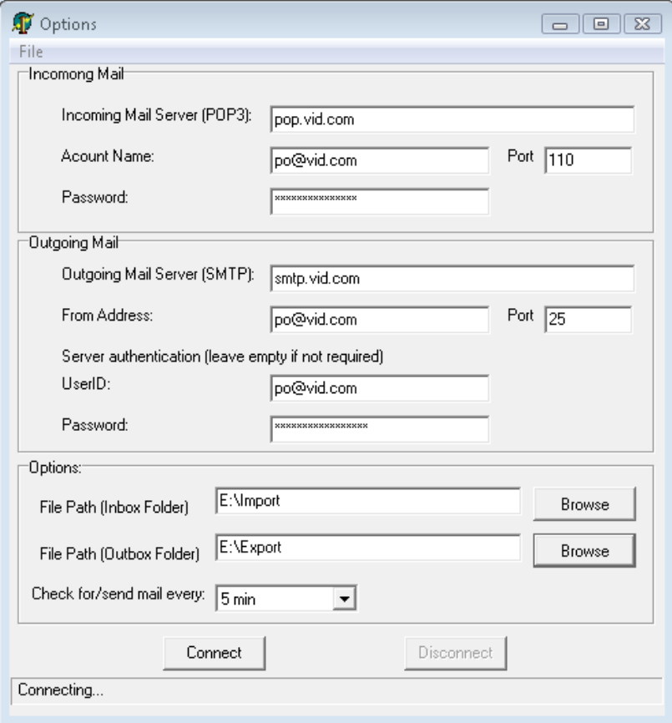  Figure 6

