Robocrib: Create New PO

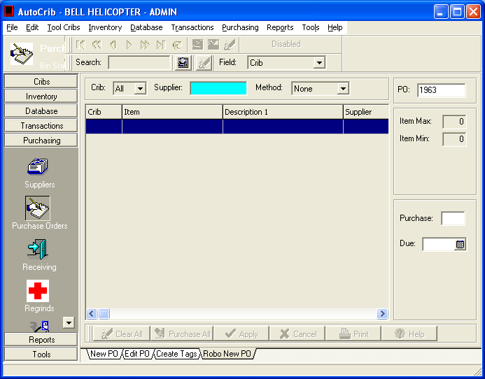 | - Click on Purchasing.  - Click on Purchase Orders.  - Click on the Robo New PO Tab.
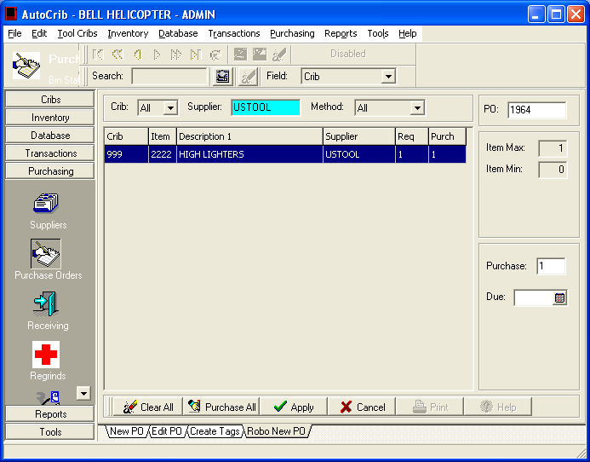 | - Select the Supplier.  - Select the method (All, Below Min, Below Max).
- Purchase the amount of items you want by clicking “Purchase All” to fill the items to the max qty.
- Purchase the amount of items desired by highlighting the item and entering in the desired quantity under the purchase box.
- Click Apply to create the PO.

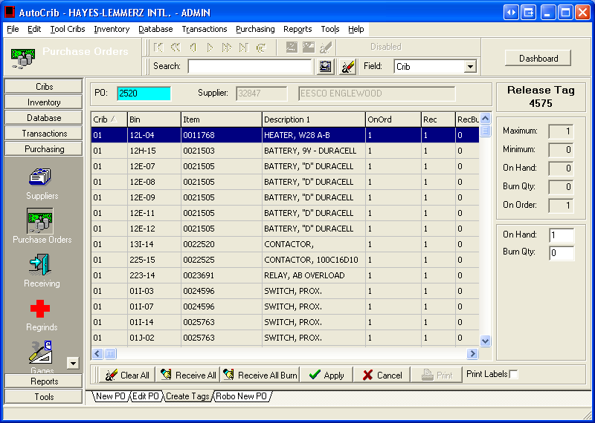 | - Click on the Create Tags tab.  - Select the purchase order created in the steps above.  - Select ‘Receive All’. Then, choose ‘Apply’.
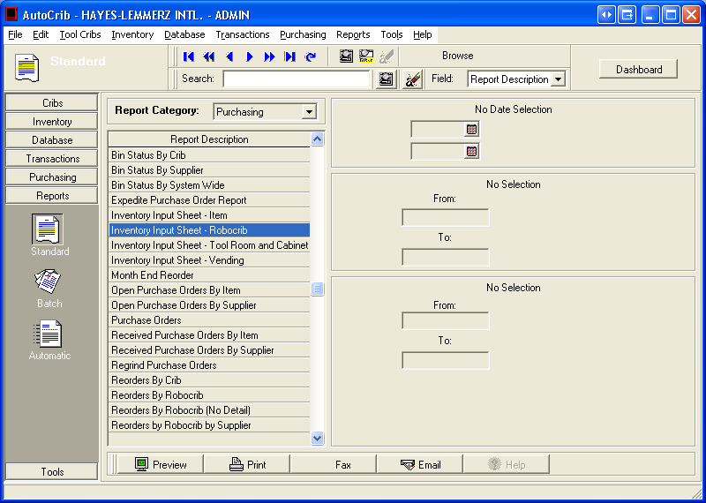 | - Click on Reports.  - Click on Standard.  - Select Purchasing as the Report Category.  - Highlight the Inventory Input Sheet – Robocrib report.  - Click Preview.  - Print the Inventory Input Sheet – Robocrib report.

