AutoCrib.Net – How to Automatically E-Mail Reports

- Go to Tools>Options>Company.
  - Click ‘Edit’ and select the ‘click here’ option under “To make this computer the Master Computer, click here”. After this has been selected, ‘$AutocribNet’ should appear in the “Master Computer” section.
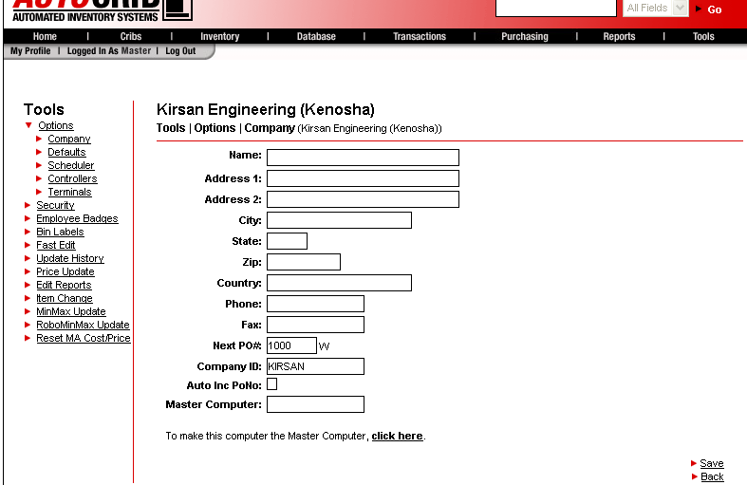

- Go to Purchasing>Suppliers and select the supplier that the automatic email should be sent. Click ‘Edit’ and insert the recipients email address in the “E-mail” option.
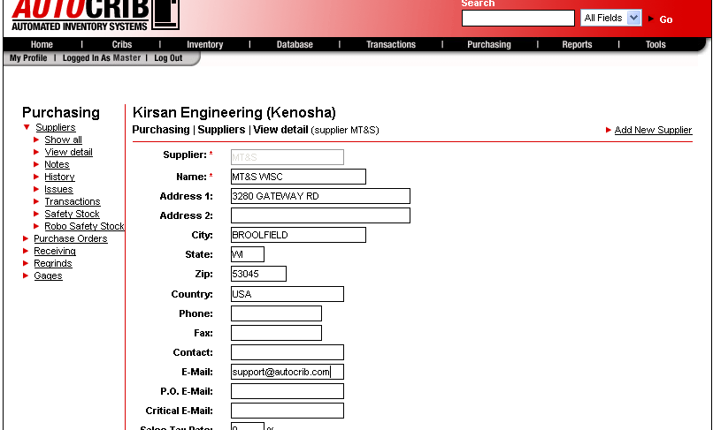

- Go to Reports>Automatic and highlight the report that will be e-mailed automatically. Select how often the report should be e-mailed (daily, weekly, or monthly) and enable the ‘Email’ checkbox.
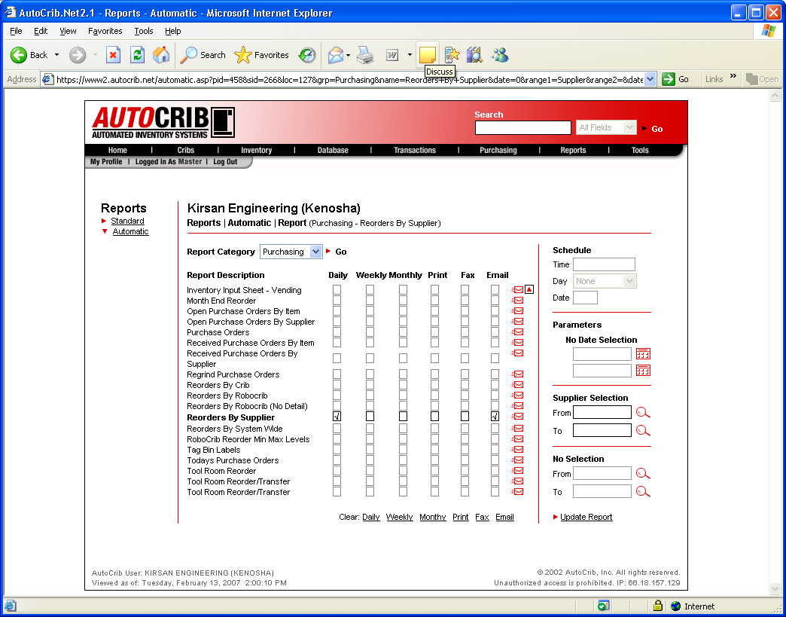

- A pop-up box will appear after the “Email” option has been selected. Enable the checkbox next to the Supplier that should receive the e-mail. Then, click ‘Add’.
- Select the file type that the report should be sent as. The options are text, crystal, rich text, and word. Once complete, select the “X” button in the upper-right portion of the screen.
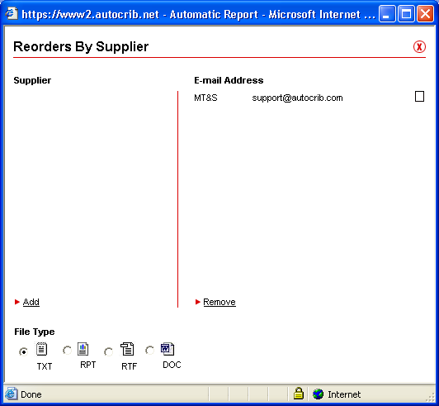

- Insert the time, day, and date (where applicable) when the report should be e-mailed.

- Finally, click “Update Report” to save the changes.

