How to setup Automatic Reports Saving to File

1) Select Reports>Automatic
2) Select your report category
3) Select one of the check boxes in the three fields highlighted below. (Daily, Weekly, Monthly

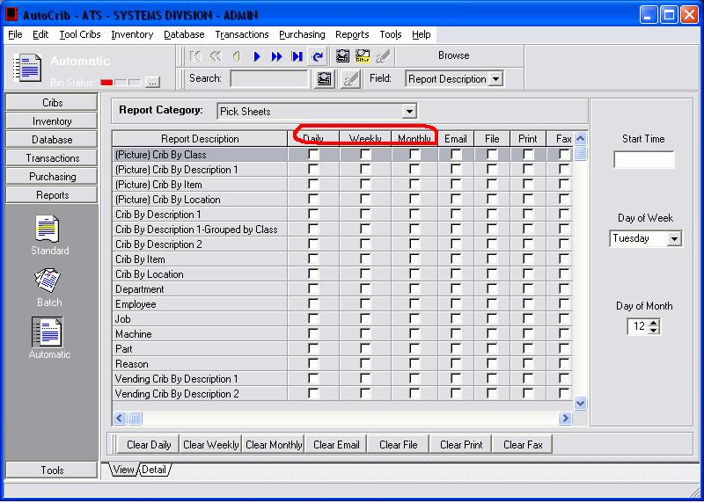

4) Insert the time the automatic reports should run in the ‘Start Time’ section on the right hand side of the screen.

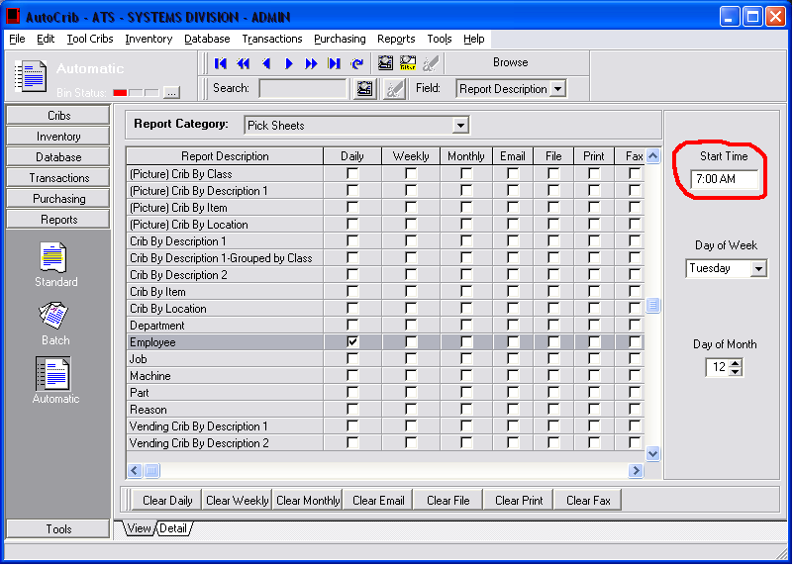

5) Enable the ‘File’ checkbox for the report that should be delivered. 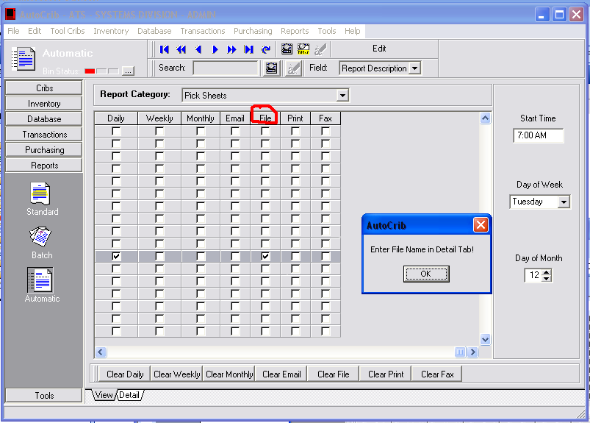

6) Click ‘OK’ in the pop up box and the ‘Detail’ screen will automatically appear. (Or simply click the detail tab).

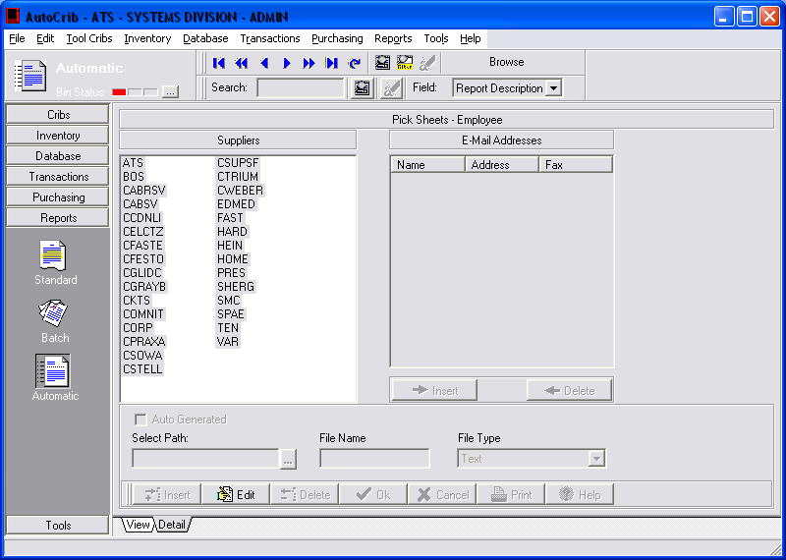

7) Select the ‘Edit’ button and select the path. Keep in mind that if you want the file saved to the desktop you can find it under C:/Documents and Settings followed by the username of the desktop you would like the file to appear on. Click until you reach the folder labeled “Desktop”
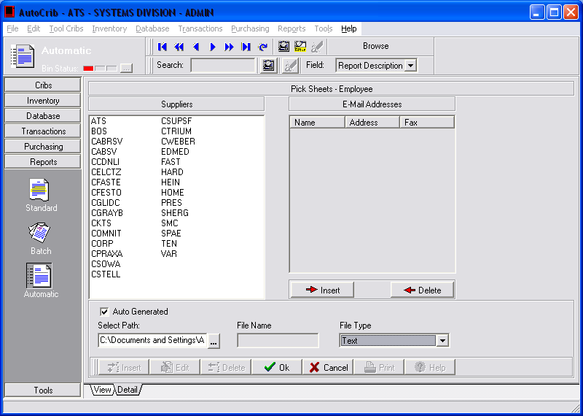

8) If you select the “Auto Generated” field the file will generate a unique name so that the file is never overwritten. If the report can be overwritten each time the report is generated, enter the desired file name in the “File Name” field.

9) Select Ok

