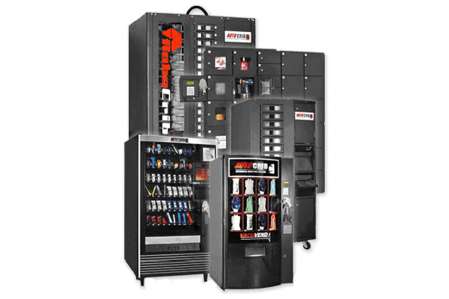

Commonly Used Reports
Descriptions and use and samples

Report category – Summary

Reports:
Employee summary report
This report is commonly used by top management to quickly determine the amount of money that was used over a period of time by specific employees. They are not usually concerned with the details of what items were taken. All summary reports i.e. Job, Department etc. are used in the same way.

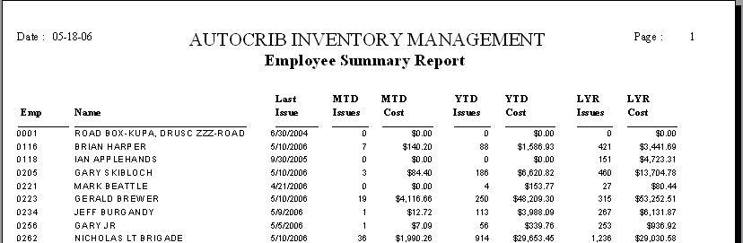

Report category – Transactions

Reports:
Transaction by employee
This report is used by line management to create a feed back loop to the user base. It is the most important report for reducing consumption of items on the shop floor. It should be printed and circulated to the user base at a minimum of once per month. The report prints out a detailed listing of what each employee dispensed over a specific period of time.

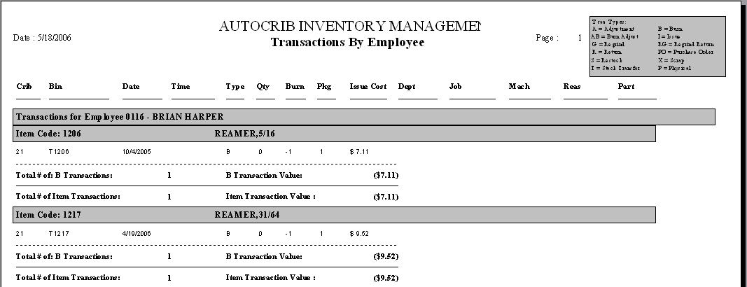

Open Issues by Department or Open issues by Employee
These two reports detail who has taken either perishable or durable tools and needs to return them to the system. This report is useful in tracking down lost or missing tools that are on the shop floor. It also assists in reducing consumption based on the accountability it brings to the line managers.

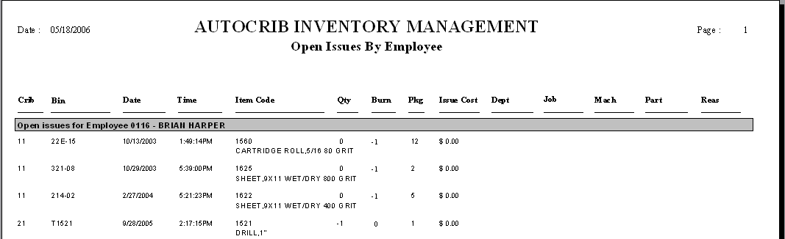

Regrinds by employee
This report details which employees are bringing tools back for regrind or recycling. By enforcing discipline on the shop floor in the area of recycling significant reductions in the use of new tools can be achieved by forcing the use of the reground or recycled tools.

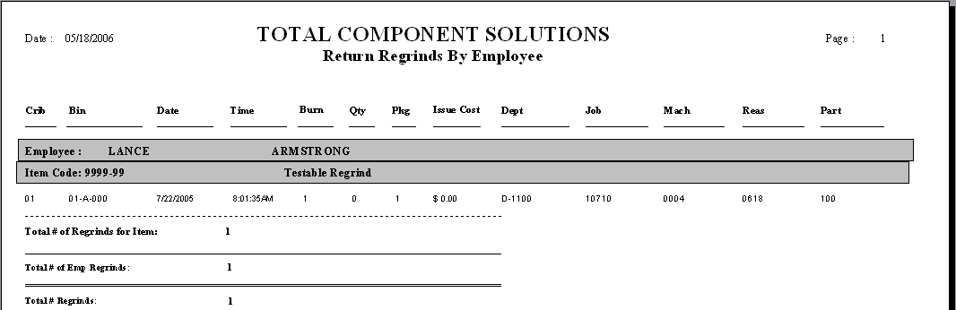

Scrap by employee
A useful report that can be used to identify which employees are scrapping tools. Line management can provide the supervision or expertise to reduce the scrapped tools. I.e. Additional operator training, improving a work set up etc.

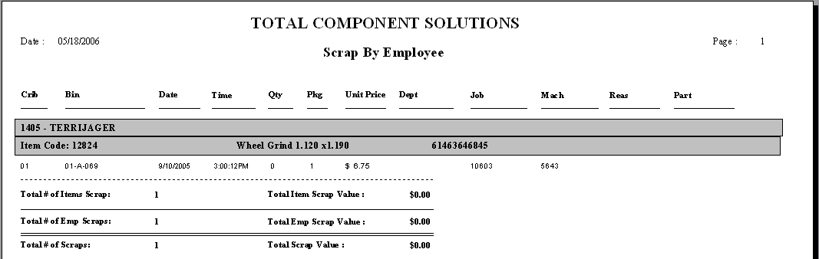

Transaction Download
This report simply dumps the transaction table with no heading or shadings. This is the report that should be used if you wish to import data into spreadsheet programs or other types of programs. It is quite typical to import the transaction table and then provide graphs utilizing the data.

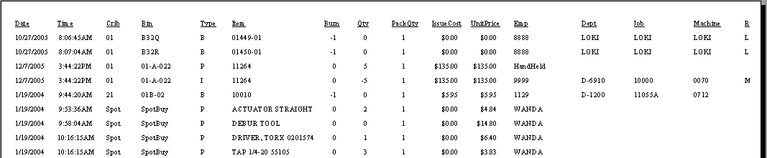

Yesterdays Transaction by employee
This is a great report for line managers who want to proactively manage the consumption of tools and supplies. It details by employee or by department what was consumed in the prior 24 hour period. Line management now has very recent data on how efficiently he or she is consuming tools.

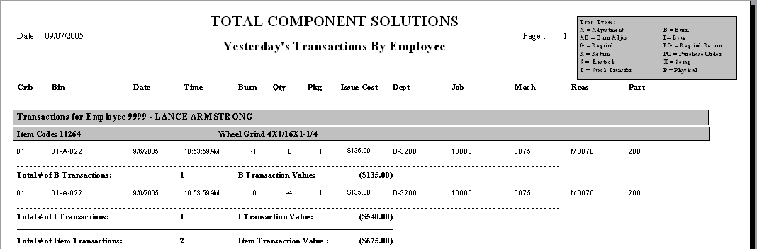

Report category – Inventory

Reports:
ABC Analysis
This report is used to classify the inventory into three cycle counting categories. A being high value items that typically move fast, B items that are relatively expensive and move more slowly and C items that are typically slow moving and low value items. Once the items are classified, you can set up cycle counting strategies for maintaining a high level of inventory accuracy.

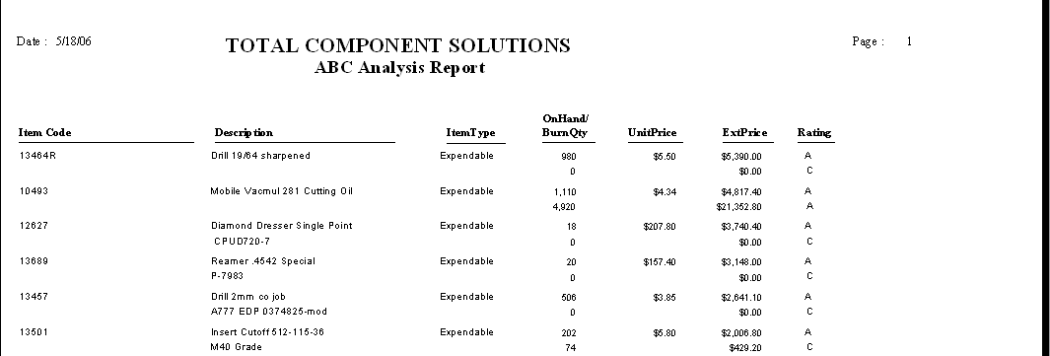

30 day average usage
This report calculates the average daily usage based on the total consumption over the last 30 days. This report is the basis for many reports that use more sophisticated demand based replenishment.

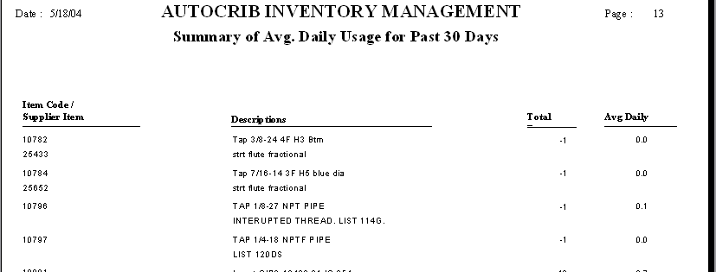

Item Master
A simple output of all the items and the detail of each item. Is primarily used when manually assigning items to bins.

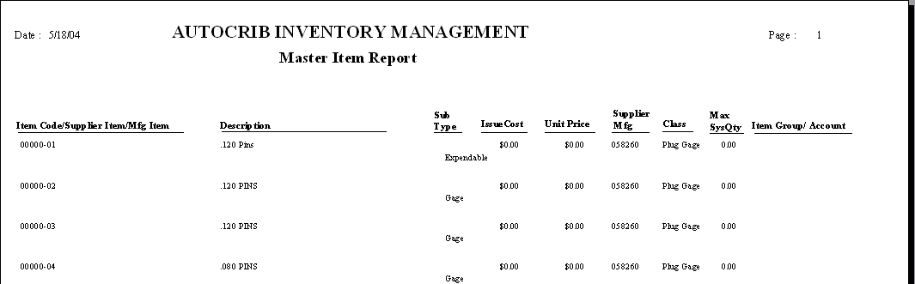

Monthly usage trend report
This report trends out the usage of product by item over a historical rolling 12 months. Is useful in looking at seasonal demand or determining if the item(s) have spiked demand.

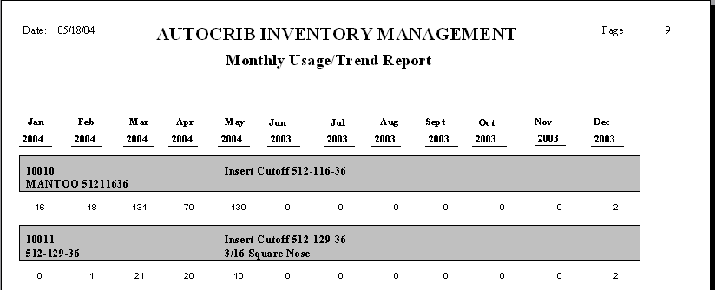

Number of stock outs
This reports records every time a bin stocks out. It can be used as one measurement on a supplier's performance. This report should not be used on item based machines that have the same item assigned to multiple bins such as the RoboCrib with out some modifications.

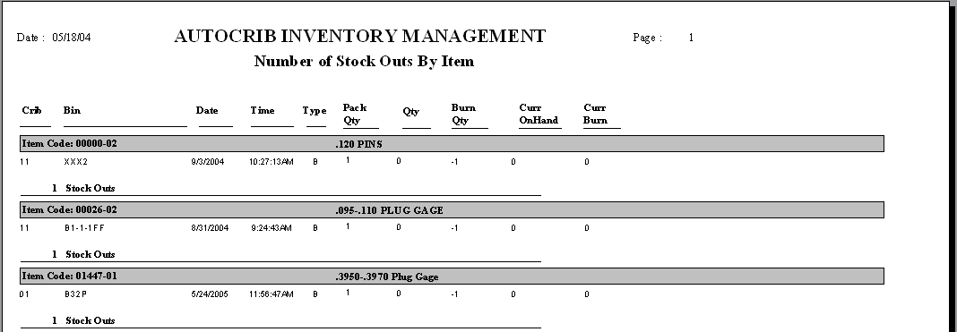

Robocrib open bins
A simple report that shows the open bins in a RoboCrib. It details the bin number and bin size so that you may easily add or edit bins after the initial set up of the machine.

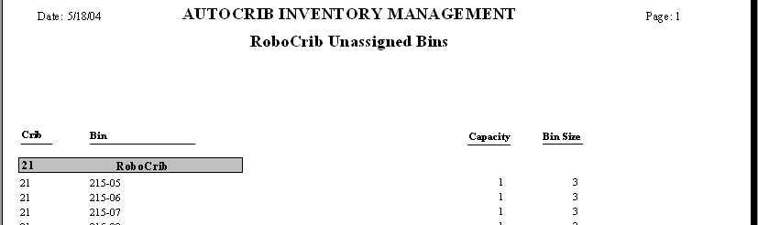

Total unassigned
A summary report of the open space in a RoboCrib by bin size.

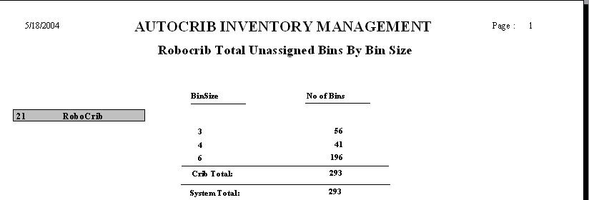

Slow and dead by bin or by Item
This report display all items that are slow moving or not moving at all the definitions are as follows:
Slow = any item that has not been dispensed in 60 days
Dead = any item that has not been dispensed in 120 days
Never Used = any item that has never been dispensed.

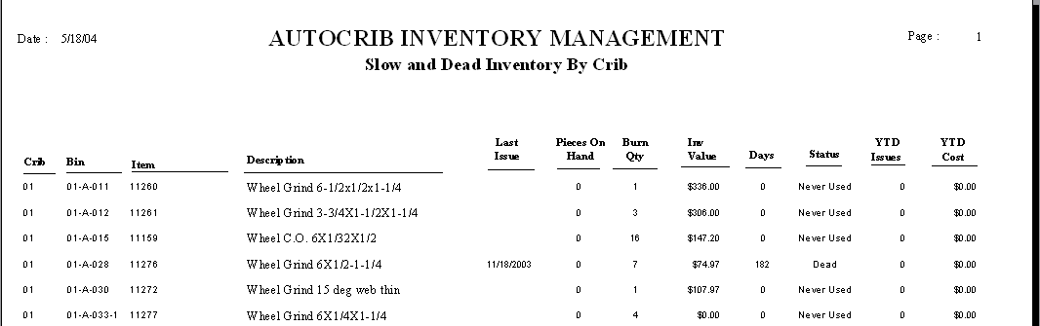

Value by Crib
Shows the items that are in the crib and their value. Gives a total value for the crib at the end of the report.

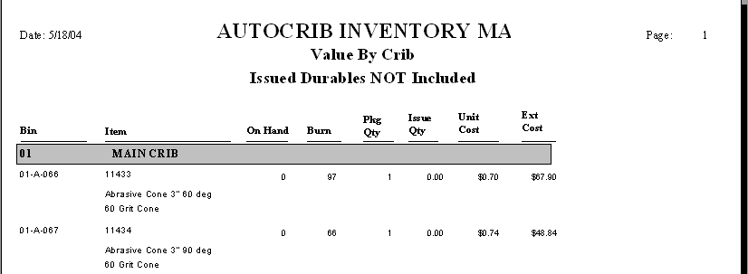

Report category – Purchasing

Reports:
Bin status by crib
Displays the detail information for a specific bin or all bins in a crib.

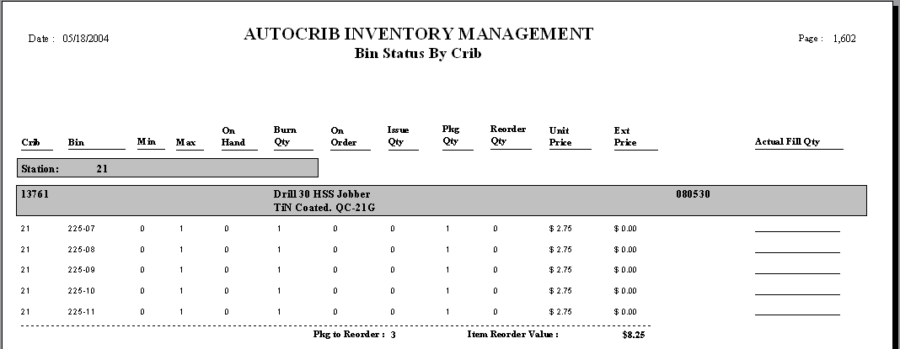

Expedite purchase order report
Displays all purchase orders that are overdue. Useful in determining which suppliers you need to expedite with.

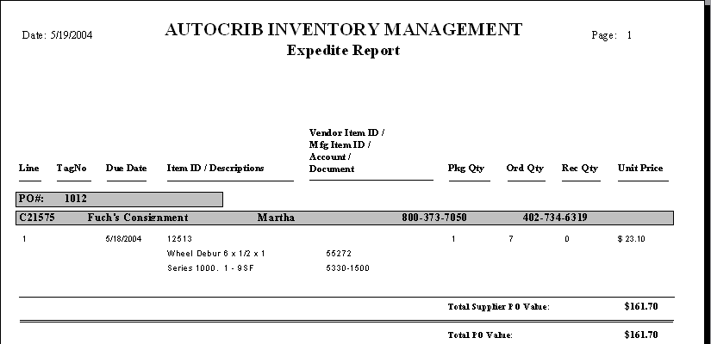

Inventory input sheet.
Details the items that are going to be restocked on a specific tag. Usually given to a supplier's driver before physically restocking a machine.

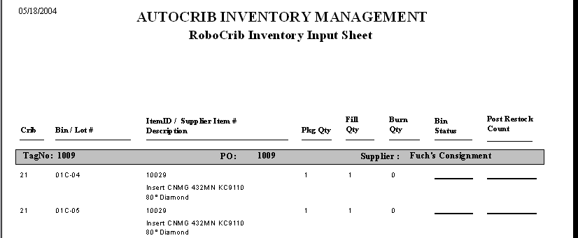

Reorders by Crib /RoboCrib
Lists all items that are in a reorder condition (fallen below a preset minimum level) the report also shows the related fields that are used in calculating the reorder condition.
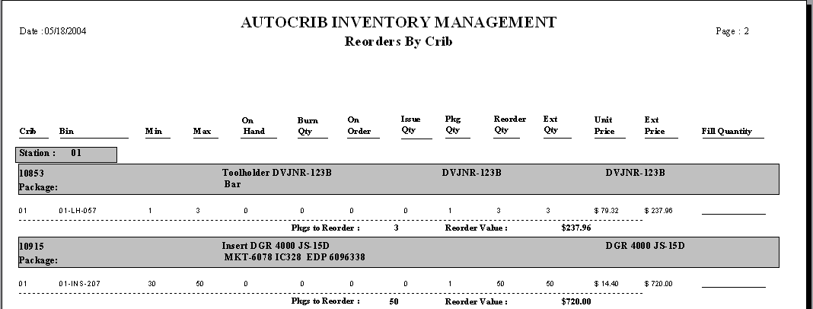

Report category – Misc.

Report:
Various billing reports
Billing reports are typically printed out by the supplier and given to the end users payables department at the end of the billing cycle. This report is commonly accompanied by the suppliers invoice.

Billing by Crib - Issues

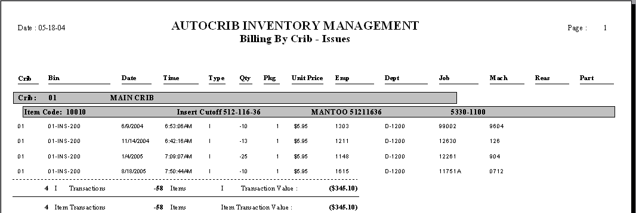

Billing by Item – Issues

