Instructions to Install a Custom Report

- Go to Tools\Options\Locations. Note what the custom path is.
- Save the report file into the custom report path. This is most likely C:\Program Files\Autocrib5.2\Custom.
- Go to Tools\Edit Reports.

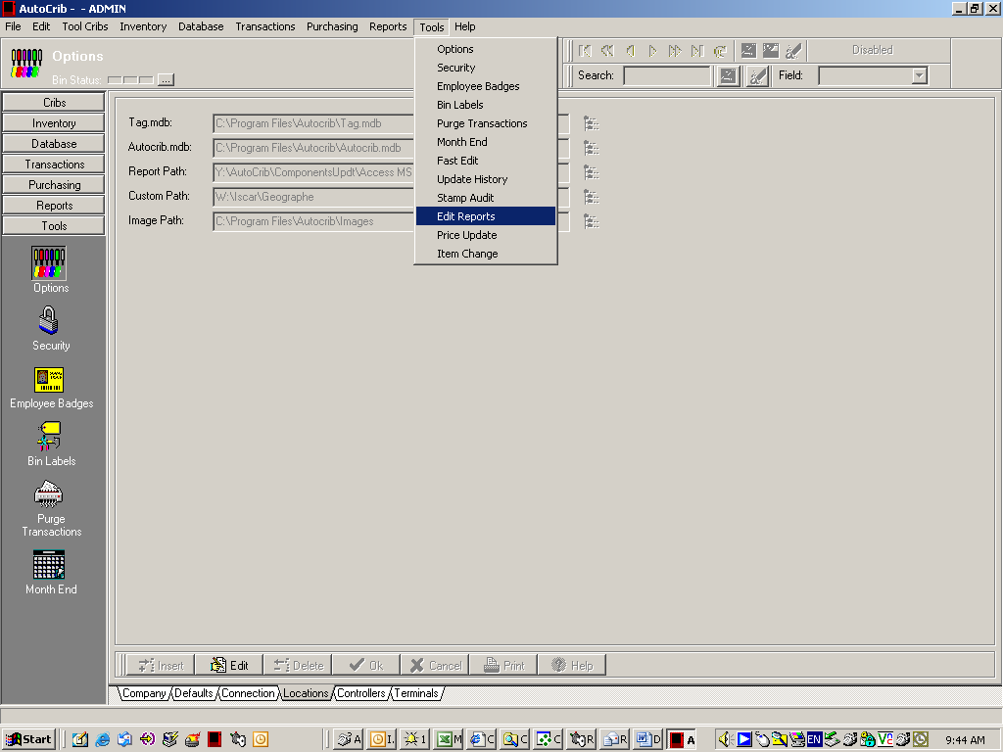

- Click on the ‘Custom Reports’ tab.

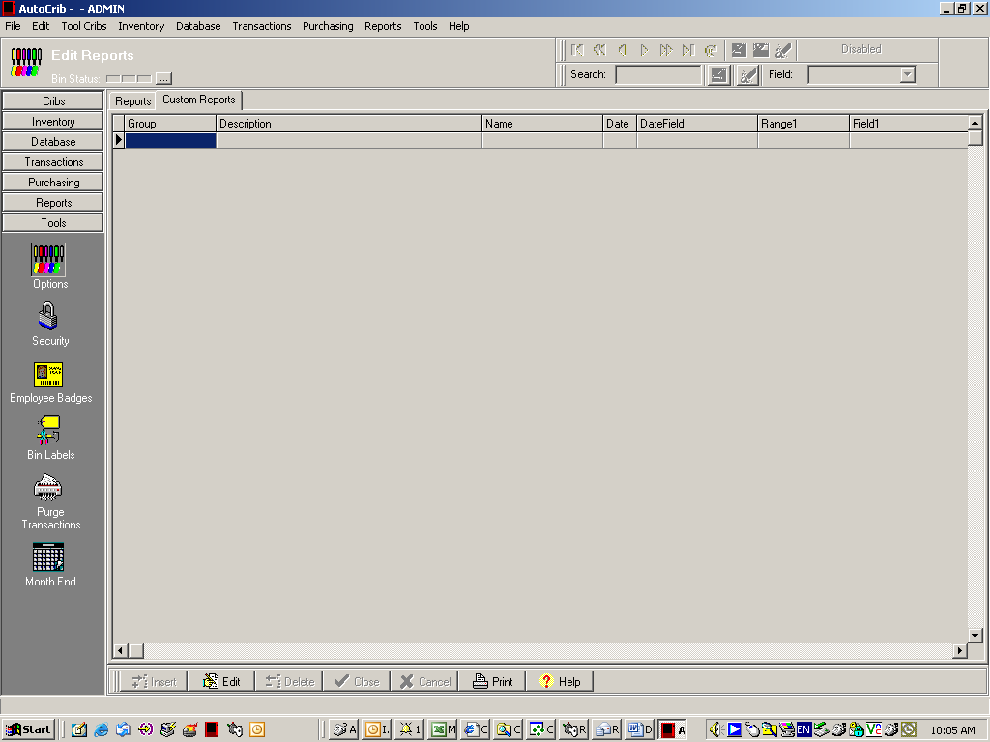

- Click the ‘Edit’ button. The section will now appear white in color.

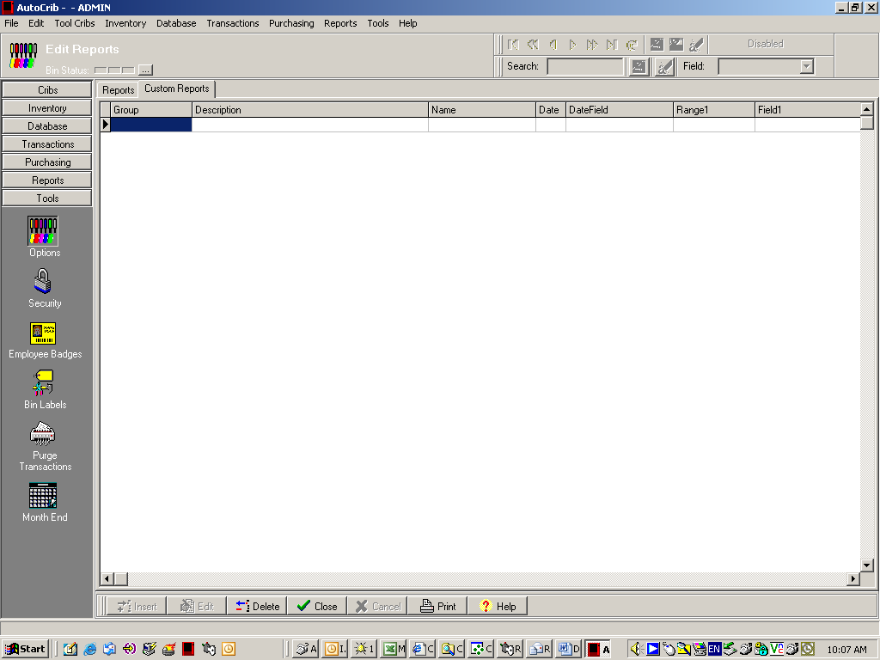

- Add the information into the grid that technical support has provided. The data provided will look like the example below.

Group | Description | Name | Date | DateField | Range1 | Field1 | Size1 | Range2 | Field2 | Size2
Custom | Yesterday's Issues by Employee | YtrIssEmp.rpt | False |  | Employee | Emp.No | 12 |  |  | 0

- The grid should look like the example below once the information has been inserted.

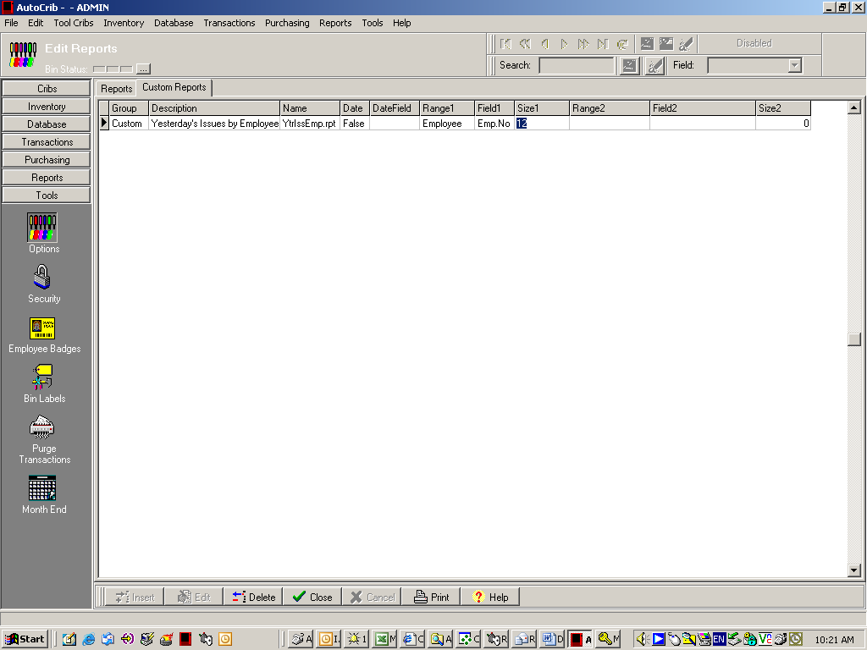

- Click the ‘Close’ button at the bottom of the screen.

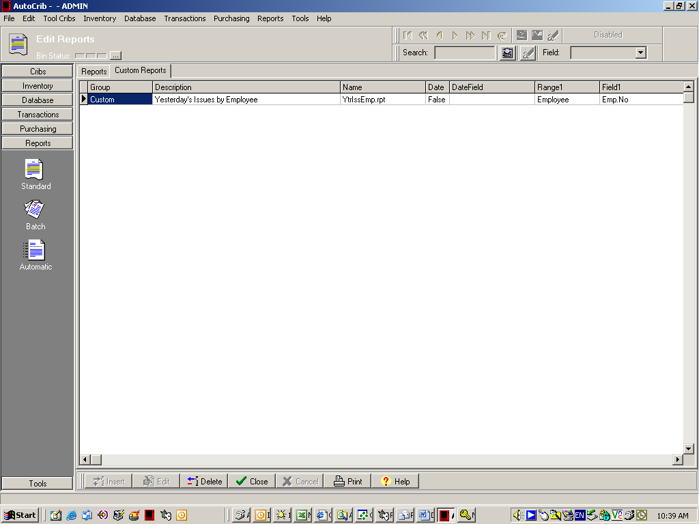

- Verify the report is viewable. To view the custom report, go to Reports\Standard.

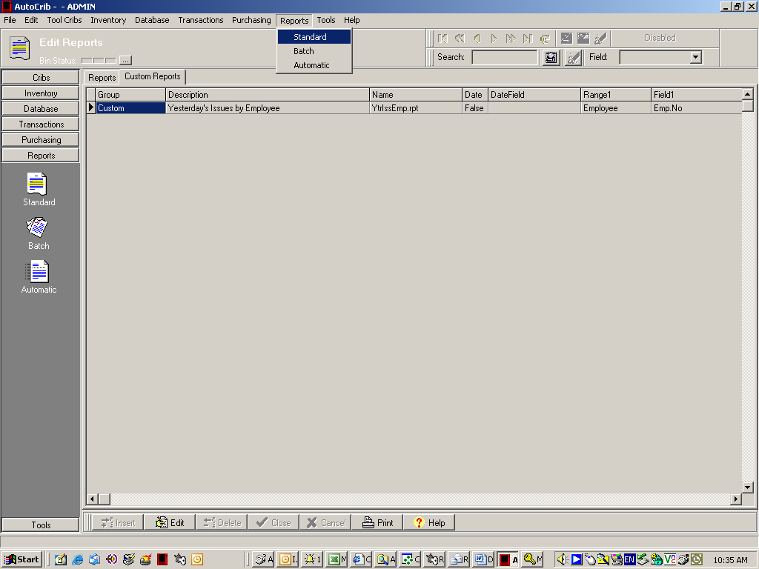

- Choose ‘Custom’ for the Report Category.

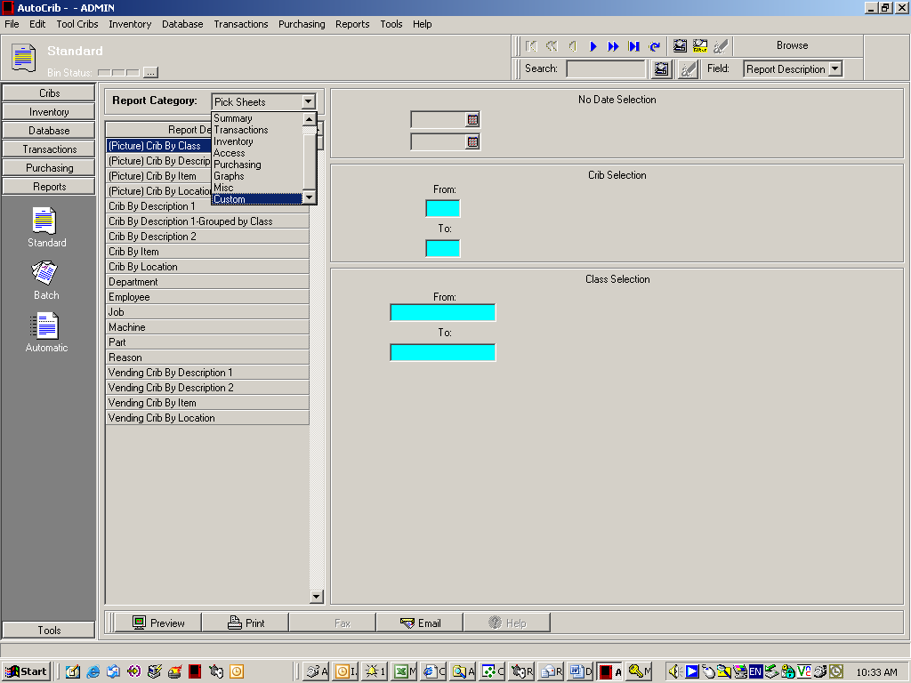

- Select the parameters that have been designated for the report.

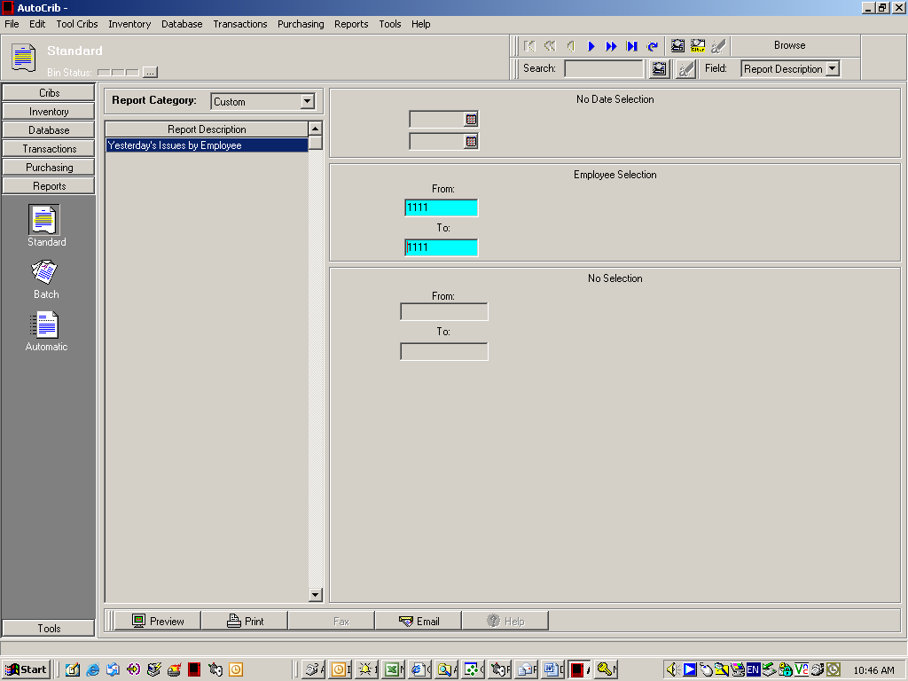

- Click ‘Preview’.

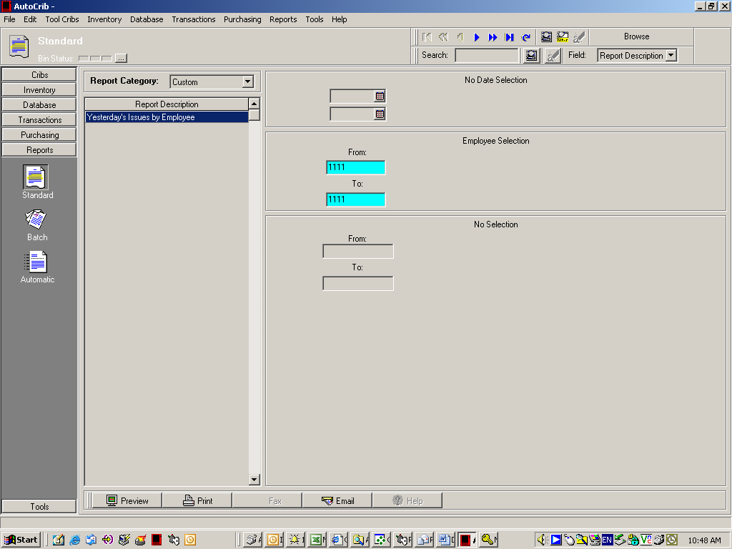

- Verify the data is correct. If the report does not preview and/or an error appears, check the following. Verify the report has been saved in the correct directory (instructions # 1 and 2). Verify the report name is spelled correctly in the grid
(instruction # 7). If problems still occur, please contact Autocrib Technical Support at 714-274-0400 option 1.

