How to Path Reports over the Network

- The ‘Reports’ folder in C:\Program Files\Autocrib5.2 on the management station should be shared. If the share has not been created, follow steps 1 and 2. Otherwise, skip to step 3. At the controlling computer, right click on C:\Program Files\Autocrib5.0\Reports and select ‘Sharing and Security’.

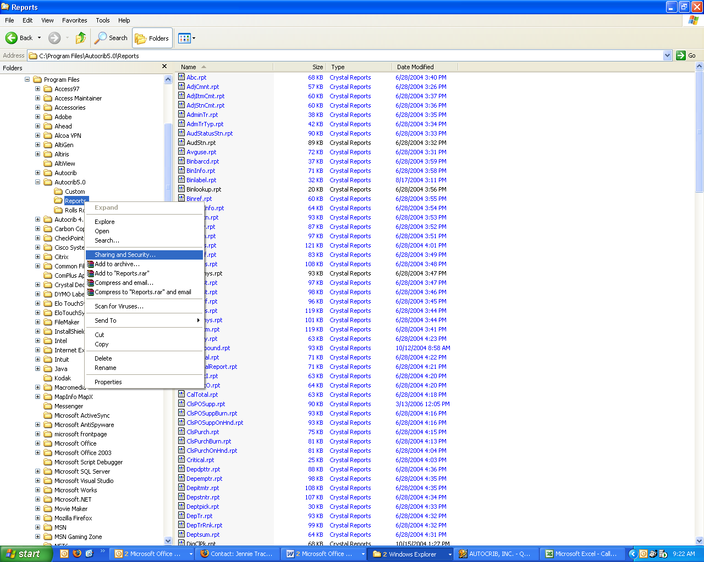

- Enable ‘Share this folder’. Then, click ‘OK’.
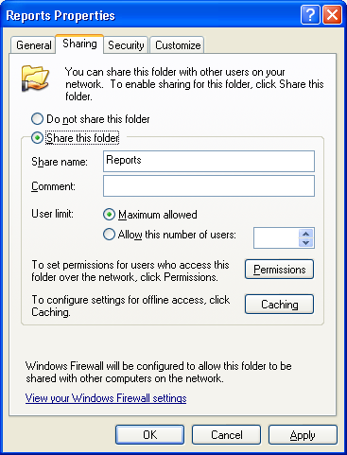
- Select Tools>Options then click the ‘Locations’ tab. Select the icon to the right of the ‘Report Path’.

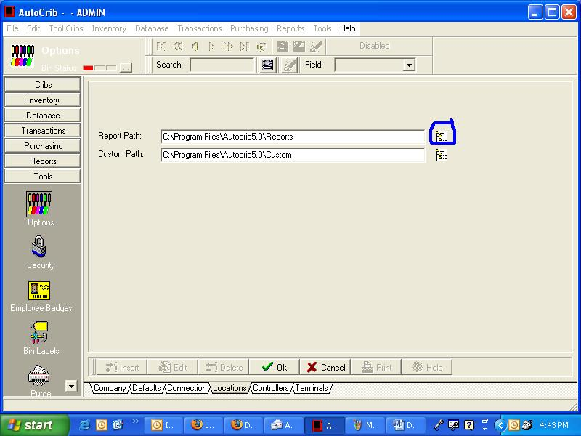

- Select the network button on the screen that pops up.

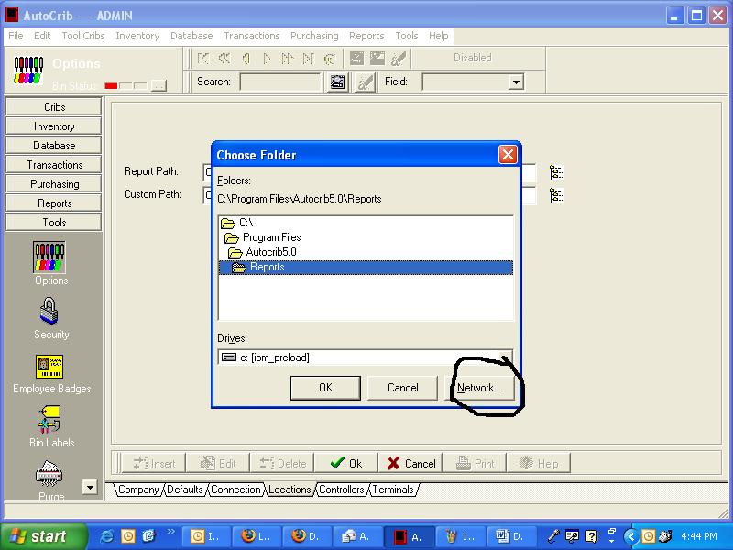

- Select the ‘Browse…’ button.

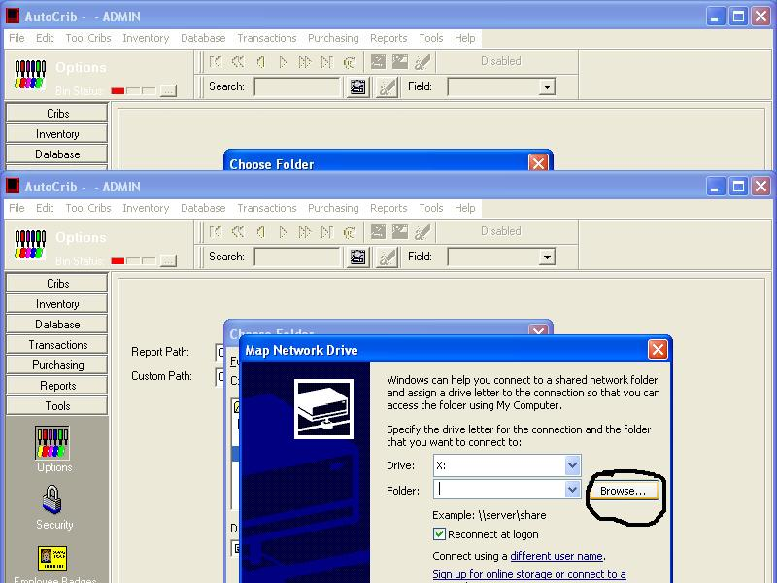

- Expand the ‘Microsoft Windows Network’ selection and find the network where the controlling Autocrib PC resides.

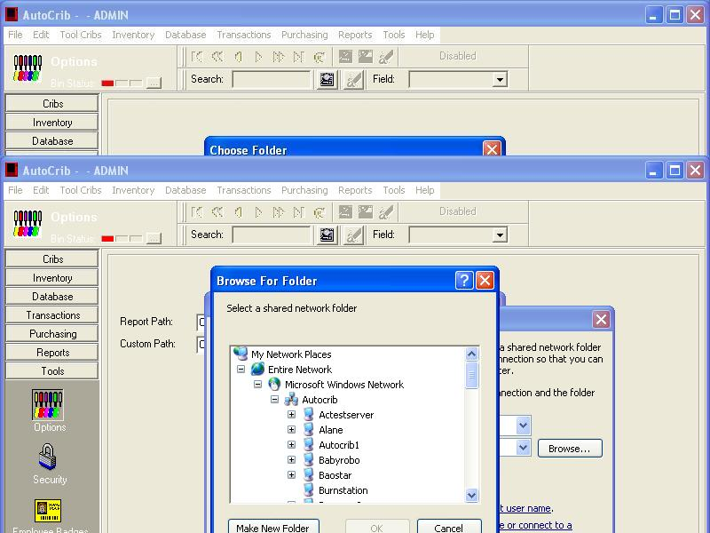

- Take note of the letter next to ‘Drive’.

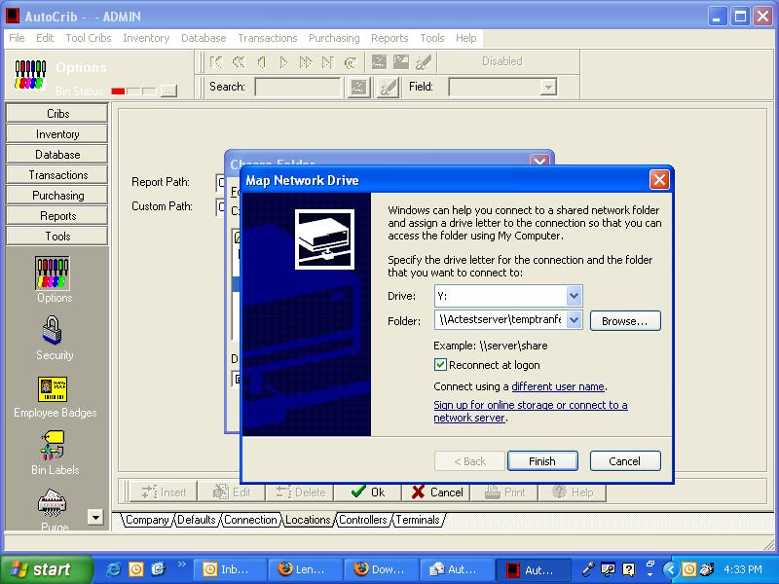

- Click Finish

- Under ‘Drives’, verify the drive letter matches the letter in step 7.

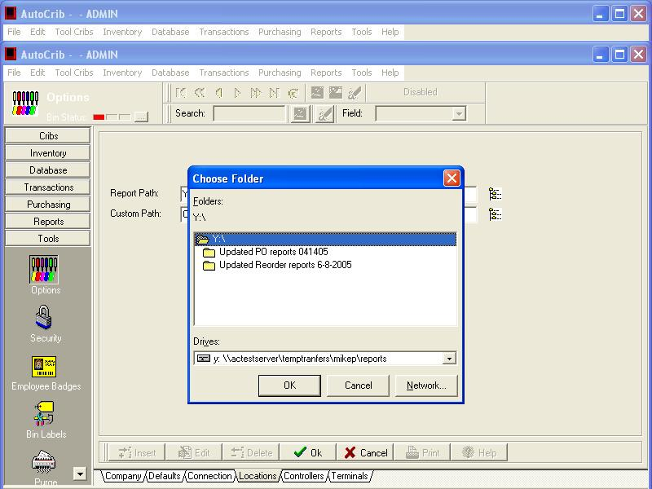

10) Click ‘OK’.

