Robo MinMax Update

The RoboMinMax tool allows a text file with Crib Minimum and Maximum levels of Robocribs to be used to update the live Bin data.

1. Create a text file in the following format:

Station[TAB]Item[TAB]New-Minimum[TAB]New-Maximum

Example:
06 3M--14661 4 5
06 3M--14662 2 3
06 3M--14663 4 5
06 3M--14664 4 5

2. Verify that there are no extra tabs or spaces by highlighting the information you created.

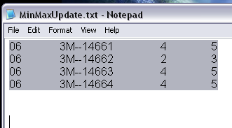

3. Give the file a name and save it.
4. Open Autocrib
- On The Menu Bar – Navigate to Tools → RoboMinMax Update:

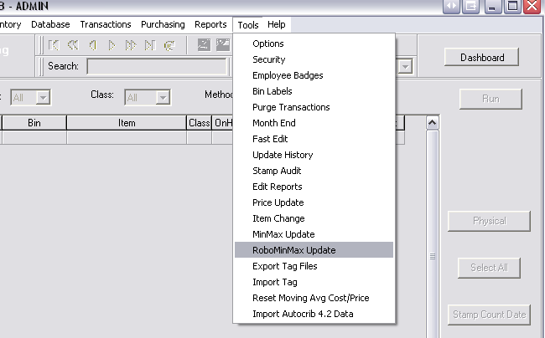

5. Click Proceed on the following screen:

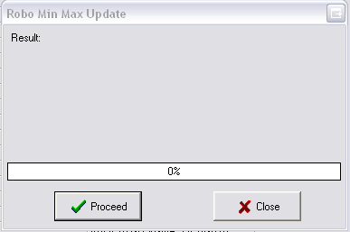

6. Navigate through the Select File Dialog Box and select the text file you created

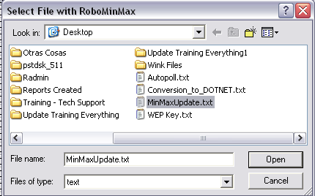

7. The Update will process and give you the results.

File didn’t process or had errors  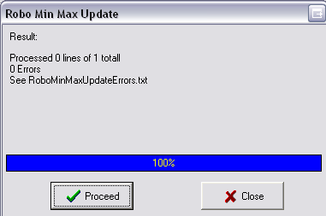 | File Uploaded Successful  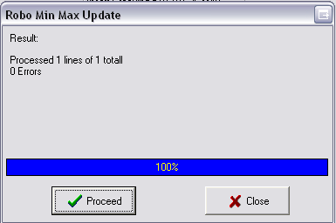

8. The RoboMinMax Tab will now show you the updated results.
Previous:  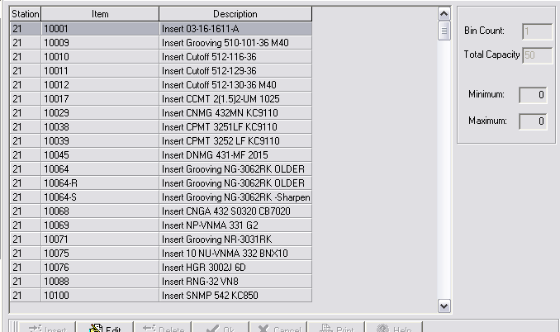 | After:  