Startup Delayer Program – How To

- Go to Start\Programs\r2 Studios\Startup Delayer\Configure Startup Delayer

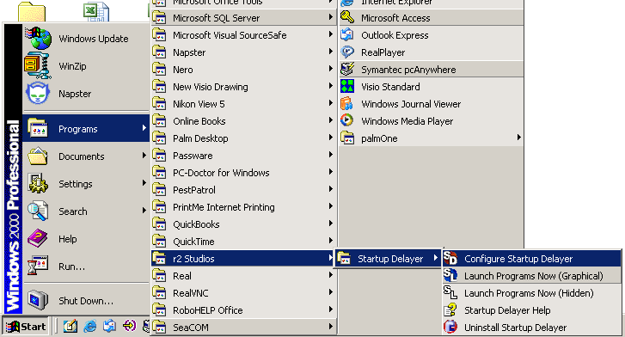

- Go to ‘File’ and choose ‘Add Program’

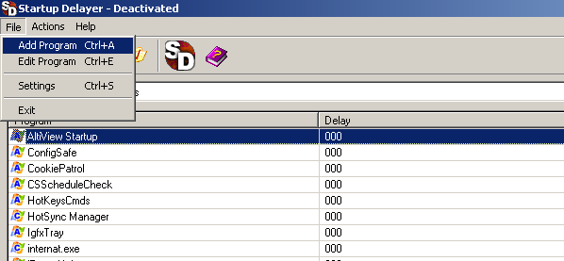

- The label field is user definable. Autocrib suggests using the name of the program that will be delayed. For example, if the Robocrib.exe file is being delayed, the label would be Robocrib.

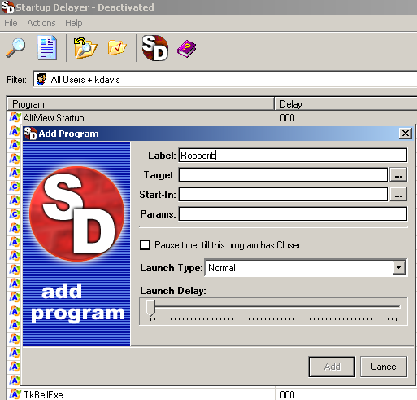

- Click on the button to the right of ‘Target’.

- Find the location of the program that will be delayed at startup by clicking on the down arrow of the ‘Look in’ box. Most likely the file will reside in C:\Program Files\Autocrib. Highlight the program that will be delayed. Then, click ‘Open’.

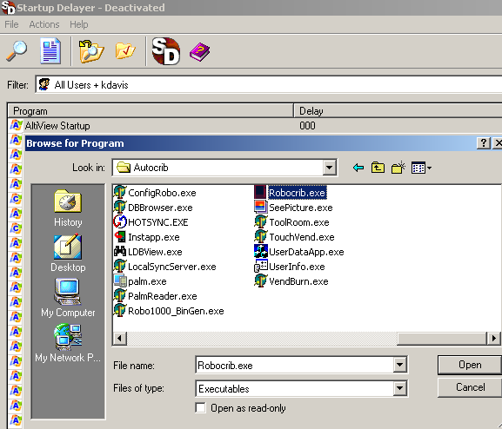

- The screen should now look similar to the following example.
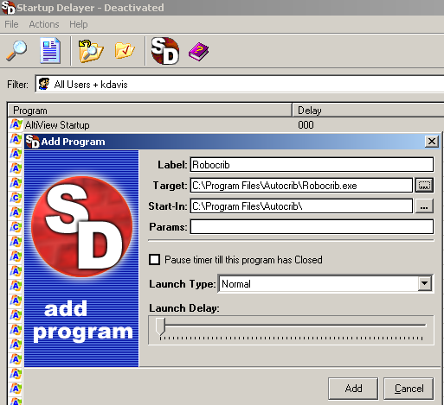

- Move the cursor for the ‘Launch Delay’ to the right until it reaches ‘30’. Depending on the network connection, the ‘Launch Delay’ time may need to be longer than 30 seconds. However, 30 seconds is normally an acceptable time period for the network connections to be made. Once the ‘Launch Delay’ time has been set, select the ‘Add’ button’.

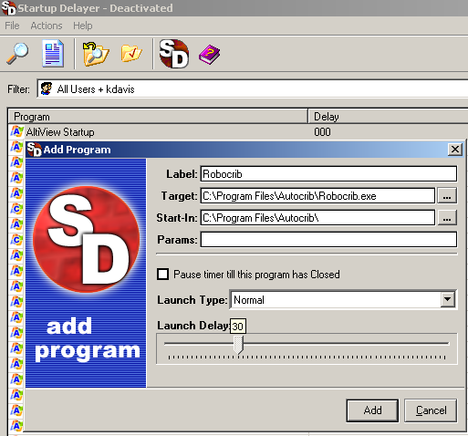

- The program which is being delayed should now appear in the grid.
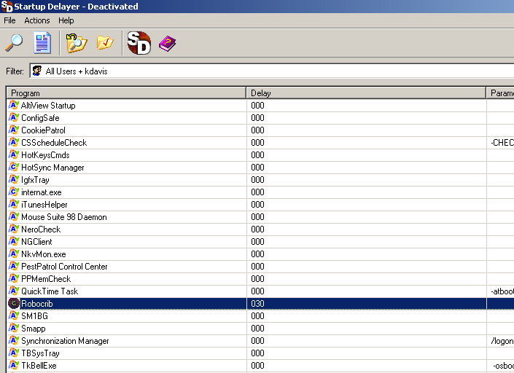

- Go to ‘File’ and choose ‘Exit’.

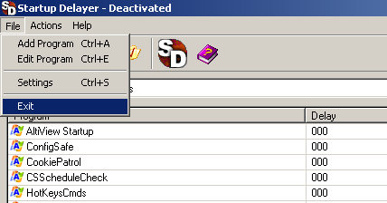

- Create a shortcut on the desktop. Go to Start\Programs\r2Studios\Startup Delayer\Start Programs Now (Graphical). Right click on ‘Start Programs Now (Graphical)’ and choose ‘Send To’ ‘Desktop.

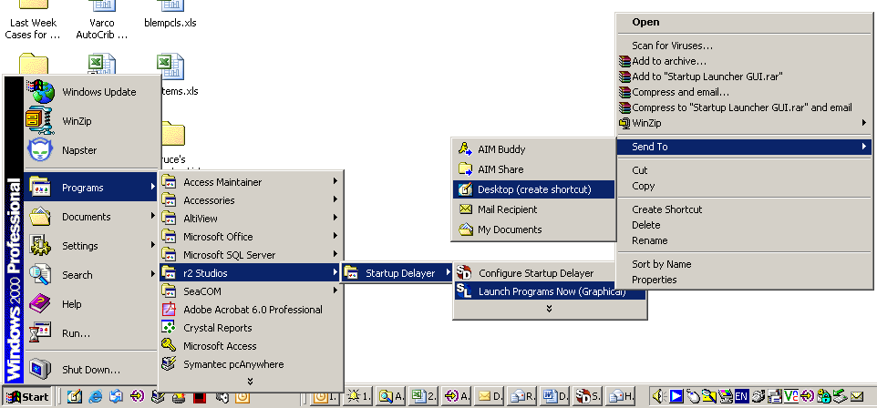

- Right click on the ‘Launch Programs Now’ shortcut and choose ‘Copy’.
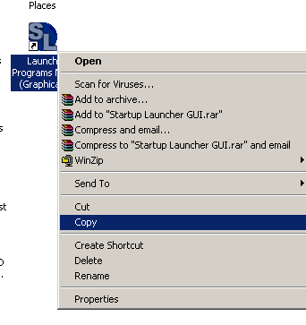
- Go to Start\Programs\Startup. Right click on ‘Startup’ and choose ‘Open All Users’.

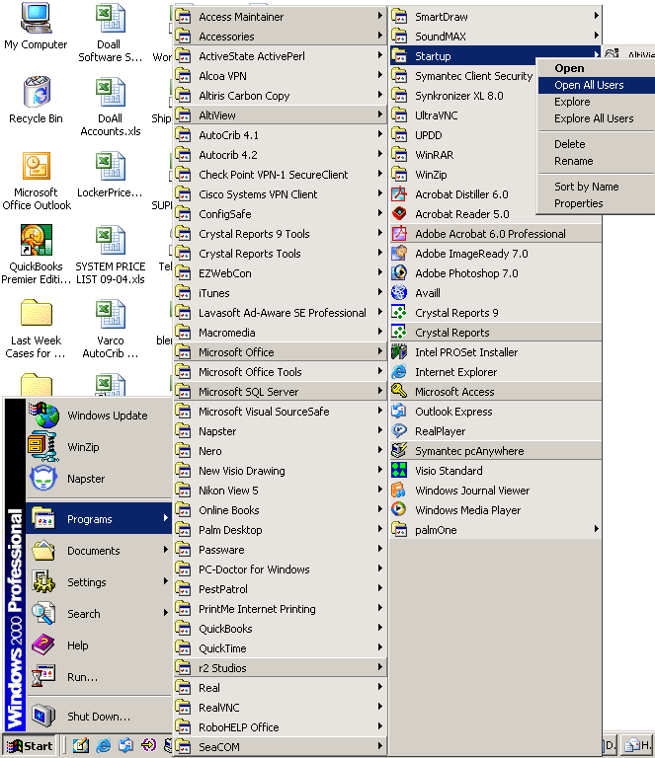

- Right click in the screen and choose ‘Paste’.

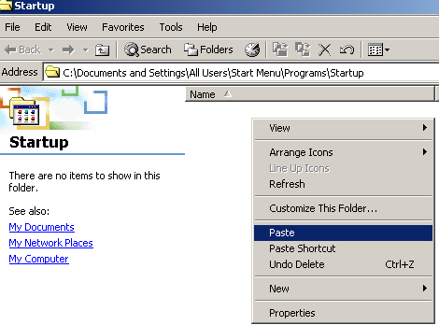

- Close the Startup window. Go to Start\Programs\Startup and delete the existing Autocrib program that exists in the Startup menu. To do this, right click on the program (i.e. Robocrib, Touchvend, etc.) and choose ‘Delete’.

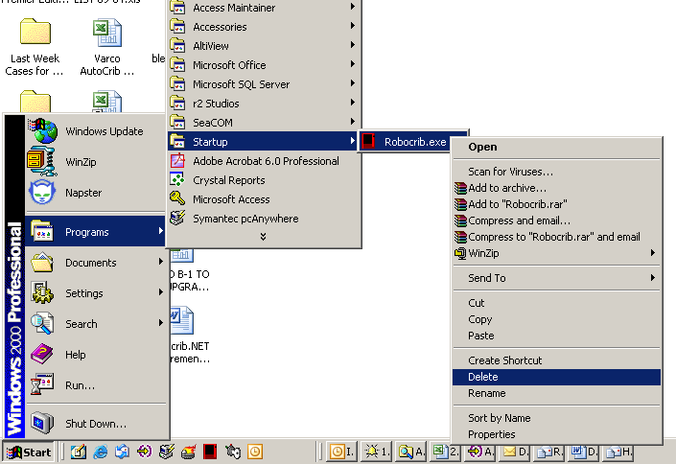

- Select ‘Yes’ to ‘Are you sure you want to send ‘Robocrib.exe’ to the Recycle Bin?’

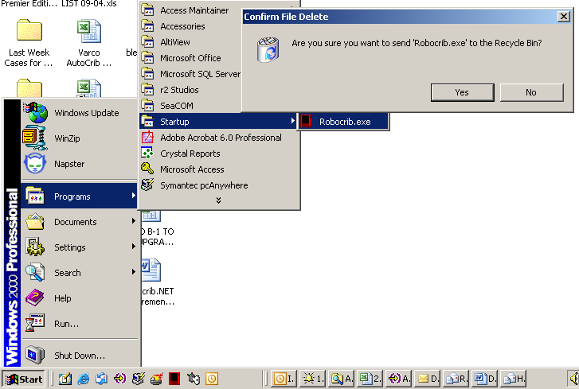

- The next time the computer is restarted, the delayer program will take effect and wait 30 seconds before starting the specified program.

