Super RoboCrib Setup Guide

1. In the Autocrib software, create a new locker station.
a) Click Cribs>Tool Cribs> Insert
b) Enter a crib number
c) Select crib type “Auto Locker’

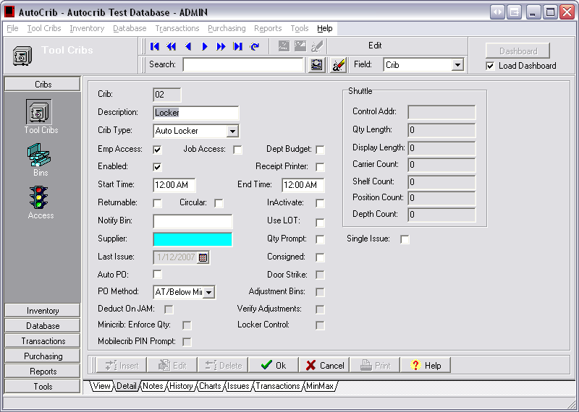

2. Connect the RS485 USB Interface Kit (Sealevel Device).
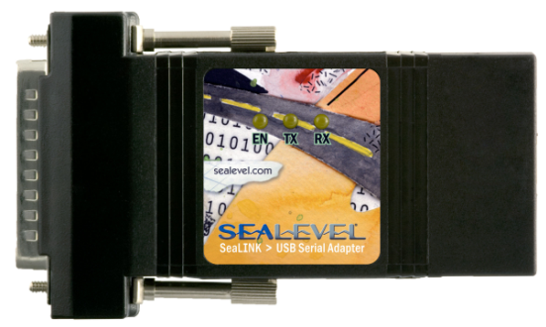

a) The RS485 USB interface needs to be connected to the PC on the RoboCrib through the USB port.
b) Once the PC has installed the drivers for the sealevel device, you will need to make sure the device is connected to COM3 through the Device Manager. (Right click on My Computer> Click Properties> click the Hardware tab and select the ‘+’ Next to ports)

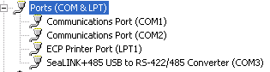
If it is setup as COM 3, skip to step 4.

3. If your RS 485 device is not connected to COM3.
a) Highlight the Sealink under ports found in Step 2.
b) Right click> Properties> Port settings> Advanced change where it says COM port Number to Com3.
c) This may require a restart.
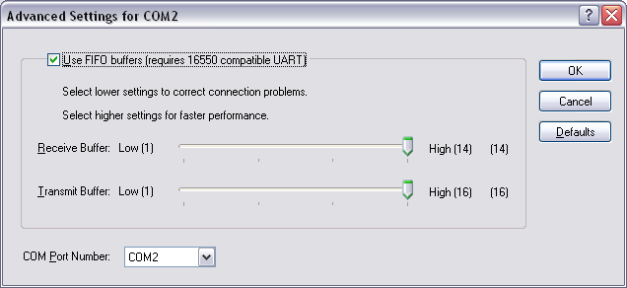

4. Insert the Robocrib PC as a Controller.
a) Start the Autocrib Software at the Robocrib.
b) Once you have logged into the software, go to Tools>Options>Controllers.
c) Click ‘Insert’. This will insert the Robocrib computer as a controller.
d) Ignore the message to restart Autocrib to apply changes.
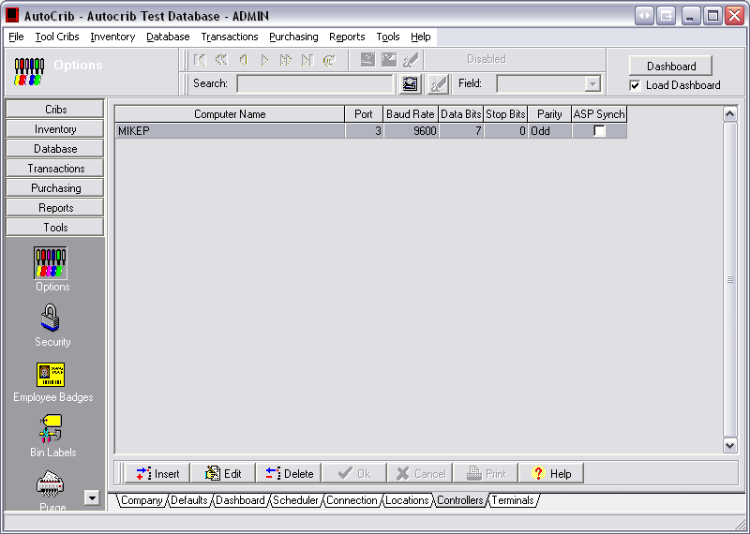

5. Insert the Terminal number for the Locker.
a) Go to Tools>Options>Terminal.
b) Select the Computer name from step 4 and click insert
c) Select the crib number of your locker set.
d) The terminal number should be ‘1’
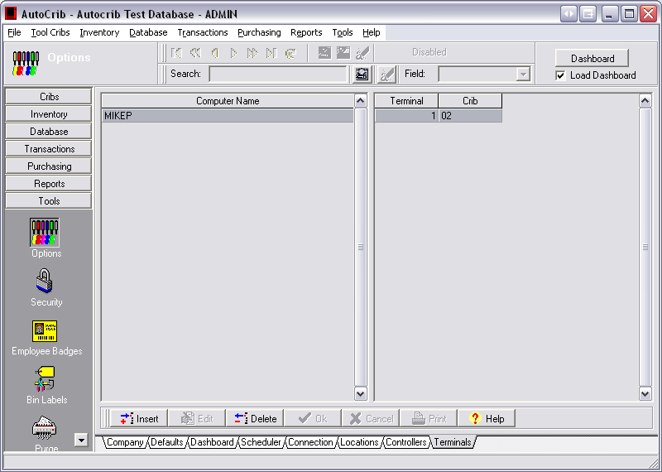
.
5. Update the Paths.ini file found in the Autocrib Directory
a) At the Robocrib, go to the Autocrib Directory (for example C:\Program Files\Autocrib 5.2) where the Robocrib.exe file is located.
b) Open the paths.ini file. Add the station number of the lockers to the line
[Station]
StationNo=01,02
The first number represents the station number of the Robocrib and the second number represents the station number of the lockers.
6. Setup the terminal number at the Locker Brain Box
a) Open the brain box for the lockers and switch the status to ‘Service Mode’. Select the ‘Esc’ Then ‘F1’ key. Select the ‘Clear’ button twice. Then, type ‘01’. Press the ‘Enter’ button. The station id on the keypad should now say ‘01’ which should match what you have in step 4.

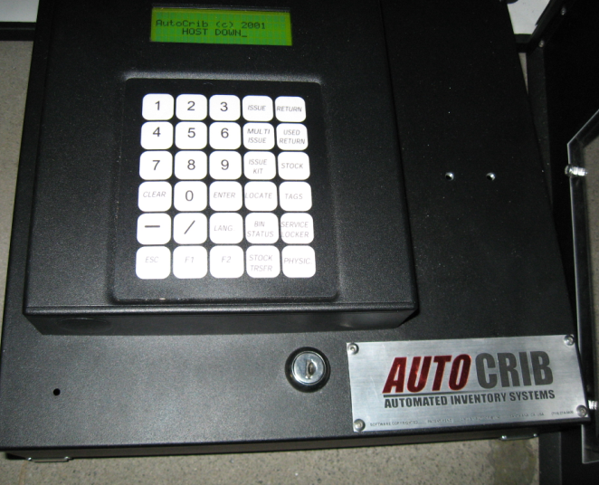

7. Connect CAT5 cable from the RS485 (Sealevel) device to the RS485 splitter port inside the brain box
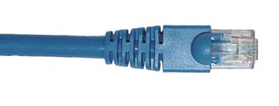
8. Register your locker
a) In your Autocrib software, click on Help > “Locker Control License”
b) Provide Autocrib Technical Support with the key and they can supply the necessary registration code.

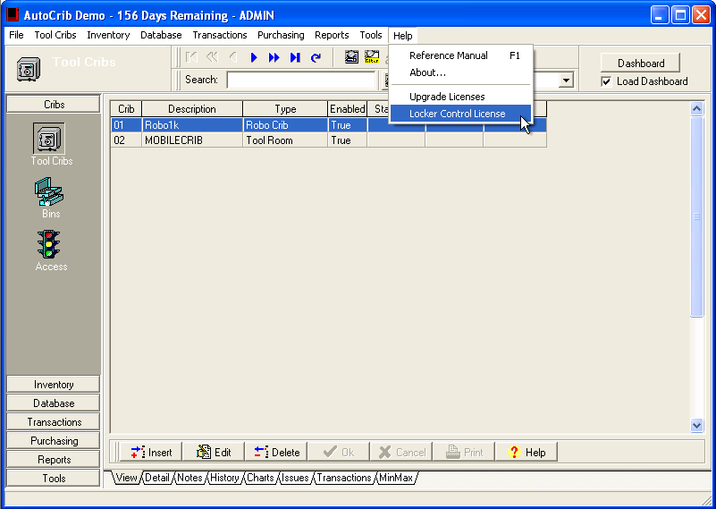

9. Place a check in “Locker Control”
a) Click on Cribs>Tool Cribs and select the Robocrib where you will be attaching lockers.
b) Place a check where it says “Locker Control”
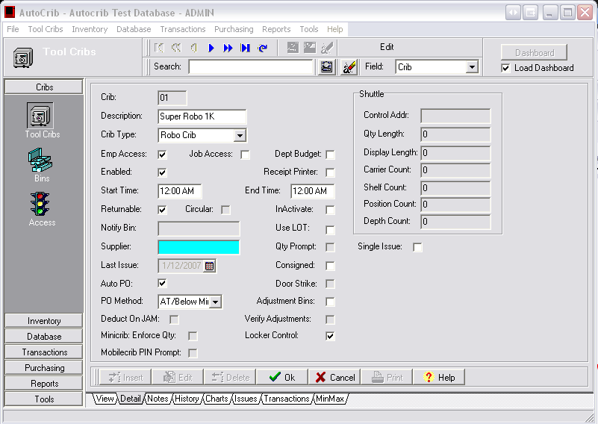

10. Close Autopoll (if it is running) in lower right hand corner on the Robocrib.
11. Startup your Robocrib software.

