AutoCrib Training – Tutorial Series

This document is a walk through setup of Symantec’s pcAnywhere remote printing configuration. It will guide you through the process of setting up the Remote caller’s printer on Host PC though the pcAnywhere printer port. Enabling remote printing through AutoCrib’s Management Station will allow the printing of billing and transaction reports, in addition to the purchase order requests from a remote location.

pcAnywhere Printer Configuration:
Windows Printer Add:

- Open Windows’ Printers & Faxes  - Under Printer Tasks – Click Add Printer | 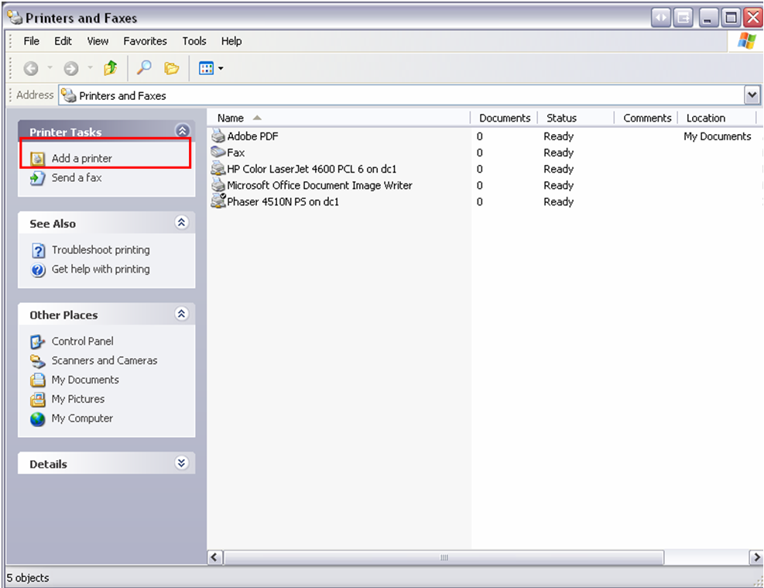  Figure 1
- Click Next to Begin Wizard | 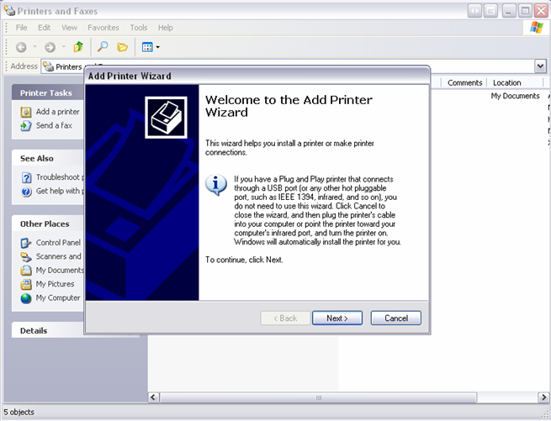  Figure 2

Continue…

- Confirm selection  ◙ Local printer attached to computer  - Click Next | 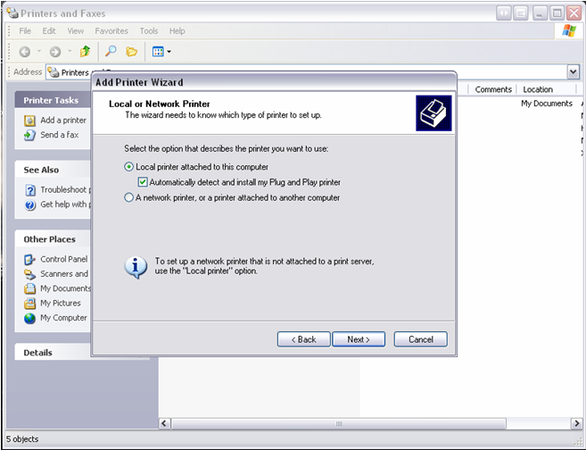  Figure 3
- Message Prompt  ◙ Wizard unable to detect Plug & Play Printer  - Click Next | 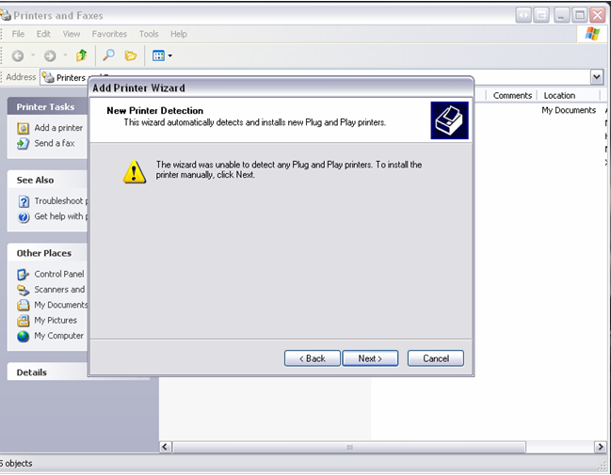  Figure 4
- Confirm Selection  ◙ Use the following port:  - Select Printer Port – PCAW: (pcAW Port)  - Click Next | 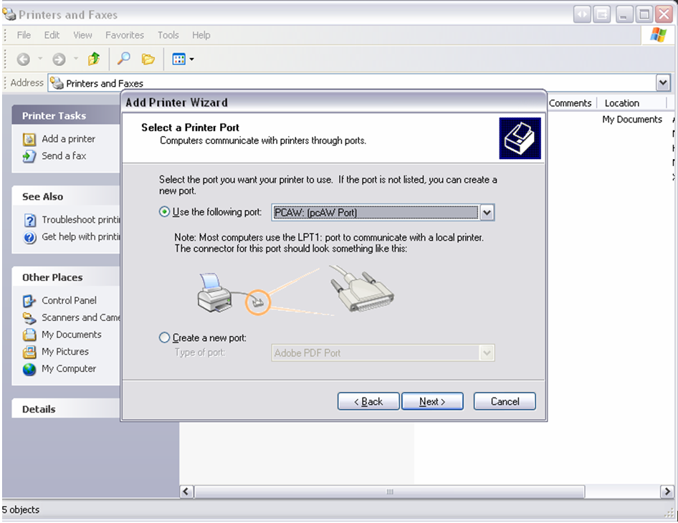  Figure 5
Continue…
- Install Remote Printer  ◙ Use drivers associated with Printer on Remote computer not printer on Host computer:  - Click Next | 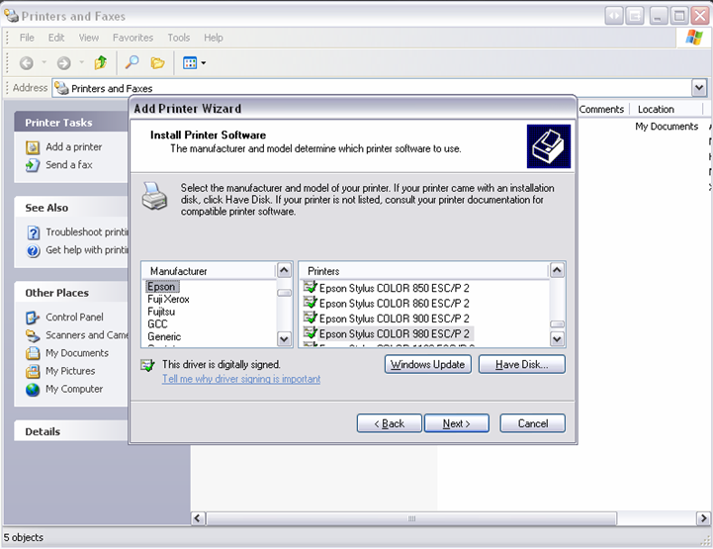  Figure 6
- Name Printer a distinguishable name  ◙ Do not make Printer the default unless there are no other printing devices.  - Click Next through prompts | 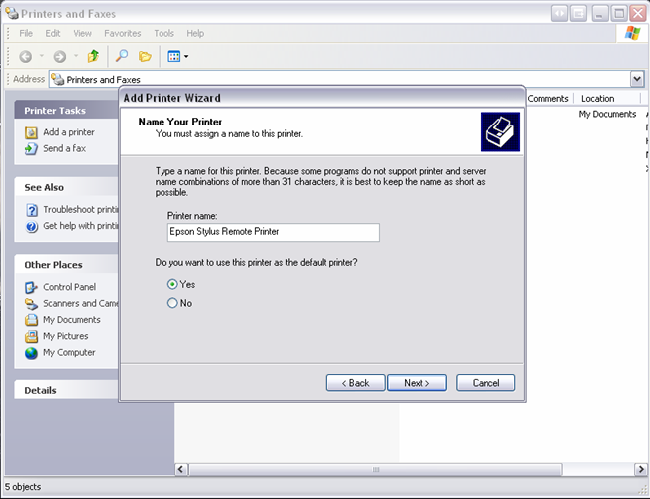  Figure 7
- Confirm Printer information  - Click Finish | 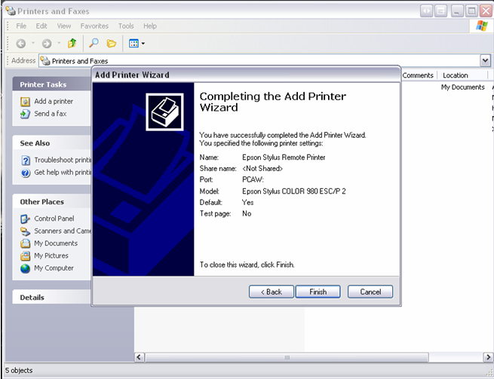  Figure 8
Continue…

- Open pcAnywhere  - On the Menu Bar – Click Edit – Choose Preferences  ◙ The will open the pcAnywhere Options window | 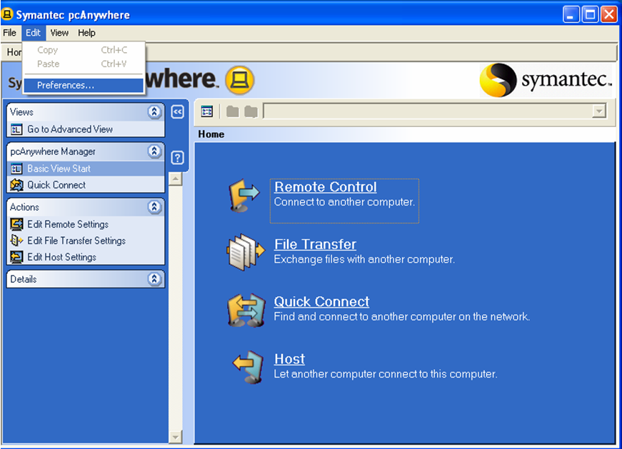  Figure 9
- Scroll Right using the arrow  - Click the Remote Printing Tab  ◙ The options Tab will now show the installed printer using the pcAnywhere Printer Port | 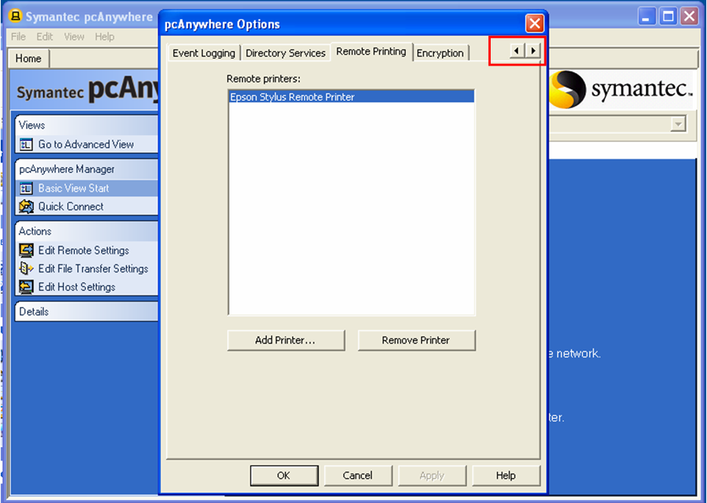  Figure 10
- Print reports normally and the Remote Printer will be shown on the Print Box confirmation  ◙ The AutoCrib software will use the default printer on the management station. If the Remote Printer is not the default, manually choose that printer in the AutoCrib software as the AutoCrib Printer. | 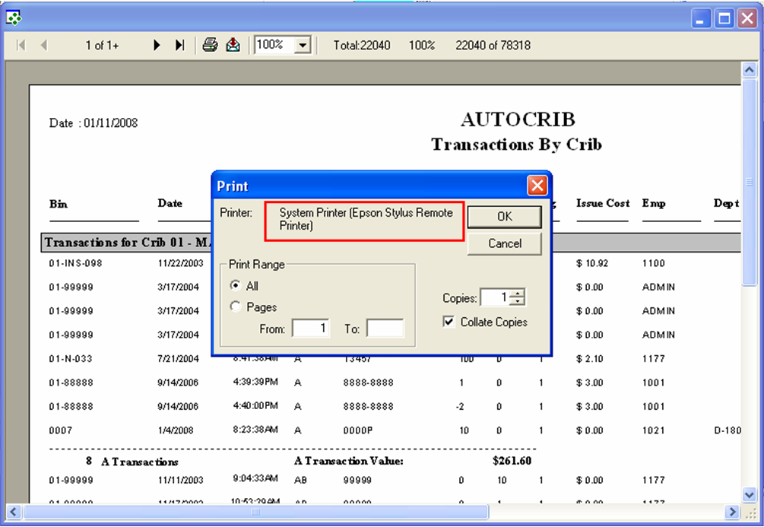  Figure 11

