AutoCrib Training – Tutorial Series

This document is a walk through setup of Symantec’s pcAnywhere host configuration. It will guide you through the process of setting up pcAnywhere and enabling the host capabilities of AutoCrib’s Management Station for remote control and administration.

pcAnywhere Host Configuration:
Connection Wizard

- Open pcAnywhere  - In Basic View – Click Host | 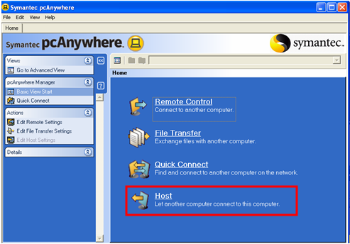  Figure 1
- Select appropriate connection  - Cable/DSL/LAN – High Speed  - Telephone model – Low Speed  - Click Next | 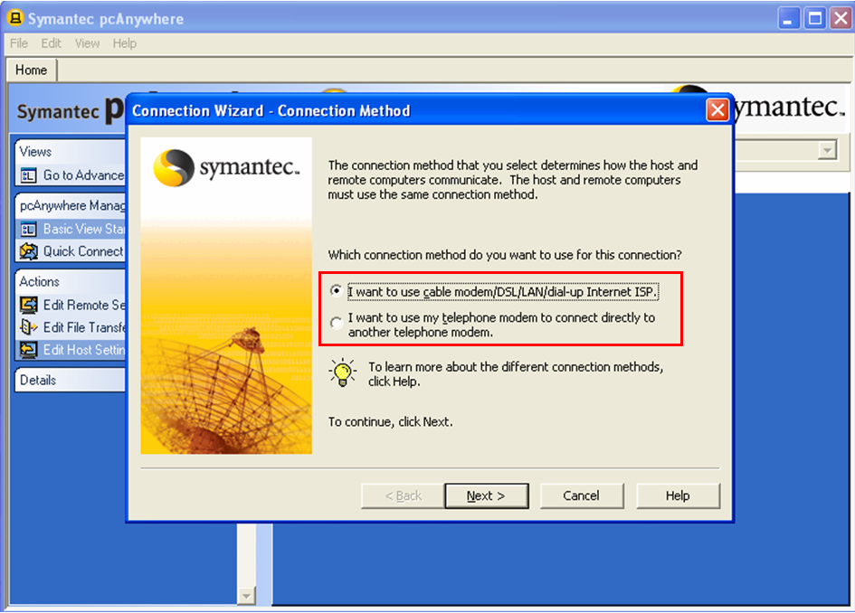  Figure 2

Continue…

- Confirm selection  ◙ Wait for someone to call me  - Click Next | 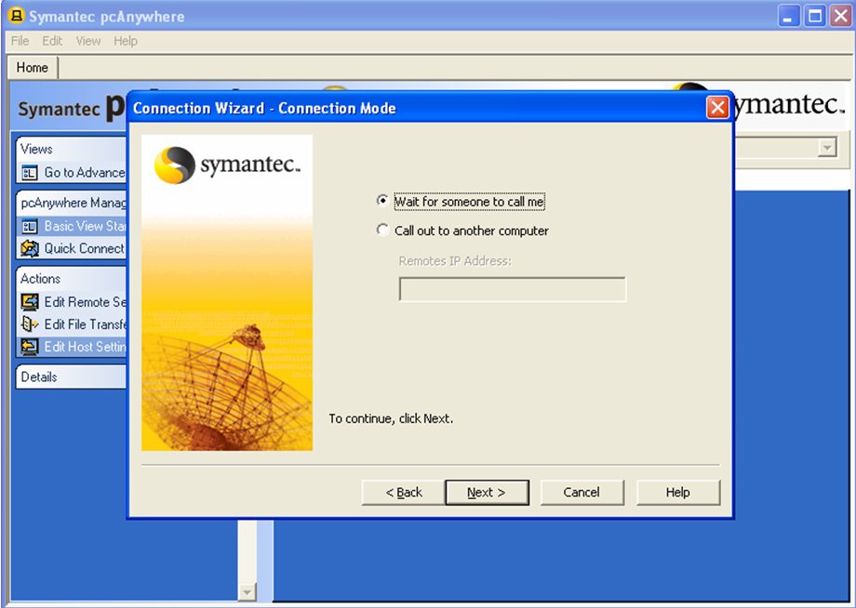  Figure 3
- Chose selection  ◙ Wait for someone to call me  - Click Next | 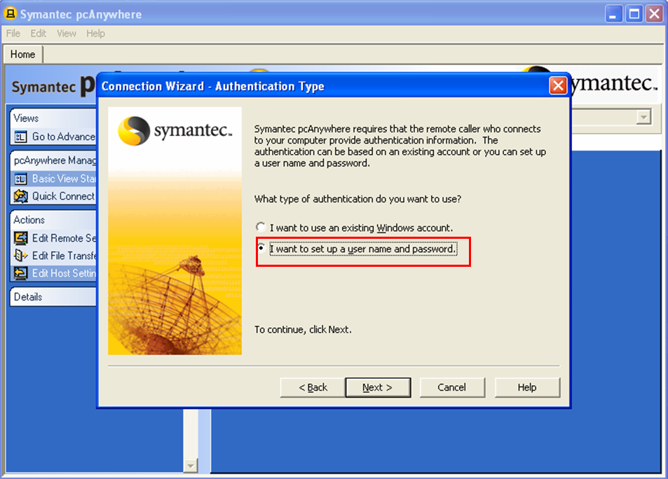  Figure 4
- Create User Name & Password  - Click Next | 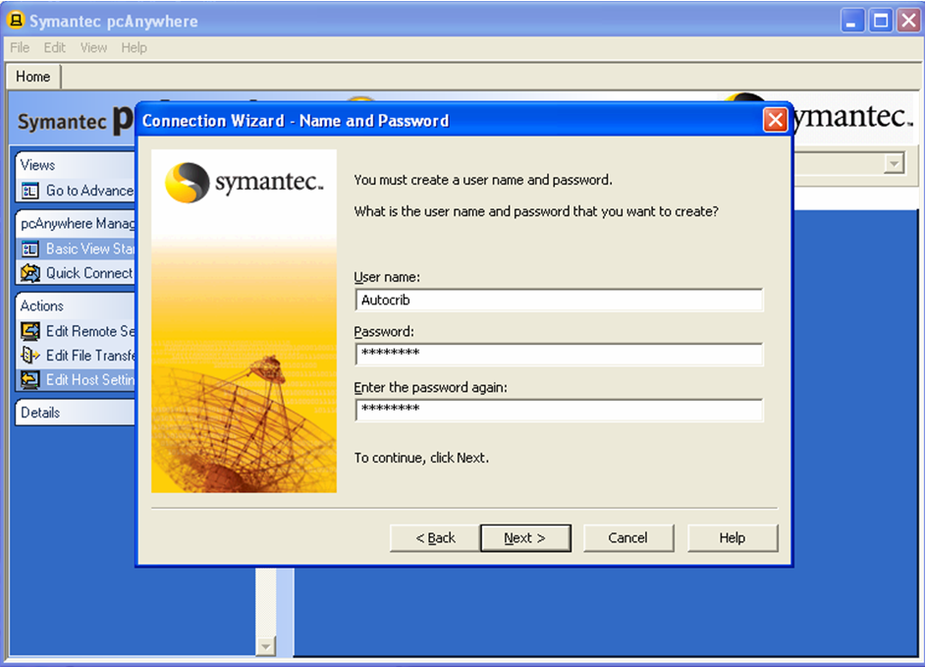  Figure 5
Continue…
- Create Name for Host Connection  - Click Next | 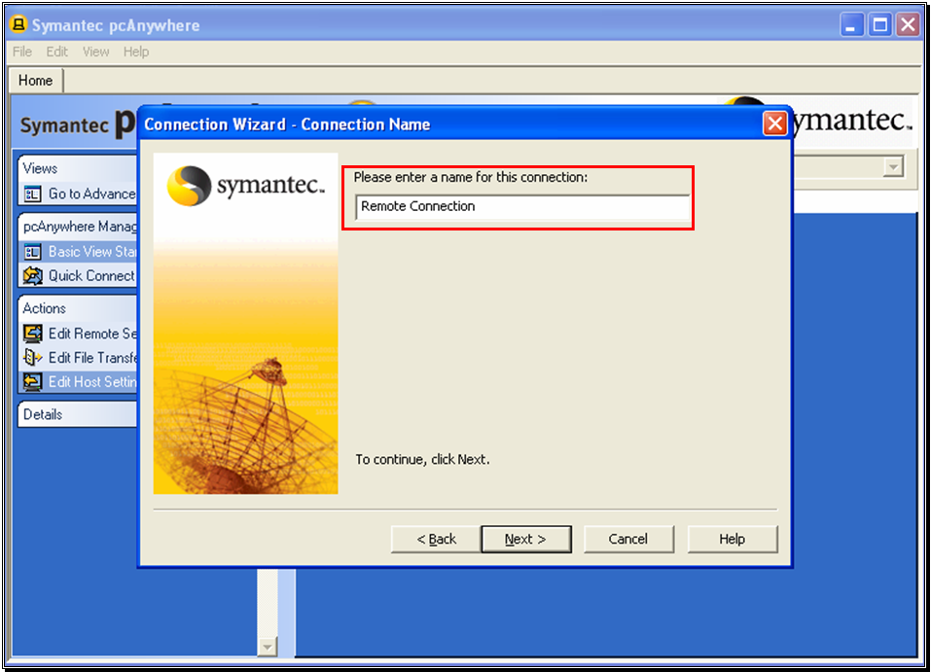  Figure 6
- Confirm Checkbox selection  √ Wait for connection after Wizard  - Click Finish | 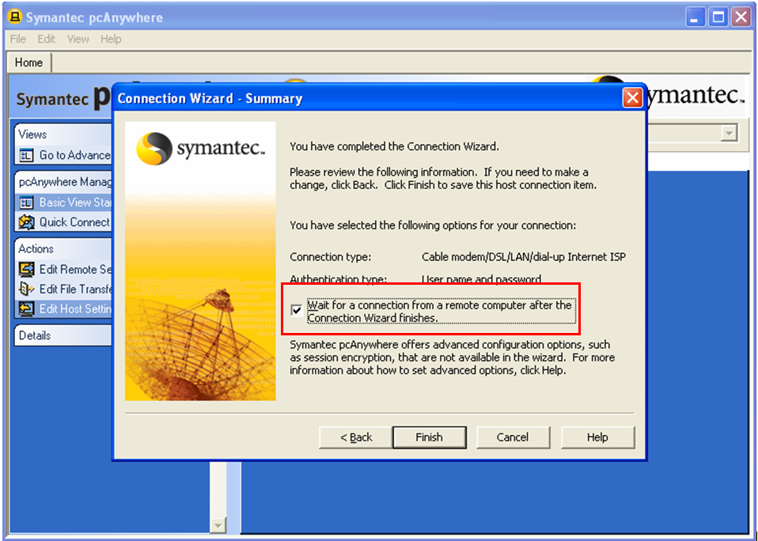  Figure 7
- Host Connection Active  - Verify Checked Blue monitor is system tray | 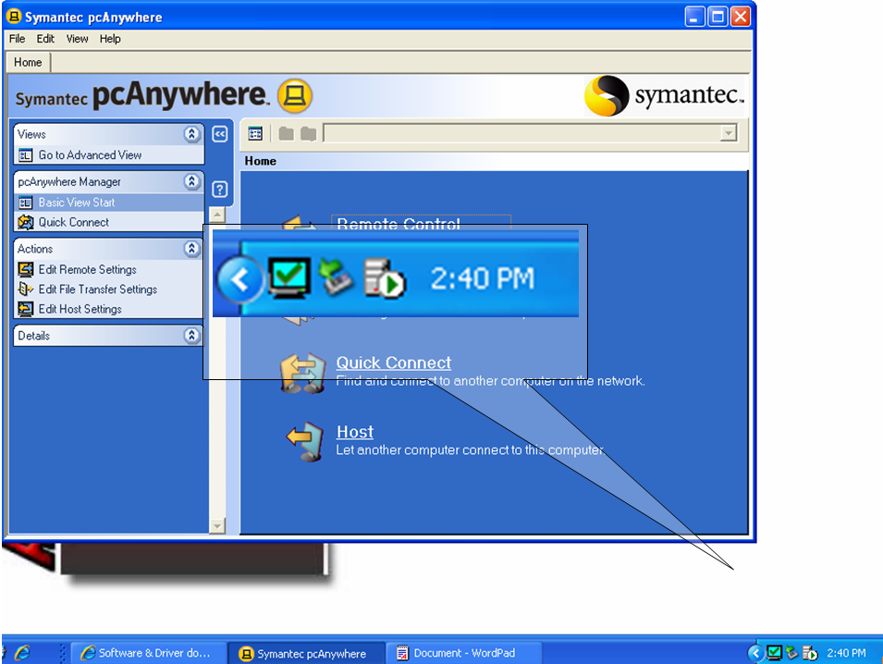  Figure 8

