EleVend Operations Manual

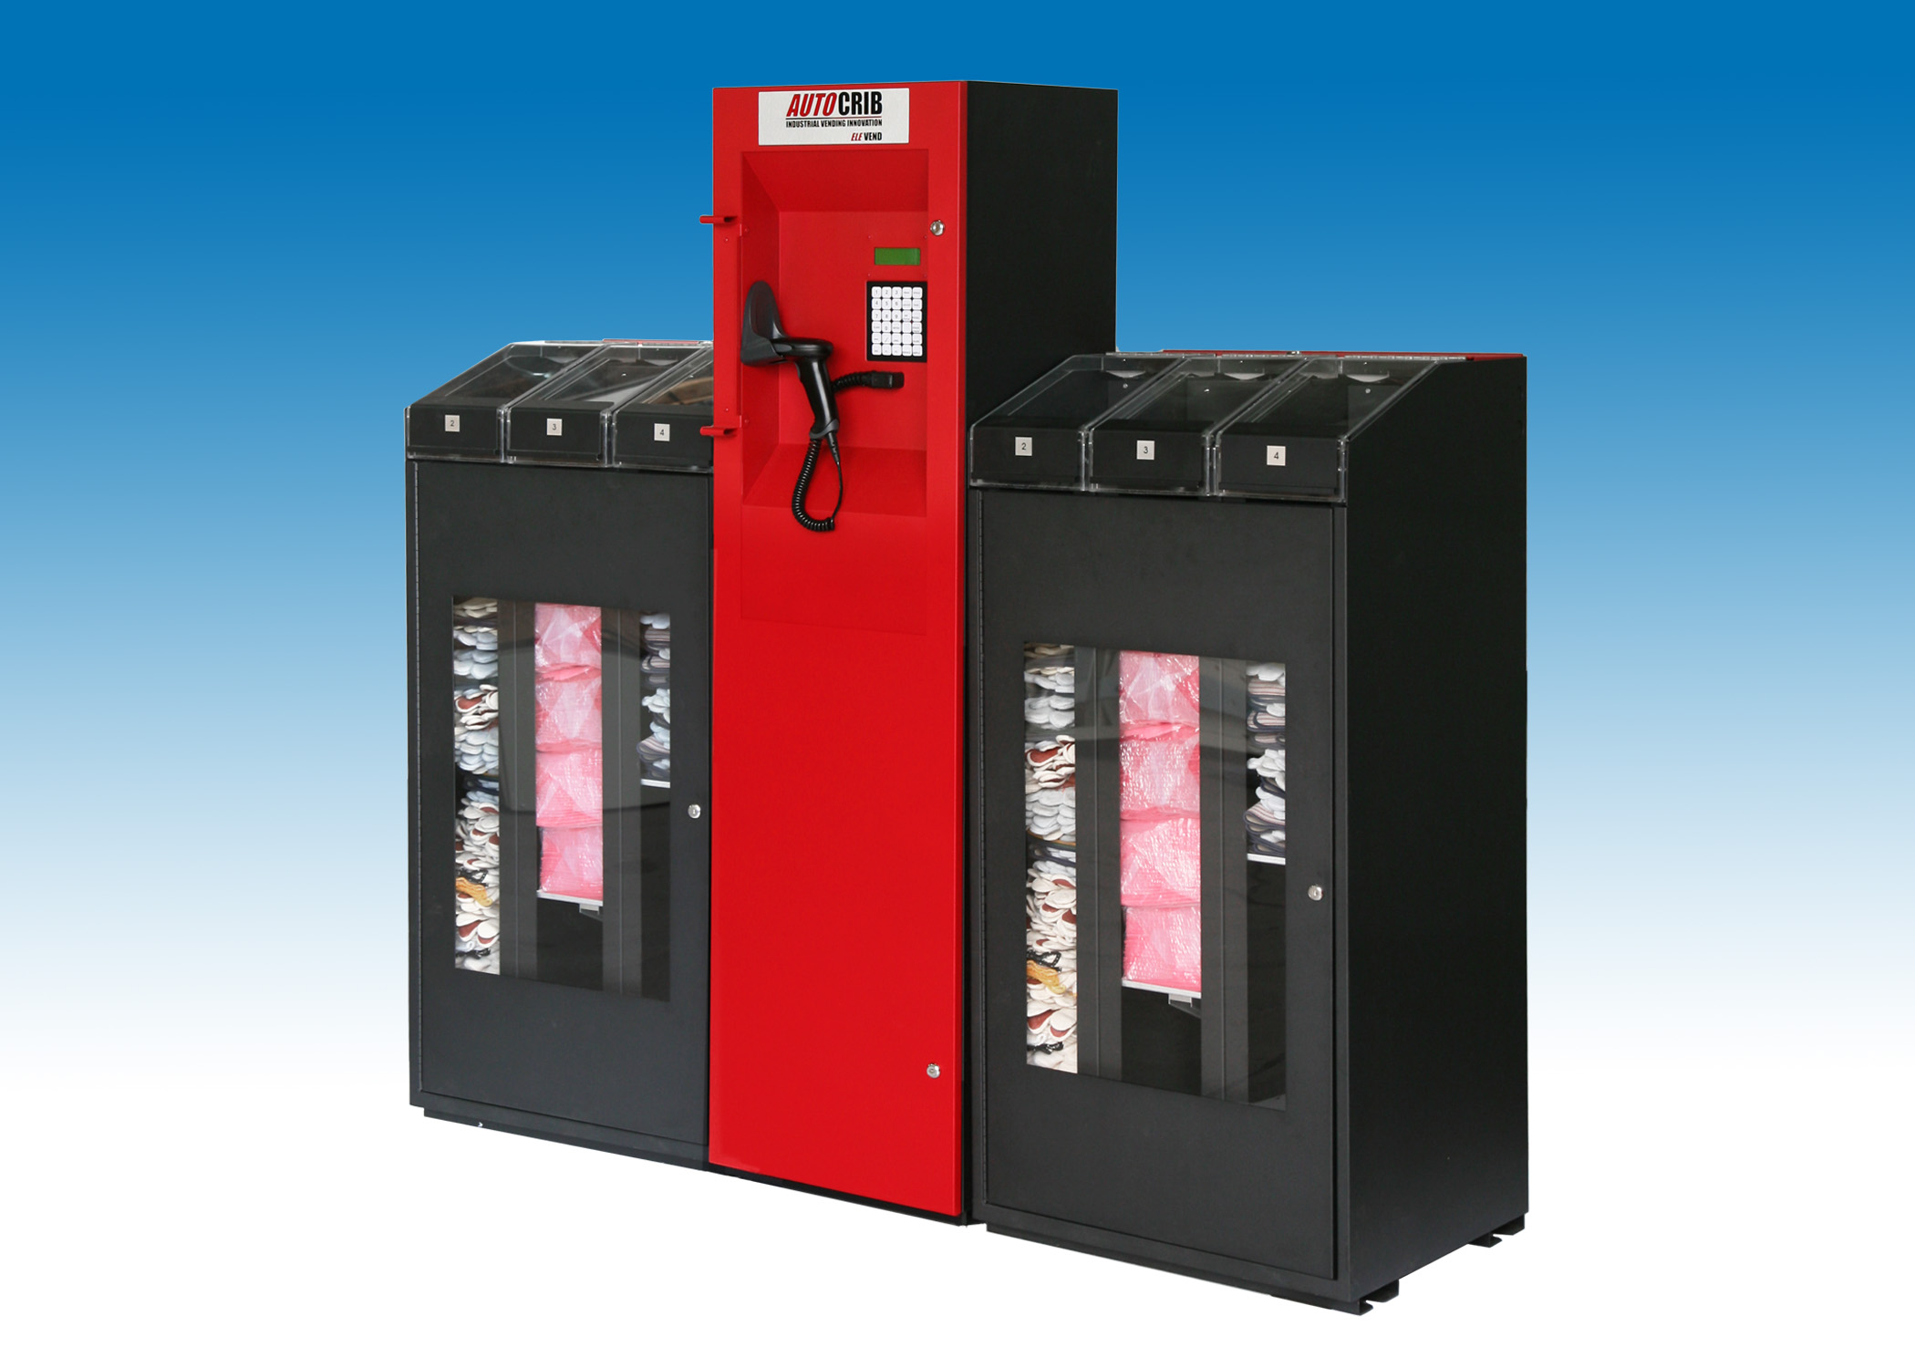

Last Revision January 2009


Tools Needed for Installation

- Outlet Tester (can be purchased at Radio Shack or comparable electronics store.)
- Battery drill with Phillips #1 bit
- Forklift with adjustable forks
- 5-64” hex driver (included with machine)
- Spirit level
- Phillips #1 screwdriver

Table of Contents

Initial Placement & Installation 4
Initial Placement 4
EleVend Preparation 4
Position Cabinets and Tower 4
Assemble Cabinets and Control Tower 4
Verify Proper Setup 6
Data Connection. 8

Management Station Installation 8
Restore the AutoCrib database. 8
Insert an EleVend Crib. 13
Assign a Controller and Terminal. 13
Assign Items to EleVend bins. 15

Complete EleVend Setup 16
Terminal Address Setting. 16
Calibrate Each Bin 16
Installation of Guide Rods. 16
Stock Bins. 17
Sample Bins. 17
Physical Bins. 17

Troubleshooting 18
Lifter Does Not Rise when Bin Door is Closed 18

Initial Placement & Installation

Initial Placement
      - Upon Arrival, check the following:

        - Damage to the pallet and/or wrapping
        - Status of “Tip-N-Tell”
        - Note any damage or irregularities on the bill of lading

Note: If any external damage is noted, remove the crate walls and inspect the machine before the truck driver leaves, and note any machine damage found on the bill of lading. Contact the trucking company to process any claims for damage to the machine caused in shipping.

DO NOT SIGN FOR SHIPMENT IF ANY DAMAGE HAS OCCURRED, REFUSE THE SHIPMENT.

The machine is shipped crated on a wooden pallet, and it should stay that way until it is positioned near its final location. An EleVend Configuration Sheet has been provided to indicate where the sections are separated. Review this document before uncrating the EleVend.

      - EleVend Preparation

        - Each control tower requires a properly configured 120VAC/60Hz grounded outlet. The system draws a maximum of 2 Amps.
        - The floor must be level in order for the cabinets to work properly and attach to each adjacent cabinet. If the floor is not level, a leveling kit (Part #772-150) can be ordered for each cabinet section. Other options for leveling include shims or building a level platform.
        - The EleVend uses RS485 protocol for communication to the management station. Using straight through CAT5 cable, a connection must be made directly from the EleVend to the Sealevel device connected to the management station. (NOTE: If a network drop using TCP/IP protocol is desired, terminal servers must be used. These devices convert the RS485 signal to TCP/IP.)

      - Uncrate and Position Cabinets and Tower

        - Move the crated cabinets to the final location. Remove the crate sides and carefully slide the wrapped cabinets off of the pallet. Take care not to put stress on the top bin doors.
        - Use a hand truck or a similar device to move the cabinets to their final positions. DO NOT push, pull, or kick the doors or hinges while moving the cabinets.
        - Unwrap the cabinets and position them per the Configuration Sheet. Note the bin door numbers and keep them in order.

      - Assemble Cabinets and Control Tower

        - Locate the door access key taped to the control tower. Remove the assembly parts, spare keys, and other accessories.
        - Push the cabinets together and align them square to each other as indicated by the Configuration Sheet.
        - Adjust the leveling feet on each cabinet and control tower to ensure the cabinet is level and stable.

LEVELING FEET

        - Using the key, unlock the top frame (locks on the right and left of unit). Lift the top frame to gain access into the cabinet. (NEED PICTURE)
        - (Optional) Insert the cabinet couplers through the holes between the cabinets and secure with a nut on each side.
        - Route the backbone cables through the couplers and attach to the backbone cable in the adjacent cabinet.

BACKBONE CONNECTION BETWEEN CABINETS (OR TERMINATION POINT)
BACKBONE OUT TO NEXT CABINET

        - After the cables have been attached, verify the wires are clear of the moving parts on the lifter assembly.
        - Attach the backbone extension cable between the control tower and the first cabinet through the coupler.

BACKBONE CABLE EXISTS TO CONTROL TOWER

BACKBONE CABLE FROM FIRST CABINET
BACKBONE CABLE
EXTENSION
BACKBONE CABLE CONNECTION TO MUX BOARD
TO AUX PORT ON CONTROLLER

      - Test EleVend to Verify Proper Setup

        - Connect the control tower to the tested power source. Turn the EleVend on by turning on the UPS in the base of the tower.
        - Verify the “Building Wiring Fault” light is not lit on the UPS. If this light does appear, correct any building wiring faults before proceeding.
        - The keypad display on the control tower will light, in addition to the status lights on the multiplexer board (MUX board) and each lifter mechanism.
        - Open the front door on each cabinet and close the top frame ensuring the frame is in its locked position.
        - Begin the test cycle for each bin.
          - Press the Bin Door Release button to open the bin door. This can be located underneath the top frame. (If the bin door does not open, see the section on Troubleshooting Bin Doors.)

          - The front panel LED should flash when the bin door is unlatched or open.
          - Using the 5-64” hex driver (provided with EleVend), depress the Mode button until the status LEDs flash several times. The lifter is now in “Service” mode.

DEPRESS MODE BUTTON UNTIL STATS LEDs FLASH SEVERAL TIMES

          - Close the bin door. The lifter will begin to rise until the top limit has been reached. Then, the lifter will automatically reverse and descend to the bottom limit. This process may take up to six minutes for each bin. (Note: If the lifter does not move up, see the section on Aligning Lasers.)
          - Continue steps i-iv for all bins. There is not a limit to the number of lifters being tested at one time.

NOTE: The lifter can be stopped by pressing the Bin Door Release button. The lifter will not move when the bin door is open. As soon as the bin door is closed, the lifter will begin moving up, even if it was moving down when the bin door opened.

          - Once each lifter has successfully completed a test cycle, the bins can be placed into “Host” mode. Using the 5-64” hex driver depress the Mode button until the status LEDs flash several times.

LASER SWITCH
MODE SWITCH
SERVICE/HOST
POWER ON WHEN LIT
LEFT LASER ALIGNED WHEN LIT
RIGHT LASER ALIGNED WHEN LIT
VERTICAL ADJUST
LASER
SERVICE MODE ON WHEN LIT
ANGULAR ADJUST
LENSE

      - Data Connection – Connect one end of the CAT5 cable into the splitter inside the control tower. Connect the other end into the RJ45 drop provided by the maintenance or IT department.

Management Station Installation

- Locate the “Quick Start” form in the software packet provided with the management station. Use this form to begin the setup of the management station. Once step 10 has been reached on the Quick Start form, continue with the instructions below.

- Upon startup of the management station, pcAnywhere and the Autocrib software will start automatically. The AutoCrib software must be turned off before restoring the database.

- Restore the AutoCrib database.

        - Place the .BAK file received from AutoCrib’s customer service department into C:\Program Files\Microsoft SQL Server\MSSQ.1\MSSQL\Backup.
        - Open the Microsoft SQL Server Management Studio and connect to the server.
          - Server Name: Computer Name\AUTOCRIB53
          - Authentication: SQL Server Authentication
          - Login: sa
          - Password: AutoCrib2005

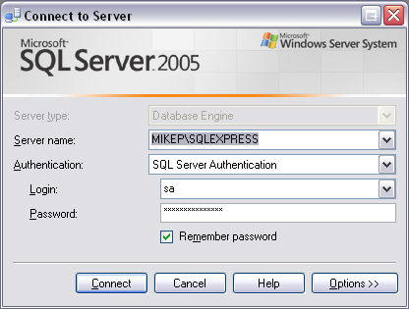

        - Click the plus (+) sign next to the server. Then, select the plus (+) sign next to the databases folder.

        - Right click the autocrib53 database.

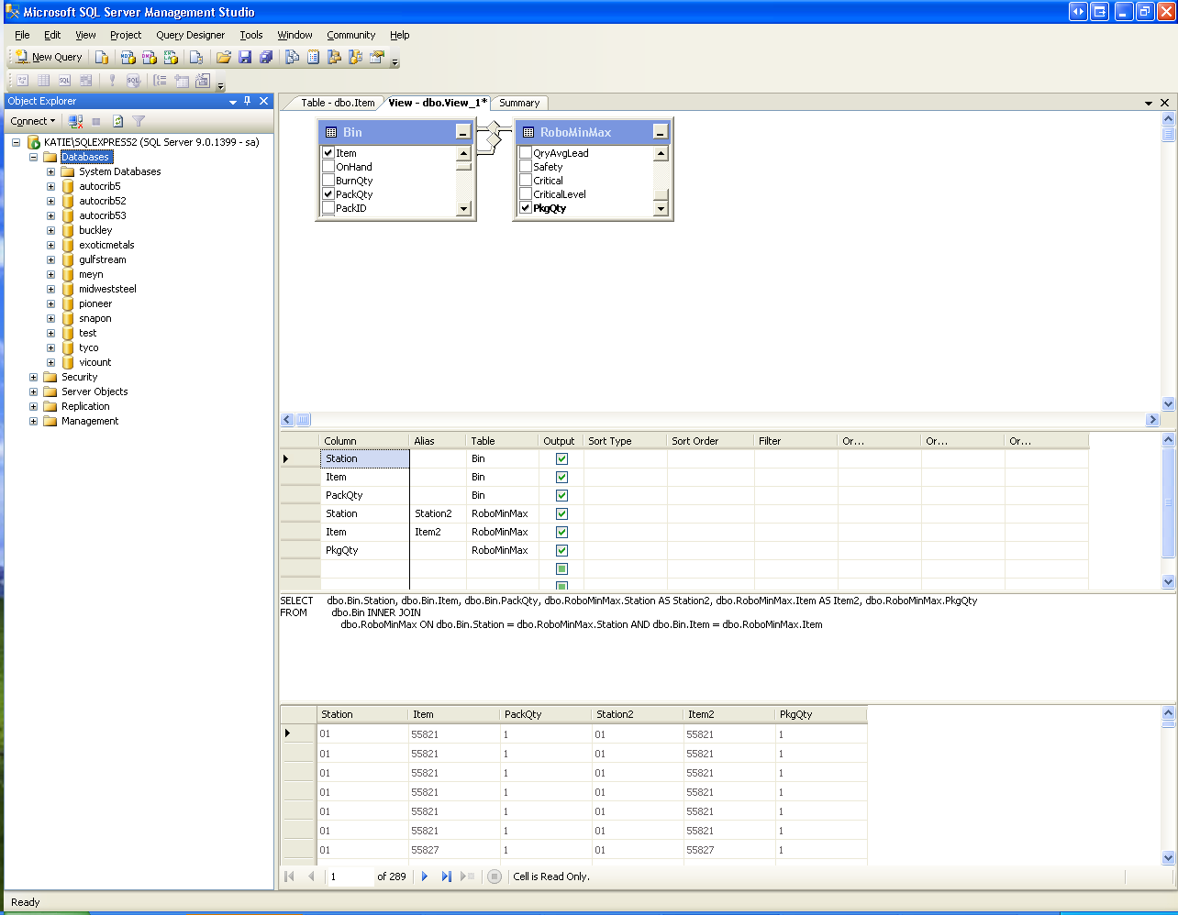

        - Select “Tasks” > “Restore” > “Database…”.
        - Under the Source for Restore menu, enable “From Device”. Then, select the Browse button.

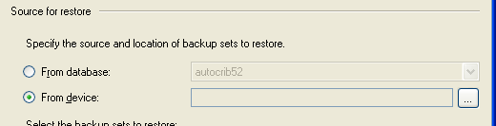

        - Select the “Add” button.
        - Locate the .BAK file saved in C:\Program Files\Microsoft SQL Server\MSSQL.1\MSSQL\Backup. Then, select “OK”.

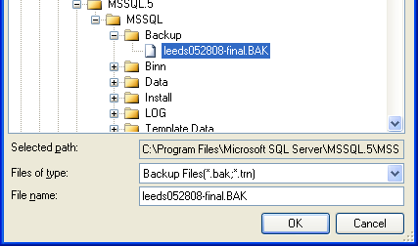

        - Select “OK” in the Specify Backup screen.
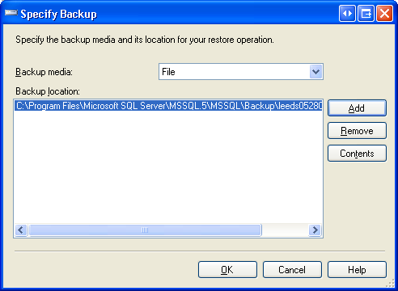

        - Under the Select the backup sets to restore menu, enable the “Restore” checkbox.

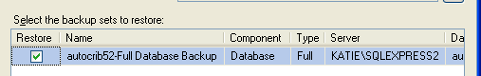

        - In the upper left hand corner of the screen under the Select a page menu, select “Options”.

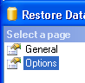

        - Under the “Restore Options” menu, enable “Overwrite the existing database”.

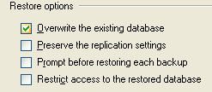

        - Under the “Restore the database files as:” menu select the first browse button.

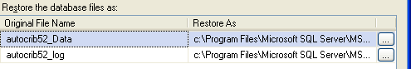

        - Locate the autocrib53_Data.mdf or autocrib53.mdf file located in C:\Program Files\Microsoft SQL Server\MSSQL.1\MSSQL\Data. Then, select “OK”.

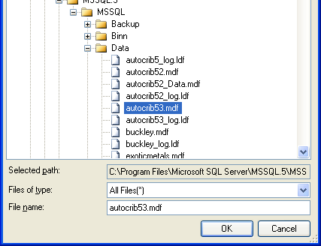

        - Under the “Restore the database files as:” menu select the second browse button.

        - Locate the autocrib53_log.ldf file located in C:\Program Files\Microsoft SQL Server\MSSQL.1\MSSQL\Data. Then, select “OK”.

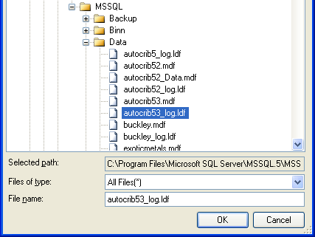

        - Under the “Recovery state” menu, verify “Leave the database ready to use by rolling back uncommitted transactions. Additional transaction logs cannot be restored. (RESTORE WITH RECOVERY)” is enabled.

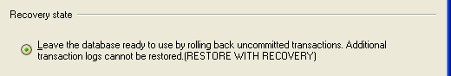

        - Select “OK”
        - Once the message “The restore of database ‘autocrib53’ completed successfully.” appears, select “OK”.

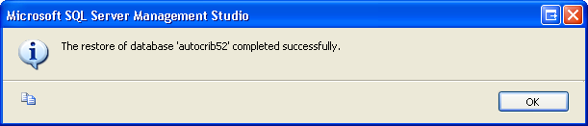

        - Congratulations!!! The database has now been restored and you are ready to begin using the AutoCrib software.

- Start the AutoCrib software

NOTE: If the AutoCrib software prompts for the server, database name, username, and password, insert the following.
Server: (LOCAL)\AUTOCRIB53
Database Name: autocrib53
Username: sa
Password: AutoCrib2005

- Once logged into the AutoCrib software, verify an EleVend crib has been created.

- Select the Tool Cribs menu at the top of the screen.
- Select the Tool Cribs module.
- If a crib type of EleVend is not listed, click ‘Insert’.
          - Crib – a unique number defining the EleVend
          - Description – describe a location in the plant where the EleVend resides
          - Crib Type – EleVend
- Click ‘OK’ to save the settings.

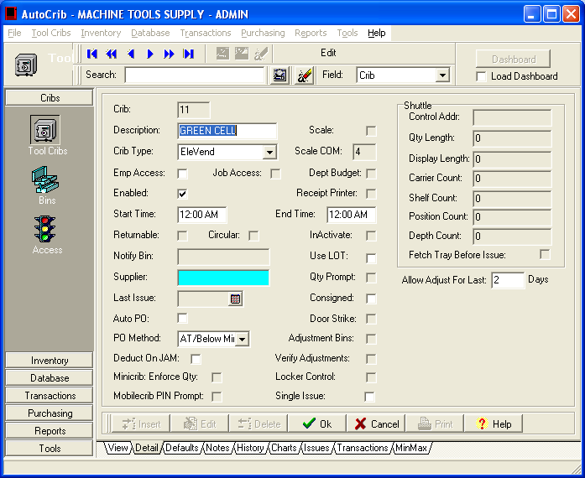

- Setup controller and terminal.

- Select the Tools menu at the top of the screen.
- Select the Options module.
- Select the Controllers tab.
- Click the ‘Insert’ button. A window will appear with the computer name. Click ‘OK’. This computer will now appear in the Controllers screen.
- Click the ‘Edit’ button. Change the Port number to the Sealevel port. Usually, this is Port 4. If you are unsure of the port number, go into the Device Manager (Right click on My Computer and select ‘Manage’) and note the port number for the “SeaLINK + 485 USB to RS-422/485 Converter (COM4)” under Ports (COM & LPT).

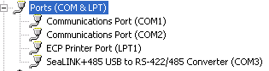

If the port number in the Device Manager matches the port number in AutoCrib, skip to the next step. Otherwise, make the necessary changes to the Port field of the Controllers tab and click ‘OK’.

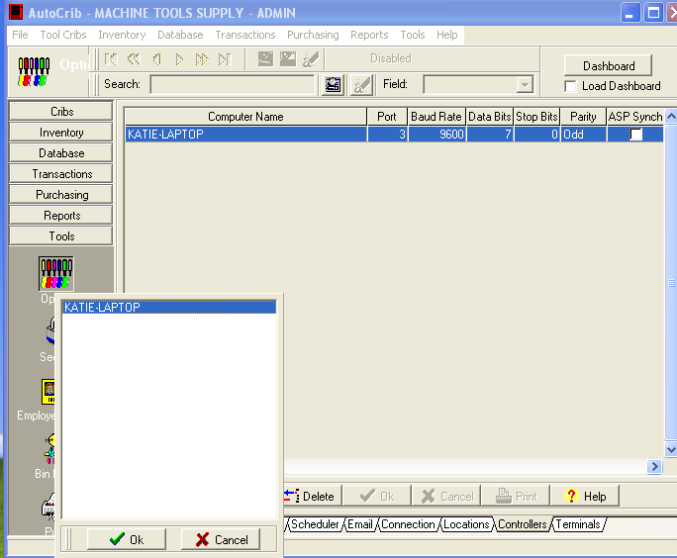

- Select the Terminals tab.

- Highlight the inserted controller from the previous step.
- Click the ‘Insert’ button.
- Select the EleVend crib created in step 11. Then, click the ‘OK’ button.
- Note the Terminal number listed.
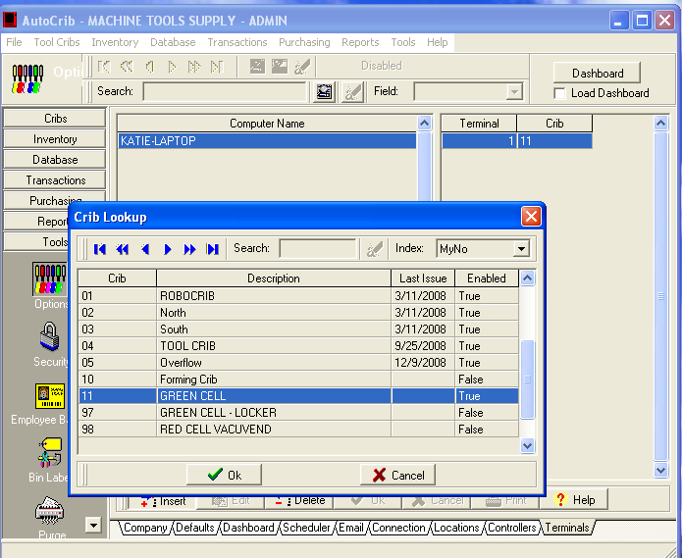

- Restart the AutoCrib software.
- Select the File menu.
- Then, select Exit.
- Click ‘Yes’ to the question, “Are you sure you want to exit AutoCrib?”
- Double click on the AutoCrib shortcut on the desktop.

- Assign items to EleVend bins.

  - Select the Tool Cribs Menu.
  - Select the Bins module.
  - Click the ‘Insert’ button. Using the EleVend Configuration Sheet, insert the first bin number.
  - Double click in the aqua field to select an item for assignment.
  - Insert a Minimum and Maximum for the bin.
  - If the gloves are being dispensed in pairs and the issue cost reflects the price of one glove, change the package quantity to 2.
  - Click the ‘OK’ button.
  - Continue this process until all items are assigned to the bins in the EleVend Configuration Sheet.

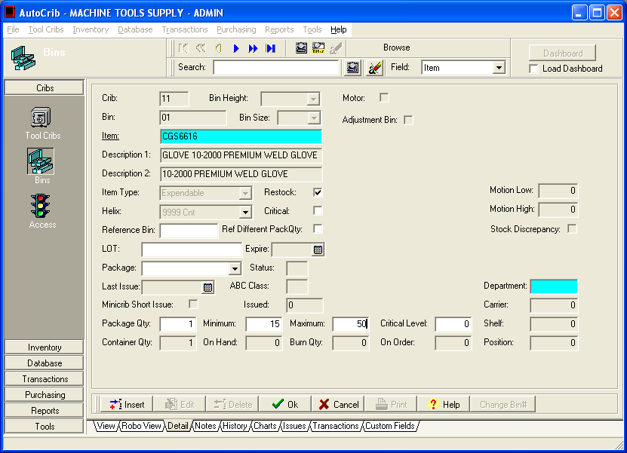

Complete EleVend Setup

            - Change terminal address on EleVend.

- Open the control tower at the EleVend.
- Move the Mode switch from “Issue” to “Service”.
- The keypad on the control tower will now be in Service Mode.
- Press the ‘F1’ button on the keypad.
- The ‘Station ID:’ on the LCD should be the terminal number noted in step 12.d.iv
above. If the terminal numbers do not match, press the ‘Clear’ button twice. Then, insert the correct terminal number. (NOTE: The terminal number is two digits. Therefore, if the terminal number is ‘1’, insert ‘01’ at the keypad.)
- Press the ‘Enter’ button to save the changes.
- Move the Mode switch from “Service” to “Issue”.

            - The keypad will now display “AutoCrib Press Function Key”. If the message “Host Down” appears, contact AutoCrib Technical Support for assistance.

            - Select the ‘CALIBR’ button on the keypad. Select the option to calibrate all bins (key 2). The keypad will display a message, “Bin Must be Empty”. Once each bin has been calibrated, the lifter will stop at the bottom limit. (NOTE: At least one employee must be setup as a stocker in the AutoCrib software.)

            - Open the front door of each cabinet and each bin door using the Bin Door Release button.

  - Place a small stack of the assigned items into each bin.
  - Adjust the upright guide rods and top plates as needed to secure the product stack. The guide rods must be situated to keep the product stack from tipping over or jamming as the lift raises the stack. You may need to experiment with several configurations to find the optimal arrangement. Test cycles can be used to adjust the guide rods by putting the lifter into the “SERVICE” mode.
  - Once the guide rods are properly situated, insert the remaining items into the bin.
  - Close the bin door. The lifter will rise until the laser has been broken.

            - After all bins have been stocked, select the ‘STOCK’ button on the keypad. Insert the stocker’s badge number and PIN. Choose the manual option and enter the total quantity stocked for each bin.

            - Because each item is different, a sample must be taken in order to calculate the quantity issued.

- Select the “SAMPLE” button on the keypad.
- Insert the stocker’s badge number and PIN.
- Insert the bin number to sample. The bin door will open.
- Remove a pair of gloves and close the door. The lifter will begin to rise until the laser has been broken.
- The bin door will open again. Remove a pair of gloves and close the door. The door will open 5 times and ask the user to remove a total of 5 pairs of gloves.
- Once the sampling process is complete for the bin, the inventory will be deducted by 5. Follow the step below to add the items back into the bin.

      - The items used for sampling can be added back into the bin by using the Physical feature.

- Select the “PHYSIC” button on the keypad.
- Insert the stocker’s badge number and PIN.
- Insert the bin number to add items.
- Select the “FILL” option.
- Insert the total quantity that will be in the bin after adding the sample items.
- The lifter will descend until the bottom limit as been reached and the bin door will open.
- Insert the items and close the bin door.
- The lifter will rise until the laser is broken.

      - Follow steps 6 and 7 until all bins have been sampled and the sample items have been added back into the bins.

Congratulations, you are ready to start dispensing!

Troubleshooting

Problem: Lifter Does Not Rise when Bin Door is Closed

      - Align Lasers – There are two lasers crossing the top of the bin that are reflected by mirrors in the front frame of the cabinet. When the beams of these two lasers have been broken, a signal is sent to the controller to stop rising the lifter. Both beams must be broken for the lifter to stop. If the lasers are not aligned, the lifter will not move up. Follow the steps below to align the lasers.

- Open the front door of the cabinet. The top frame must be in its closed position and locked.
- Open the bin door by pushing the Bin Door Release button.
- Using the 5-64” hex driver, turn the lasers on by pushing and holding the LASER SWITCH button for about 2 seconds or until the lasers turn on.
- To Adjust Lasers:
  - Insert the laser adjustment tool into the adjusting port at either the 9 o’clock position (left laser) or the 3 o’clock position (right laser) depending on which laser is not aligning to the diffuser. Twisting the driver will move the laser beam along a line at approximately 60 degrees to horizontal. Position the beam above or below the center of the diffuser.
  - Insert the laser adjustment tool into the adjusting port at the 12 o’clock position. Twisting the driver will move the laser straight up or down, directly in the center of the diffuser.

CAUTION: DO NOT TWIST THE DRIVER MORE THAN ONE FULL TURN IN EITHER DIRECTION. All adjustments should be accomplished within ½ a turn or less. If the laser will not align within half a turn, the laser needs to be inspected to verify it and its adjusting mechanism are properly seated.

Left Laser Adjusting Port (12 o’clock) – moves laser up and down
Right Laser Adjusting Port (12 o’clock) – moves laser up and down
Laser Switch Button
Left Laser Adjusting Port (9 o’clock) – moves laser 60 degrees to horizontal
Left Laser Adjusting Port (3 o’clock) – moves laser 60 degrees to horizontal
Diffusers

  - Once both lasers are aligned and both laser status LEDs are lit, break each beam with your hand. The laser status LED should turn off when the beam is broken.

Both Laser Status LEDs are lit
Lasers are aligned to center of each diffuser

- Using the laser 5-64” hex driver, turn the lasers off by pushing and holding the LASER SWITCH button for about 2 seconds or until the lasers turn off.
- After closing the bin door, the lifter should begin to rise when the cabinet is in SERVICE mode.

