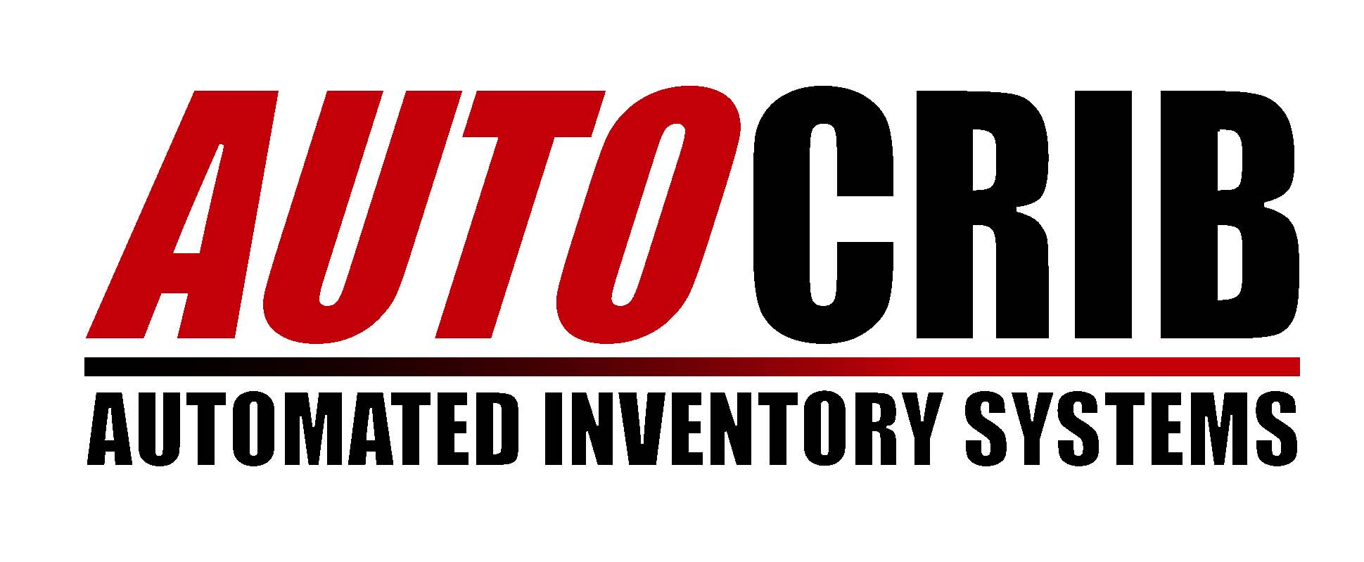

MiniCrib
OPERATIONS MANUAL 5.x

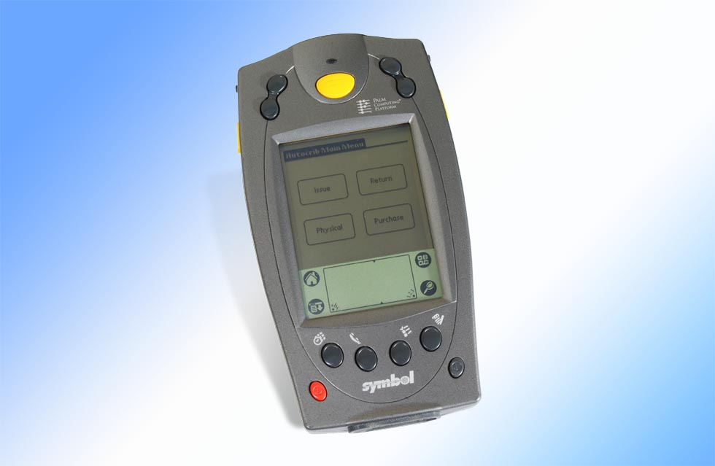

Please note MiniCrib for 5.X has 5 buttons, not 4 as depicted here.

Thank you for purchasing the MiniCrib. The MiniCrib is a handheld device made by Symbol that runs the Palm Operating System. AutoCrib has written a custom application for this device, which is designed to provide mobility while managing traditional tool cribs and stores. You can perform 5 different transactions with the MiniCrib including Issue, Return, Physical, Purchase and Receive. Before using the MiniCrib, all of the bin locations must be labeled with barcodes printed from the AutoCrib software. The first section covers the set up of your crib and the second covers the operation of the MiniCrib handheld device itself. These instructions do not cover basic Palm Pilot operations.

Steps in Setting Up a Tool Room

- Purchase cabinets and dividers from Kennedy, Lista, Stanley-Vidmar, etc… as well as any shelf units that would be appropriate.

- Purchase tools and give thought to the layout of tools within the cabinets.

- Build an item database in Excel with appropriate item codes, descriptions and prices.

- Arrange dividers to suit the sizes and quantities of the items.

- Assign items to bin locations in the AutoCrib software giving careful consideration to Min and Max. We recommend the following logic when establishing bin locations in a traditional crib or stores. This is an example of the first bin location in a crib that has less than 100 cabinets and less than 100 bins per drawer: cabinet location (1st=01), drawer (top=A), bin (1st=01), bin location is 01A01 or 01-A-01. If there were 100 or more cabinets or shelf units in this crib the bin location would add an additional placeholder to the cabinet location and become 001A01 or 001-A-01. The use of placeholders and following a consistent numbering sequence are the primary considerations.

- Print and adhere bin labels to the bins within the cabinets of on the shelves. This can be done easily in the Tools Menu under the “Bin Labels” section. Please ensure that you select the “Tool Room” style of label so that the individual bin’s bar code will be provided. For additional information please see the Software Manual. You can also use Reports Module and then select the Pick Sheet category and then the “Crib by Location” report or the Inventory category and then the “Tool Room, RoboCrib, Cabinet Labels #1 or Tool Room, RoboCrib, Cabinet Labels #2” reports.

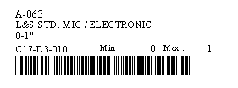

- Print “Physical by Tool Crib” Report and make note of the physical counts as the stocking process takes place.

- Using the Receiving module, increment on hand quantities consistent with items that were physically stocked.

- Begin to issue items from your new Tool Room using your MiniCrib.

Using the MiniCrib

From the Main Menu you have five soft buttons to choose from: Issue, Return, Physical, Purchase and Receive. It is important to note the MiniCrib for 5.X adds an additional step that needs to be performed or the transaction will not be completed.

ISSUE:
Press the Issue button and enter badge number by scanning a barcode or using stylus and soft keyboard to enter data. Enter any other overhead data like department, job, part, machine, etc. and press Next to proceed or Cancel to return to Main Menu. If no overhead data needs to be entered, you will go directly to the Bin Number prompt. Now enter the Bin Number by scanning the barcode attached to the bin. Now you must enter the Quantity of the item to be issued on the soft numeric keyboard. Finally, you must choose the Issue button to complete the transaction for that item. If you have made a mistake or want to return to the badge number prompt, chose the Back button. Now scan the next bin or choose the Done button to return to the Main Menu.

RETURN:
Press the Return button and enter badge number by scanning a barcode or using stylus and soft keyboard to enter data. Enter any other overhead data like department, job, part, machine, etc. and press Next to proceed or Cancel to return to Main Menu. If no overhead data needs to be entered, you will go directly to the Bin Number prompt. Now enter the Bin Number by scanning the barcode attached to the bin. Now you must enter the Quantity of the item to be returned on the soft numeric keyboard. Finally, you must choose the Return button to complete the transaction for that item. If you have made a mistake or want to return to the badge number prompt, chose the Back button. Now scan the next bin or choose the Done button to return to the Main Menu.

PHYSICAL:
Press the Physical button and enter badge number by scanning a barcode or using stylus and soft keyboard to enter data. Now enter the Bin Number by scanning the barcode attached to the bin. Now you must enter the Quantity of the item to be physically counted on the soft numeric keyboard. You must choose the Physical button to update the on hand quantity. Now enter the next bin number to count, Back to go to the Employee Badge prompt or Done if you are done with this transaction and need to go to the Main Menu.

PURCHASE:
Press the Purchase button and enter badge number by scanning a barcode or using stylus and soft keyboard to enter data. Now enter the Bin Number by scanning the barcode attached to the bin. Now you must enter the Quantity of the item to be purchased on the soft numeric keyboard. You must choose the Purchase button to complete that line item. Now enter the next bin number, Back to go to the Employee Badge prompt or Done if you are done with this transaction and need to go to the Main Menu.

RECEIVE:
Press the Receive button and enter badge number by scanning a barcode or using stylus and soft keyboard to enter data. Now enter the PO Number on the soft numeric keyboard. This number can be found in the Transaction History or in both of the “Open Purchase Orders” reports after synching the unit. Although AutoCrib adds an “M” suffix to the PO such as “1000M” signifying the PO was generated on the MiniCrib, only “1000” needs to be entered. Now enter the Bin Number by scanning the barcode attached to the bin. Now you must enter the Quantity of the item to be received on the soft numeric keyboard. You must choose the Receive button to complete that line item. Now enter the next bin number, Back to go to the Employee Badge prompt or Done if you are done with this transaction and need to go to the Main Menu.

NOTE: It is important to place the MiniCrib in its cradle consistently to charge the battery and synchronize the data. Although RF MiniCrib units can be synchronized over the air, they must maintain a consistent charge from the cradle as well.

SCAN BARCODE

MiniCrib Buttons

ISSUE
RETURN
PURCHASE
PHYSICAL
LAUNCH MINICRIB APPLICATION
HOTSYNCH (FOR RF UNIT)
ADJUST CONTRAST
TOUCH HERE OR HERE WITH STYLUS TO ENABLE ALPHANUMERIC KEYBOARD ON SCREEN

POWER
ON/OFF

