

MobileCrib

OPERATIONS MANUAL 5.1 and 5.2

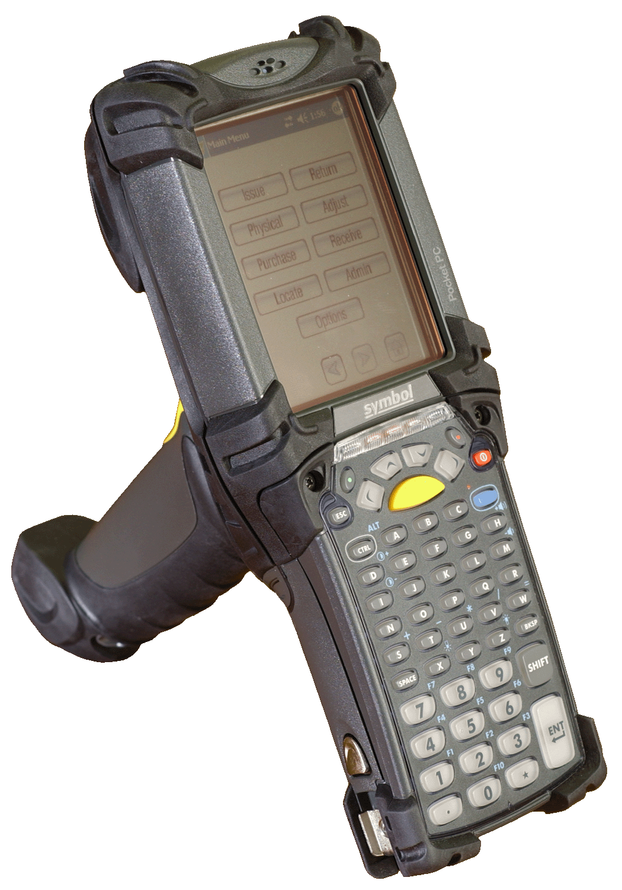

Please note MobileCrib is for AutoCrib 5.1 only.

Thank you for purchasing the MobileCrib. The MobileCrib is a handheld device made by Symbol that runs the Windows Mobile2003 Operating System. AutoCrib has written a custom application for this device, which is designed to provide mobility while managing traditional tool cribs and stores. You can perform 8 different transactions with the MobileCrib including Issue, Return, Physical, Adjust, Purchase, Receive, Locate, and create bins. Before using the MobileCrib, all of the bin locations must be labeled with barcodes printed from the AutoCrib software. The first section covers the set up of your crib and the second covers the operation of the MobileCrib handheld device itself. These instructions do not cover basic Pocket PC operations.

Steps in Setting Up a Tool Room

- Purchase cabinets and dividers from Kennedy, Lista, Stanley-Vidmar, etc… as well as any shelf units that would be appropriate.

- Purchase tools and give thought to the layout of tools within the cabinets.

- Build an item database in Excel with appropriate item codes, descriptions and prices.

- Arrange dividers to suit the sizes and quantities of the items.

- Assign items to bin locations in the AutoCrib software giving careful consideration to Min and Max. We recommend the following logic when establishing bin locations in a traditional crib or stores. This is an example of the first bin location in a crib that has less than 100 cabinets and less than 100 bins per drawer: cabinet location (1st=01), drawer (top=A), bin (1st=01), bin location is 01A01 or 01-A-01. If there were 100 or more cabinets or shelf units in this crib the bin location would add an additional placeholder to the cabinet location and become 001A01 or 001-A-01. The use of placeholders and following a consistent numbering sequence are the primary considerations.

- Print and adhere bin labels to the bins within the cabinets of on the shelves. This can be done easily in the Tools Menu under the “Bin Labels” section. Please ensure that you select the “Tool Room” style of label so that the individual bin’s bar code will be provided. For additional information please see the Software Manual. You can also use Reports Module and then select the Pick Sheet category and then the “Crib by Location” report or the Inventory category and then the “Tool Room, RoboCrib, Cabinet Labels #1 or Tool Room, RoboCrib, Cabinet Labels #2” reports.

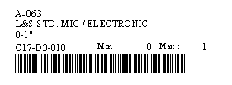

- Print “Physical by Tool Crib” Report and make note of the physical counts as the stocking process takes place.

- Using the Receiving module, increment on hand quantities consistent with items that were physically stocked.

- Begin to issue items from your new Tool Room using your MobileCrib.

Using the MobileCrib

From the Main Menu you have eight soft buttons to choose from: Issue, Return, Physical, Adjust, Purchase, Receive, Locate, and Admin.

Sign in to Autocrib by entering the badge number and PIN by scanning a barcode or using the stylus and soft keyboard to enter data.

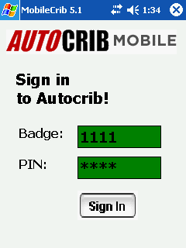

****LEGEND
BACK
NEXT
MAIN MENU

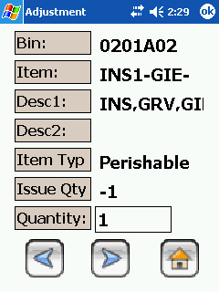

ISSUE:
Press the Issue button. Enter any other overhead data like department, job, part, machine, etc. and press Next (see legend) to proceed or Home (see legend) to return to Main Menu. If no overhead data needs to be entered, you will go directly to the Bin Number prompt.

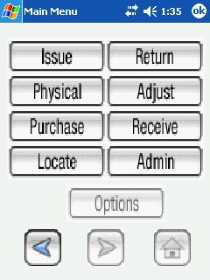

Now enter the Bin Number by scanning the barcode attached to the bin and press Next.

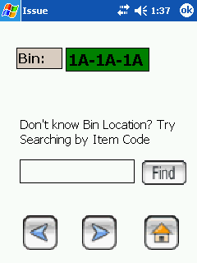

Now you must enter the Quantity of the item to be issued on the keyboard. Finally, you must choose the Next button to complete the transaction for that item and confirm the issue. If you have made a mistake or want to return to the badge number prompt, chose the Back button. Now scan the next bin or choose the Main Menu button to return to the Main Menu. If you would like to go back to the Sign In screen, click the OK button in the right hand portion of the screen after selecting the Main Menu button.

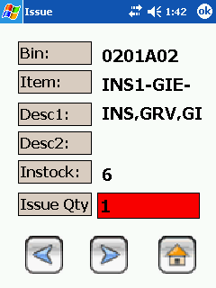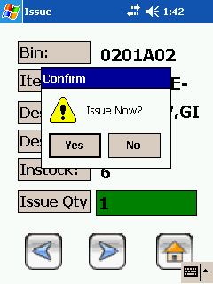

RETURN:

Press the Return button.

Now enter the Bin Number by scanning the barcode attached to the bin and press Next.

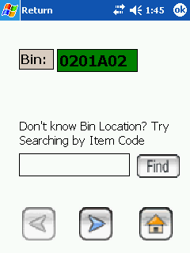

Now you must enter the Quantity of the item to be adjusted. Finally, you must choose the Next button to complete the transaction for that item and confirm the return. If you have made a mistake or want to return to the badge number prompt, chose the Back button. Now scan the next bin or choose the Main Menu button to return to the Main Menu. If you would like to go back to the Sign In screen, click the OK button in the right hand portion of the screen after selecting the Main Menu button.

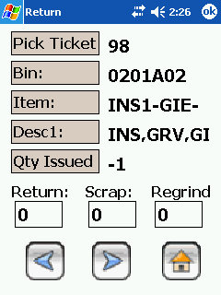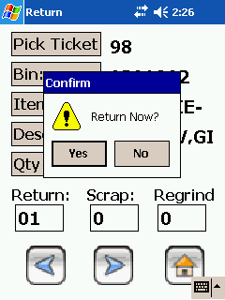

PHYSICAL:

Press the Physical button.

Now enter the Bin Number by scanning the barcode attached to the bin and press Next.

Now you must enter the Quantity of the item to be physically counted. You must choose the Next button to update the on hand or burn quantity. Now scan the next bin or choose the Main Menu button to return to the Main Menu. If you would like to go back to the Sign In screen, click the OK button in the right hand portion of the screen after selecting the Main Menu button.

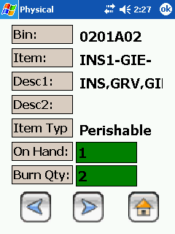

ADJUST:

Press the Adjust button.

Now enter the Bin Number by scanning the barcode attached to the bin and press Next. Enter any other overhead data like department, job, part, machine, etc. and press Next.

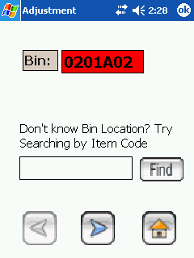

Now you must enter the Quantity of the item to be adjusted. You must choose the Next button to update the quantity. Now scan the next bin or choose the Main Menu button to return to the Main Menu. If you would like to go back to the Sign In screen, click the OK button in the right hand portion of the screen after selecting the Main Menu button.

PURCHASE:
Press the Purchase button.

Now enter the Bin Number by scanning the barcode attached to the bin. Now you must enter the Quantity of the item to be purchased. Finally, you must choose the Next button to complete the transaction for that item and confirm the purchase. Now scan the next bin or choose the Main Menu button to return to the Main Menu. If you would like to go back to the Sign In screen, click the OK button in the right hand portion of the screen after selecting the Main Menu button.

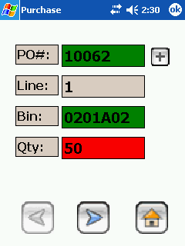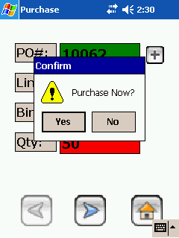

RECEIVE:

Press the Receive button.

RECEIVE PO SCREEN

Now enter the PO Number on the keyboard. This number can be found in the Transaction History or in both of the “Open Purchase Orders” reports. Now enter the Bin Number by scanning the barcode attached to the bin or select the Find button to select the bin being received and select the Next button. Now you must enter the Quantity of the item to be received. You must choose the Next button to complete that line item and confirm the transaction. Now enter the next bin or purchase order number or choose the Main Menu button to return to the Main Menu. If you would like to go back to the Sign In screen, click the OK button in the right hand portion of the screen after selecting the Main Menu button.

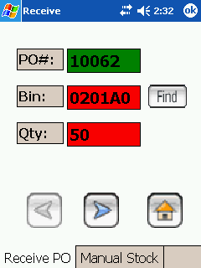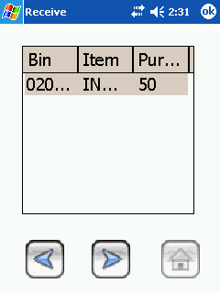

MANUAL STOCK SCREEN

Now enter the Bin Number by scanning the barcode attached to the bin being stocked and select the Next button. Now you must enter the Quantity of the item to be received. You must choose the Next button to complete the stock and confirm the transaction. Now enter the next bin or purchase order number or choose the Main Menu button to return to the Main Menu. If you would like to go back to the Sign In screen, click the OK button in the right hand portion of the screen after selecting the Main Menu button.

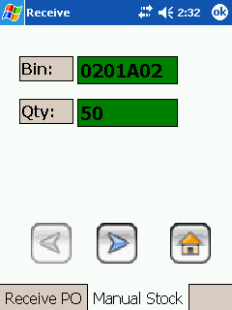

LOCATE

Press the Locate button.

Now enter the Item Code by using the keyboard and select the Find button. Highlight the bin and select the Next button to receive detailed information regarding the bin. Select the Back button to view more bins or choose the Main Menu button to return to the Main Menu. If you would like to go back to the Sign In screen, click the OK button in the right hand portion of the screen after selecting the Main Menu button.

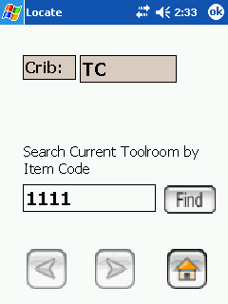

ADMIN

The Admin feature allows the user to create new bins in the toolroom and assign items to these bins in one easy step. Follow the steps below to create a new bin.

Press the Admin button.

Now enter the new Bin Number by either scanning the existing barcode attached to the bin being created or enter the new bin number using the keyboard, enter the item code using the keyboard and insert the quantity inside the bin. Now enter the next bin or choose the Main Menu button to return to the Main Menu. If you would like to go back to the Sign In screen, click the OK button in the right hand portion of the screen after selecting the Main Menu button.

