RoboCrib 500 Operations Manual
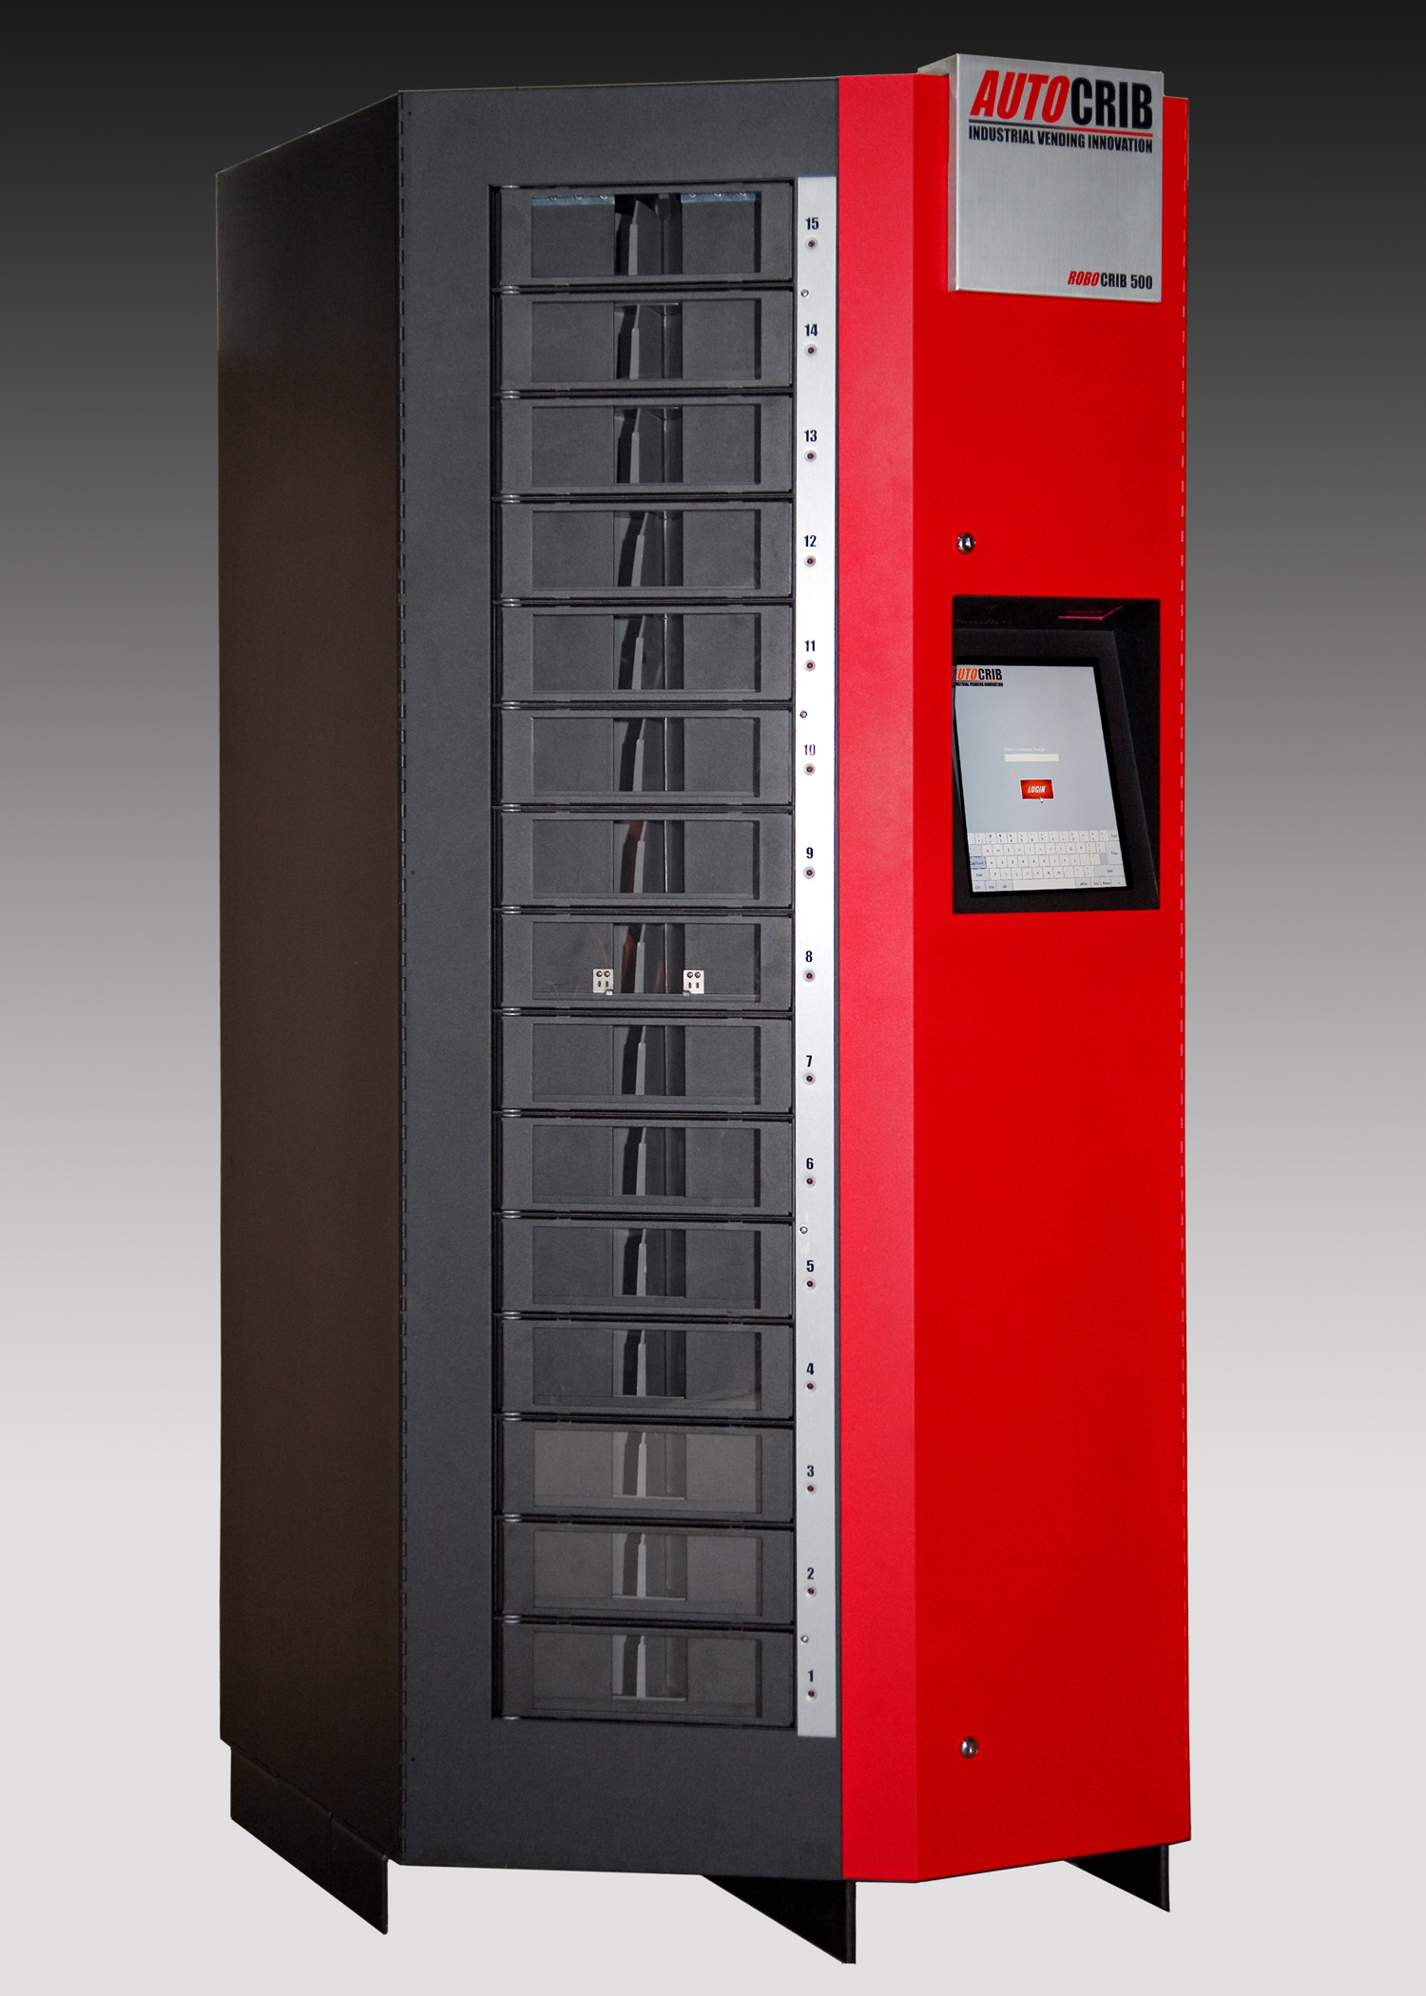
Last Revision November 2008


Tools Needed for Installation

- Outlet Tester (can be purchased at Radio Shack or comparable electronics store.)
- Battery drill with Phillips #1 bit
- Forklift with adjustable forks
- ¾” open end wrench or adjustable wrench for leveling foot nuts
- Spirit level
- Phillips #1 screwdriver
- 5/32 pin-in-hex driver (included with machine)

Table of Contents

Table of Contents 3
Initial Placement & Installation 4
Initial Placement 4
Powering up and Calibration 6
Management Station Installation 9
Common Parts on the RoboCrib 500 16
Troubleshooting 17
Problem: Receiving a jam or stall error, Finding dropped items 17
Problem: Motors will not turn or LEDs on controller do not light or flash as they should 19
Problem: Door Does Not Open 20
Problem: The LED on Door Remains On 22
Problem: Open Door error message or LED does not turn on when door is open 23
RoboCrib Door Schematic and Part Numbers 24
Problem: Baffle error warning 26
Problem: Calibration Errors 27

Initial Placement & Installation

Initial Placement
      - Upon Arrival, check the following:
        - Damage to the pallet and/or wrapping
        - Status of “Tip-N-Tell”
        - Note any damage or irregularities on the bill of lading

Note: If any external damage is noted, remove the crate walls and inspect the machine before the truck driver leaves, and note any machine damage found on the bill of lading. Contact the trucking company to process any claims for damage to the machine caused in shipping.

DO NOT SIGN FOR SHIPMENT IF ANY DAMAGE HAS OCCURRED, REFUSE THE SHIPMENT.

The RoboCrib 500 is a self-contained automated vending unit, ready to use right out of the crate with very little set-up. The machine is shipped crated on a wooden pallet, and it should stay that way until it is positioned near its final location.

      - Machine Setup – Cut the metal shipping straps and unscrew the crate walls. Save the crate walls and screws for future use if you anticipate relocating the machine. Remove the inner shrink-wrap and bubble packaging from the machine.
      - Leveling feet are included, and if used, should be installed while the machine is on the forklift. This allows easy access to the mounting points on the bottom.
      - Using a forklift, lift the machine off the pallet and place it in its final location. If using the leveling feet, use a spirit level to adjust the nuts on the leveling feet to level the machine. The machine sits flat on the floor on 3 metal flanges. Optional wheels can replace the stock corner flanges. The machine can also be moved with a typical pallet jack, if there are no wheels installed. The machine will fit through a standard office door without disassembly.

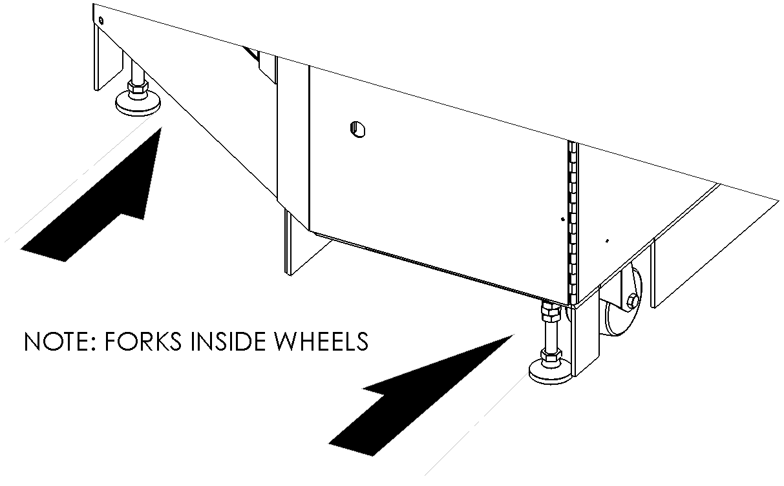

NOTE: THE MACHINE IS TALL WITH A NARROW BASE. EXERCISE CAUTION WHEN MOVING THE MACHINE BY FORK LIFT. IF THE MACHINE IS ON WHEELS, THE FORKS WILL HAVE TO BE PUSHED CLOSER TOGETHER TO FIT IN BETWEEN THE WHEELS, CAUSING THE MACHINE TO BE MORE EASILY TIPPED SIDEWAYS AS THE FORKLIFT MANUEVERS.

TAKE CARE NOT TO PUSH ON THE BIN DOORS OR MONITOR WHEN MOVING THE MACHINE. WHENEVER POSSIBLE, USE A PALLET JACK INSERTED FROM THE FRONT OR BACK TO MOVE THE MACHINE. A THREE-WHEELED APPLIANCE-RATED DOLLY MAY ALSO BE USED ON THE RIGHT SIDE, BUT NOT THE FRONT, BACK OR LEFT. STANDARD TWO-WHEEL DOLLIES SHOULD NOT BE USED.

      - There are several items shipped with the machine that are stored behind the flake board – the spare bin door assembly (#772-104), a network switching hub, CAT5 network cables, spare fasteners, and the security screwdriver. Be sure these items remain with the machine after the packing materials are removed.

Powering up and Calibration

      - Using the key taped to the front door, open the front right door panel by turning the key counterclockwise in both locks.
      - The system power cord is coiled up and attached to the UPS with a 3-position detachable connector. Detach the power cord. The power can be routed through the top or bottom of the machine depending on where the power outlet is located.
        - Routing Power Cord through Roof: feed the connector end down through the hole in the top right corner, routing the cable between the touch screen alcove and the right side wall. Then, attach to the UPS.
        - Routing Power Cord through Bottom: feed the connector end up from the bottom through the hole in the bottom right corner. Then, attach to the UPS.
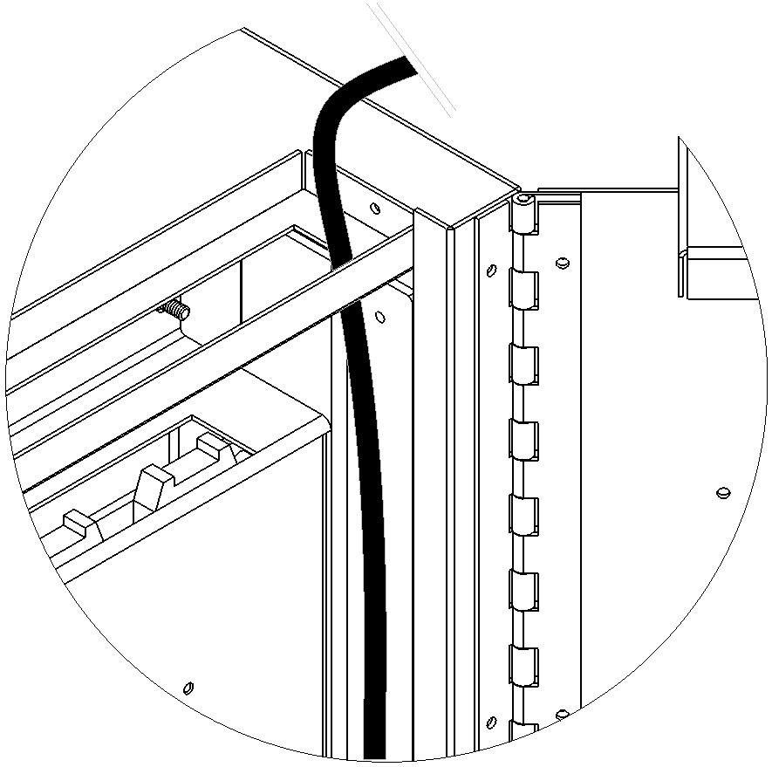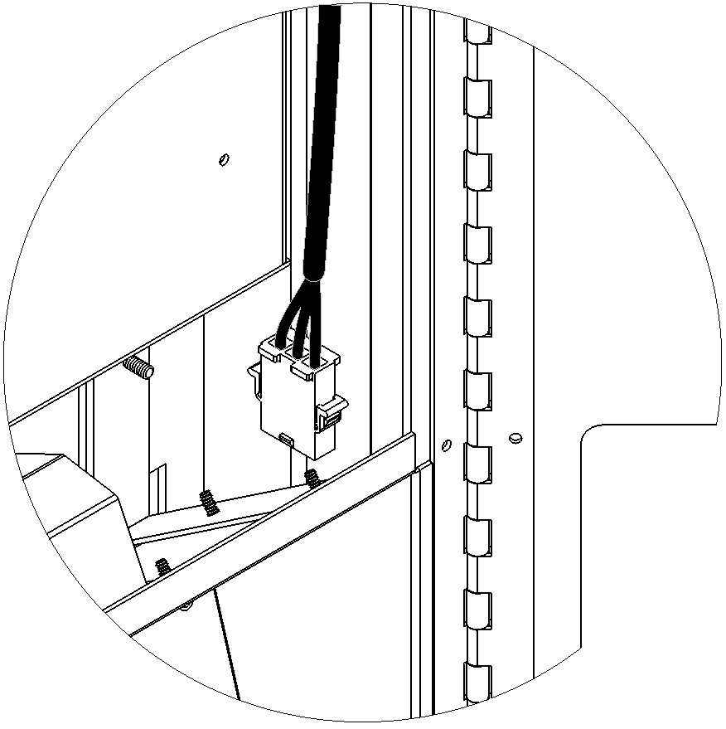
STEP A: DOWN THRU THE HOLE IN THE ROOF.

ROUTE BETWEEN THE TOUSCHSCREEN MONITOR ALCOVE & RIGHT WALL

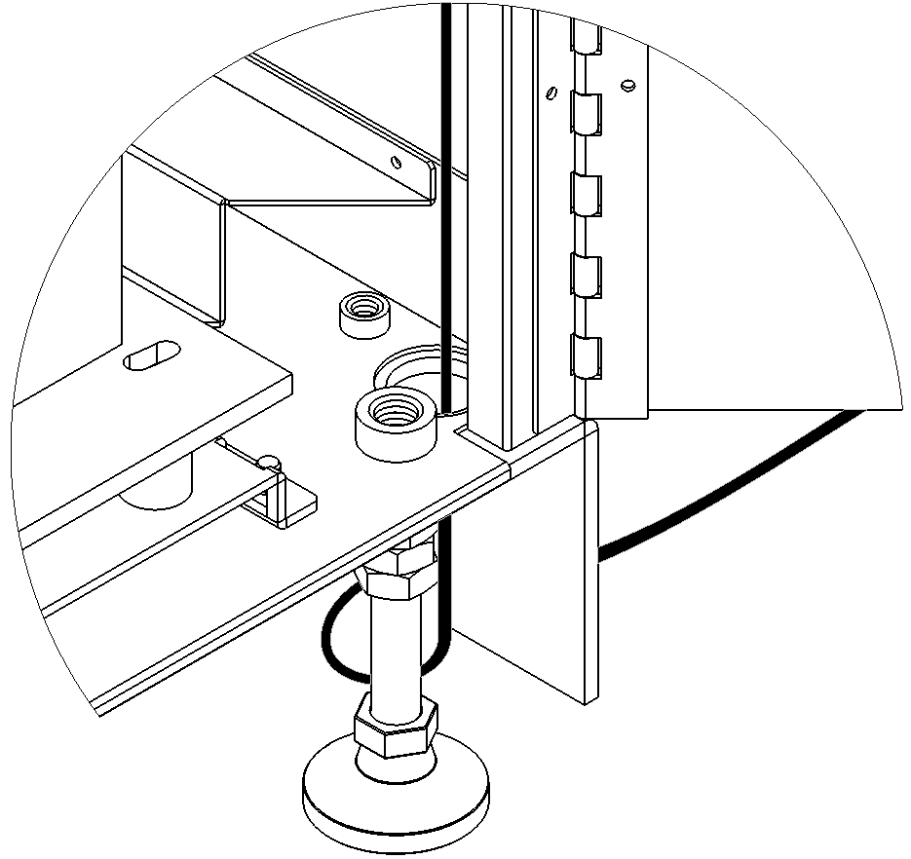
STEP B: UP FROM THE HOLE IN THE BOTTOM RIGHT CORNER

CONNECT WITH MATING CABLE FROM UPS

      - Network Connection: Run the CAT5 network cable (25 ft provided with machine) through one of the same routes as described for the power cord – up or down, depending on preference. Connect the CAT5 cable to the flash pc Ethernet port and connect the other end of the cable into the network drop provided to you by the facility.

NOTE: If a peer to peer setup will be used instead of the facility’s existing network, connect the end of the CAT5 cable into the hub provided with the machine rather than the network drop.
      - Attach the service keyboard to one of the open ports on the AUX USB hub attached to the flash pc.

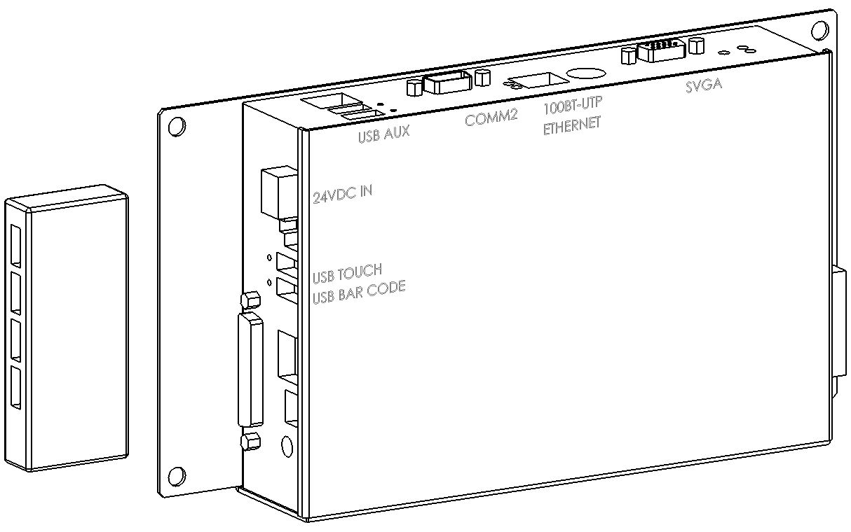
ETHERNET PORT ON TOP OF FLASH PC

ATTACH SERVICE KEYBOARD TO AUX USB HUB

      - Turn the UPS on by pushing the power button. Verify a green light appears on the UPS and the red building wiring fault LED on the top is off. If the red LED is lit, contact the facility electrician to repair the power outlet before proceeding.

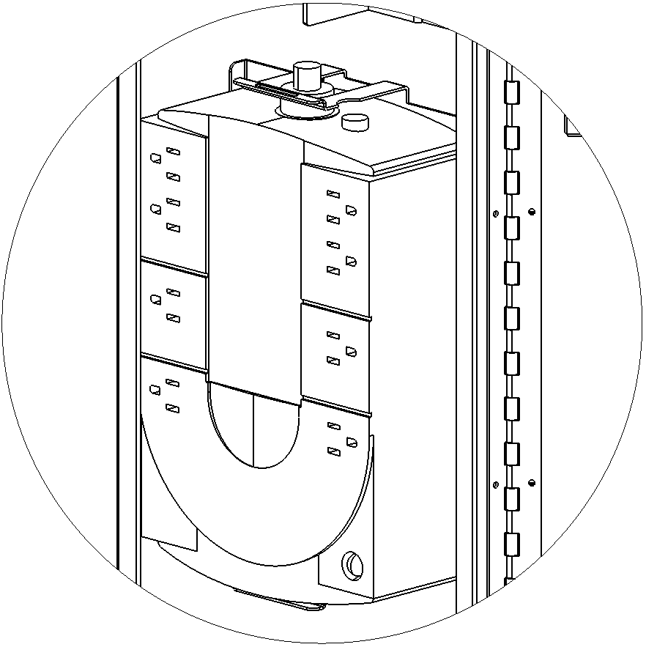
BUILDING WIRING FAULT LED – IF RED, TURN POWER OFF & CONTACT ELECTRICIAN!

UPS POWER SWITCH

      - Turn the MAIN power switch on the controller panel on. The pc and touch screen monitor will boot. Press the ‘esc’ key on the keyboard to avoid having the RoboCrib software launch.
      - Turn the CONTROLLER power switch on the controller panel. The green LED will illuminate and the red LED will blink.
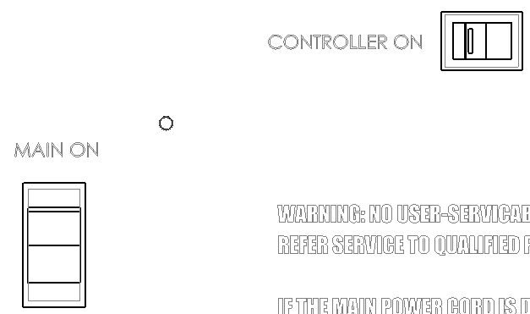
CONTROLLER POWER SWITCH

MAIN SYSTEM POWER SWITCH

      - There is no platter locking mechanism on the RoboCrib 500. Therefore, the RoboCrib 500 is ready for testing.
        - Set the motor direction switch to counter-clockwise. Use the LSP motor switch to move the LSP motor until the red reference light blinks on then off. The green and yellow encoder LEDs should blink rapidly as the motor turns.
        - Move the SSP motor until the red reference light blinks off then on. (This is opposite of how the LSP performs.) The green and yellow encoder lights should blink slowly as the motor turns.
        - Move the baffle motor briefly and verify the vertical baffle doors open.

If there are any problems with the motors or the lights blinking, check the connections at the top of the controller and the connections at the motors.
MOTOR DIRECTION MOTOR SWITCHES REF LEDs SENSOR LEDs
SWITCH

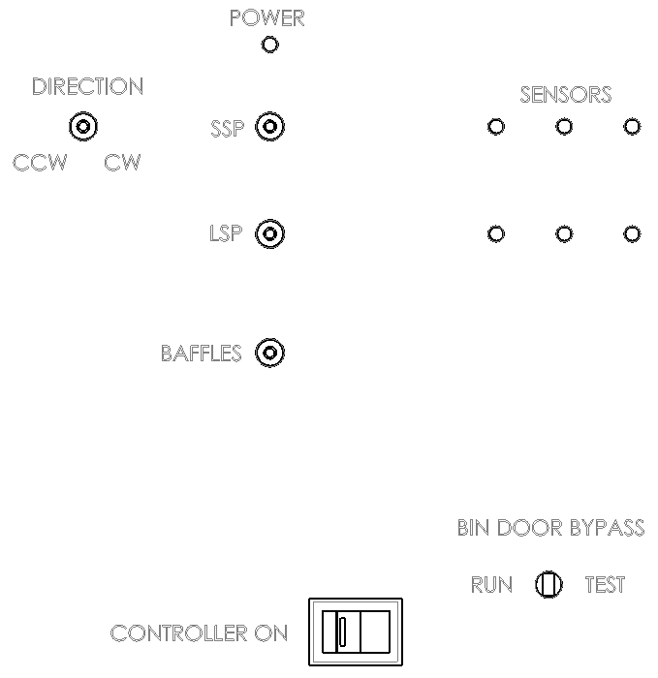

Management Station Installation

      - Locate the “Quick Start” form in the software packet provided with the management station. Use this form to begin the setup of the management station.
      - Upon startup of the management station, pcAnywhere and the Autocrib software will start automatically.
      - Restore the AutoCrib database.
        - Place the .BAK file received from AutoCrib’s customer service department into C:\Program Files\Microsoft SQL Server\MSSQ.1\MSSQL\Backup.
        - Open the Microsoft SQL Server Management Studio and connect to the server.
          - Server Name: Computer Name\AUTOCRIB53
          - Authentication: SQL Server Authentication
          - Login: sa
          - Password: AutoCrib2005

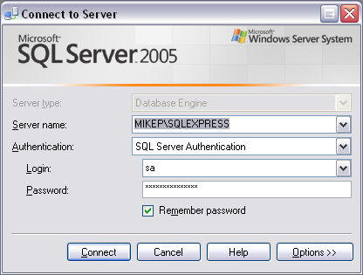

        - Click the plus (+) sign next to the server. Then, select the plus (+) sign next to the databases folder.

        - Right click the autocrib53 database.

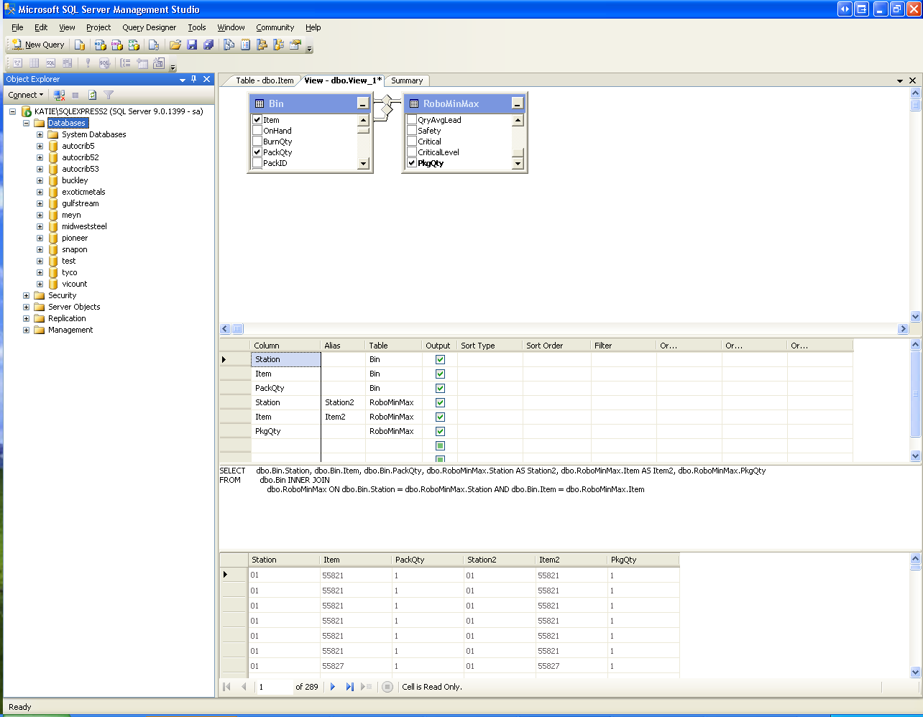

        - Select “Tasks” > “Restore” > “Database…”.
        - Under the Source for Restore menu, enable “From Device”. Then, select the Browse button.

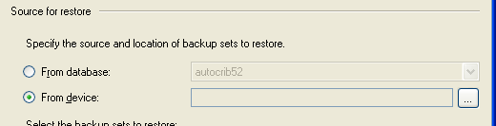

        - Select the “Add” button.
        - Locate the .BAK file saved in C:\Program Files\Microsoft SQL Server\MSSQL.1\MSSQL\Backup. Then, select “OK”.

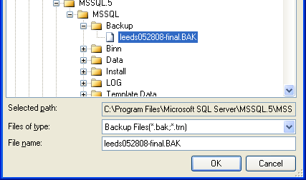

        - Select “OK” in the Specify Backup screen.
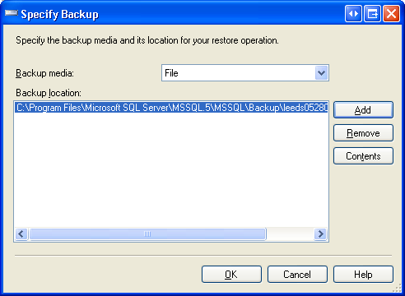

        - Under the Select the backup sets to restore menu, enable the “Restore” checkbox.

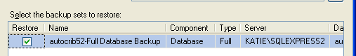

        - In the upper left hand corner of the screen under the Select a page menu, select “Options”.

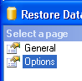

        - Under the “Restore Options” menu, enable “Overwrite the existing database”.

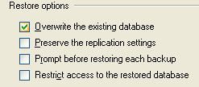

        - Under the “Restore the database files as:” menu select the first browse button.

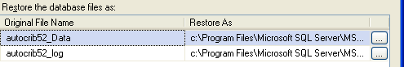

        - Locate the autocrib53_Data.mdf or autocrib53.mdf file located in C:\Program Files\Microsoft SQL Server\MSSQL.1\MSSQL\Data. Then, select “OK”.

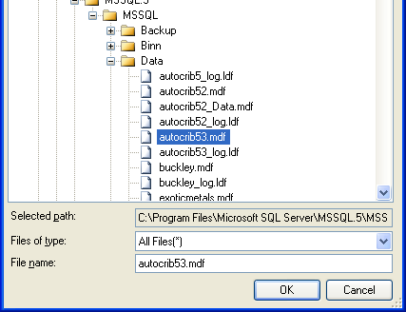

        - Under the “Restore the database files as:” menu select the second browse button.

        - Locate the autocrib53_log.ldf file located in C:\Program Files\Microsoft SQL Server\MSSQL.1\MSSQL\Data. Then, select “OK”.

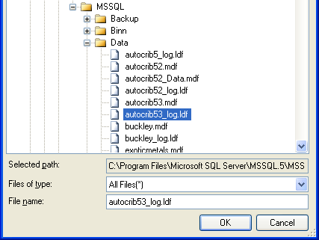

        - Under the “Recovery state” menu, verify “Leave the database ready to use by rolling back uncommitted transactions. Additional transaction logs cannot be restored. (RESTORE WITH RECOVERY)” is enabled.

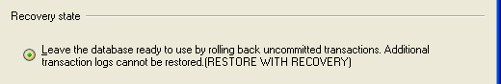

        - Select “OK”
        - Once the message “The restore of database ‘autocrib53’ completed successfully.” appears, select “OK”.

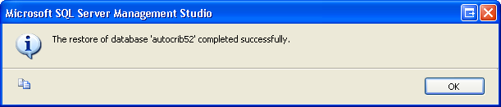

        - Congratulations!!! The database has now been restored and you are ready to begin using the AutoCrib software.

      - Start the AutoCrib software
NOTE: If the AutoCrib software prompts for the server, database name, username, and password, insert the following.
Server: (LOCAL)\AUTOCRIB53
Database Name: autocrib53
Username: sa
Password: AutoCrib2005

      - Connect the CAT5 cable from the management station’s Ethernet port to a port in the hub provided or a LAN drop. Once this connection has been made, the corresponding light on the hub should be lit.

Complete RoboCrib Setup

      - Exit from the RoboCrib software on the RoboCrib.
        - Click on the AutoCrib icon in the upper left hand corner.
        - Insert user name: Rumen
        - Insert password: Rumen

      - Verify RoboCrib computer is viewing correct data.
        - Start the Autocrib software by double clicking on the shortcust available on the desktop.
        - Login to the Autocrib software using ‘admin’ as the user name with no password.
        - Navigate to Tools > Options > Locations.
        - Verify the following:
          - Server Name: Management Station Computer Name\autocrib53
(i.e. mgmtstation\autocrib53)
OR
Management Station IP Address\autocrib53
(i.e. 192.168.168.24\autocrib53)

          - Database Name: autocrib53
          - Username: sa
          - Password: AutoCrib2005 (This password will be encrypted.)

If the RoboCrib is not viewing the correct database, select “Edit” and enter the correct server name, database name, username, and password. Then, select “OK”.

      - Exit the AutoCrib software.
      - Start the RoboCrib software by doubling clicking on the shortcut available on the desktop.
      - Once the RoboCrib software has started, allow the machine to calibrate.

      - Enter your supervisor I.D. and password. Select the “Console” button.
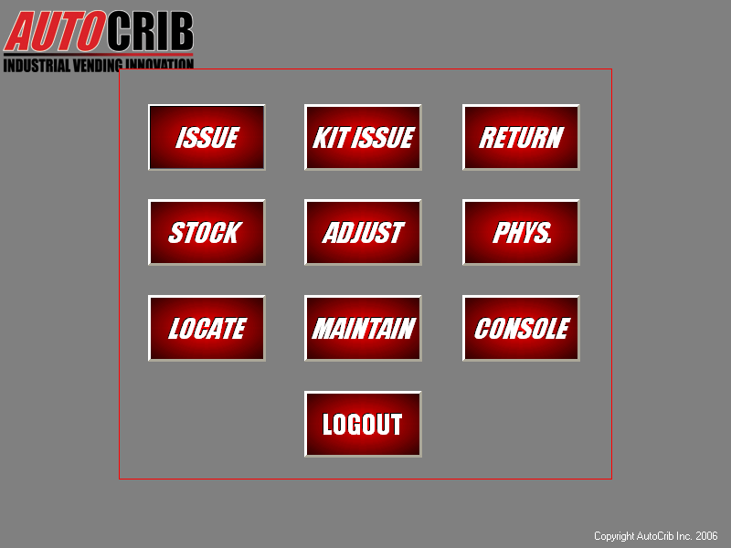
(This step requires an employee with supervisor rights. This is set up in the AutoCrib software of the Database > Employee module.)

      - Check the doors for normal operation by typing in the command LON 01, this will actuate door number 1. Repeat for each door through door 15. If any doors fail to open repeatedly refer to the following steps.

Troubleshooting Doors
- Remove the door panel and manually open the door.
- Look at each door to make sure there is an equal amount of space between the top and bottom of the door and the doorframe.
To actuate the solenoid, pull the “L” shaped, silver door latch to the right.
The door should open with ease and the “open door” indicator light should illuminate until the door has been closed. Due to movement during shipment, the alignment of the doors may have shifted. If a door is not opening with ease, adjustments of the door will be necessary to ensure free operation.

- Swing the door back and forth to loosen the spring. Look to see if the plunger is aligned with the door latch. If the alignment is off, adjust the door up or down depending on how the door shifted during shipment.
- While the doors are closed, there should be an equal amount of space between the top and bottom of each door. You may need to lift on the door or push down on the door to adjust it so that it fits correctly in the doorframe.
- Once you have completed the alignment process, try actuating the door with the LON command again. It should open easily.

      - Reassemble the front panel on the machine.

Congratulations, you are ready to start dispensing!

Common Parts on the RoboCrib 500

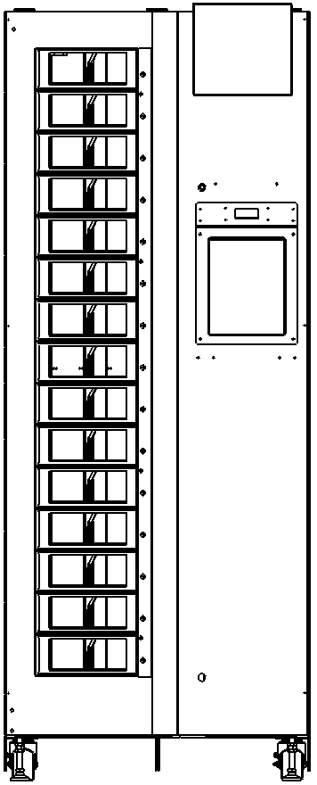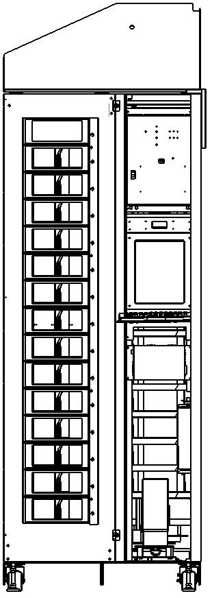
RIGHT DOOR
LOCKS

CONTROLLER PANEL

TOUSCHSCREEN MONITOR

FLASH PC

UPS

LSP MOTOR

Troubleshooting

Problem: Receiving a jam or stall error, Finding dropped items

      - Locate Source of Jam from Front Door

- Open the right front door with the key by turning both locks counterclockwise.
- Remove the left door hold-down screws using a #1 Phillips driver.
- The left door will swing open. The bin doors and baffle assembly are mounted to the door, unlike other RoboCribs.

BE AWARE THE MACHINE MAY TEND TO TIP FORWARD WHEN THE LEFT DOOR IS OPEN, ESPECIALLY WHEN UNLOADED – USE CAUTION.
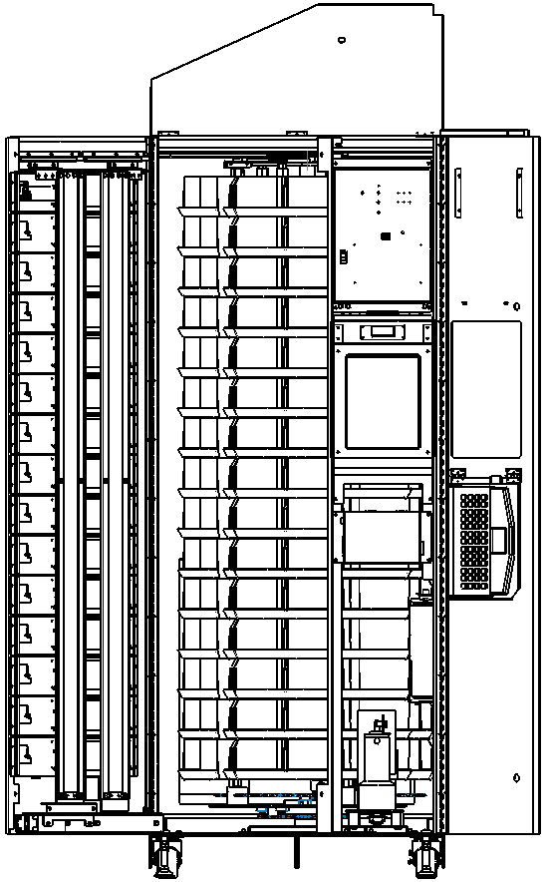

NOTE: THE MOTORS WILL TURN AND THE BINS WILL MOVE WHEN THE LEFT DOOR IS OPEN. ALWAYS EXERCISE CAUTION WHEN REACHING INTO THE MACHINE OR USING THE MANUAL SWITCHES WHEN THE LEFT DOOR IS OPEN.

      - Alternative Methods to Locate Jam

- If the source of the jame cannot be located from the front, use the key to open the top cover.
- Using a flashlight, look between the stacks to see if the source of the jam can be found.
- Turn motors manually.
  - Use the SSP motor switch to turn the SSP motor 360 degrees.
  - Use the LSP motor switch to turn the LSP 360 degrees.
  - If at any time the motors do not turn freely, reverse the direction and try again.
- If the jam still cannot be located or the dropped item cannot be reached from the front or top, remove the back access panel using the 5/32 pin-in-hex driver to remove the two security screws.

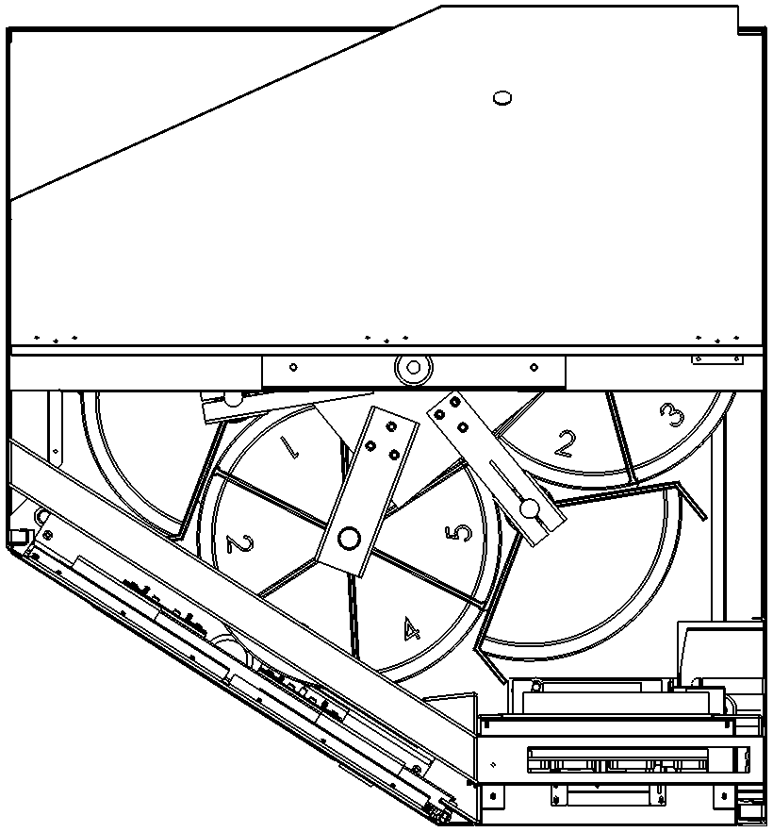

- Issue from RoboCrib

  - Once the jam has been cleared, rotate the LSP and SSP motors 360 degrees to verify the stacks are not being impeded.
  - Replace the rear panel, close the left door and replace the door retaining screws.
  - Close the right door and secure with the locks.
  - Start the software and allow the machine to go through the calibration process.
  - Perform a test issue from the RoboCrib.

NOTE: IT IS ACCEPTABLE TO RUN THE MACHINE WITH THE LEFT DOOR RETAINING SCREWS MISSING, BUT WE RECOMMEND THAT WHENEVER THE DOOR IS CLOSED, YOU REPLACE THE SCREWS. THE SCREWS MUST BE IN PLACE WHEN THE MACHINE IS BEING MOVED OR SHIPPED.

Problem: Motors will not turn or LEDs on controller do not light or flash as they should

- Check wiring

- Open the top cover with the key and check the wiring at the top of the controller.
- The connectors should be centered on their heads and seated completely.
- If the headers are properly in place, use a volt meter or continuity tester to verify the continuity of each lead back to its corresponding pin at the motor location. Call AutoCrib technical support for assistance.

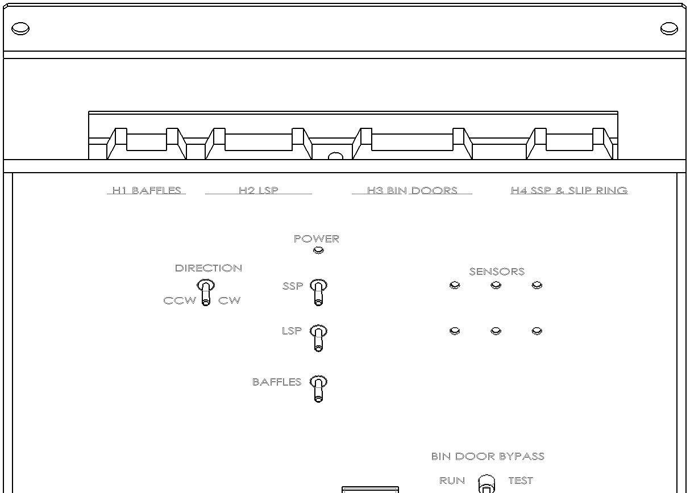

The headers and corresponding systems are:
H1 – BAFFLE – 5 PINS –WHITE, BROWN, BLUE, (NONE) RED, BLACK
H2 – LSP – 8 PINS – RED, WHITE, BLACK, GREEN, BLUE, NONE, ORANGE, BROWN
H3 – BIN DOORS – 26-PIN RIBBON CABLE
H4 – SSP – 9 PINS – ORANGE, WHITE, BLUE, GREEN, BLACK, NONE, NONE, RED, BROWN

Problem: Door Does Not Open

- Verify Power is OK

- The RoboCrib should be plugged into an active power outlet, the UPS status light should be green not beeping.
- Verify the Robocrib power cord is plugged into UPS
- Verify sure controller lights are on
  - If the controller is not on, recheck power, switch OFF, wait 5 seconds, switch ON.
- Attempt to dispense using the RoboCrib software. If the RoboCrib dispenses correctly, there is no further troubleshooting that needs to take place.

- Use the RoboCrib software to open the door

- Login to the RoboCrib software as a supervisor. Select the Console button.
- Actuate the door by sending the open door command in the Console screen.
  - LON ## ← ## - Representing the door.
  - If the door opened, attempt to issue a tool through the RoboCrib software. If the RoboCrib dispenses correctly, there is no further troubleshooting that needs to take place.
  - If the door did not open, check the ribbon cable connection at the top of the controller in header H3.
      - Remove the left door screws and open the left door.
      - Check the ribbon cable connection at the top center of the left door.
      - Verify each connector on the ribbon is seated firmly.

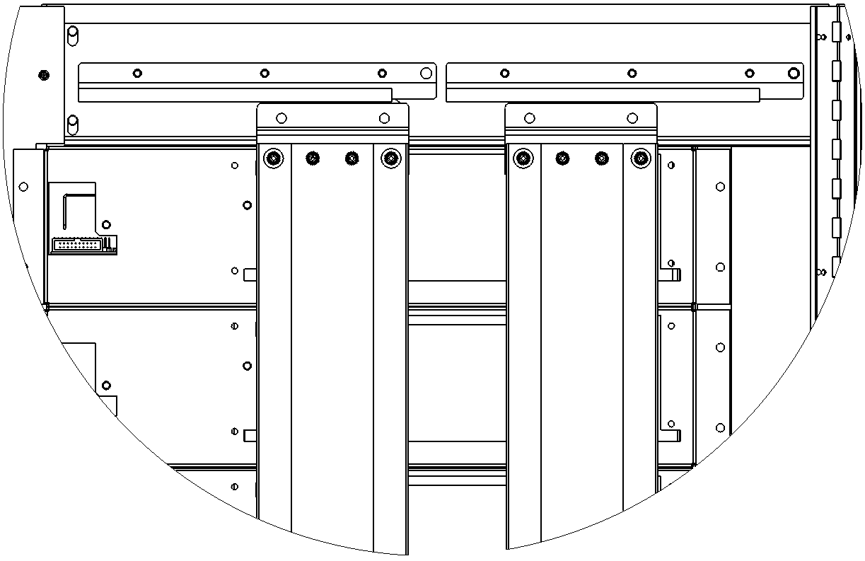
RIBBON CABLE BACKBONE CONNECTION

TOP BAFFLE WHEEL ASSEMBLIES

RIBBON CABLE CONNECTION TO DOOR LATCH

  - If the ribbon cable is connected properly, verify the other doors will open using the LON command.
      - If no other doors will open, there is a problem with the communication between the controller and the computer. Turn off the computer and the controller. Wait 5 seconds. Then, turn the controller back on and then turn the computer on. Reattempt steps (a) and (b).
      - If the faulty door opens after attempting the LON command, attempt to issue through the RoboCrib software. If the RoboCrib dispenses correctly, there is no further troubleshooting that needs to take place.

      - Manually Open the Door

        - Open the front panel.
        - Remove the solenoid cover from the door.
        - Open the door by pulling the manual release lever.
        - If the door opens without tension, try re-positioning the jumper.
          - Turn the controller off.
          - Move the jumper into position 1 and remove the jumper on door 1.
          - Turn the controller on.
          - Using the Console screen, attempt to open the door using the LON 01 command.
            - If the door opens, replace both jumpers into the correct position. Attempt to issue through the RoboCrib software. If the RoboCrib dispenses correctly, there is no further troubleshooting that needs to take place.
            - If the door does not open, use the spare door supplied with the RoboCrib.
              - Turn the controller off.
              - Remove the entire door.
              - Place the jumper on the appropriate pin of the new door.
              - Install the new door and attach ribbon cable.
              - Turn the controller on and attempt to issue through the RoboCrib software.
              - If the RoboCrib dispenses correctly, contact AutoCrib technical support to receive a replacement door.
              - If the RoboCrib does not dispense correctly, contact AutoCrib technical support for further troubleshooting.
        - Follow the steps below if the door opens with tension. The door may need to be realigned or debris is blocking the solenoid.
          - Remove any debris blocking the door.
          - While closing the door look at the tab as it enters the bracket. Make the necessary adjustments until the manual release lever has a fluid motion while opening the door.
        - If the door does not open, the solenoid standoff has fallen off and needs to be placed back on the solenoid plunger.
          - Remove the cover bracket over the LED light.
          - Locate the plastic standoff and place it back on the plunger.
          - Replace the cover and attempt to operate the door as usual.
          - If the door cannot be opened, use the spare door supplied with the RoboCrib.
            - Turn the controller off.
            - Remove the entire door.
            - Place the jumper on the appropriate pin of the new door.
            - Install the new door and attach ribbon cable.
            - Turn the controller on and attempt to issue through the RoboCrib software.
            - If the RoboCrib dispenses correctly, contact AutoCrib technical support to receive a replacement door.

Problem: The LED on Door Remains On

- Adjustment of the front-side solenoid encoder

- Turn the controller off.
- Remove the left door screws and open the left door.
- Open the door by pulling the manual release lever.
- Remove the solenoid cover bracket.
- Adjust the front encoder (U4 position on the board) that is next to the LED light to the right.
    - Use a non-magnetic flathead screw driver and place it in between the encoder and the plunger guide wall.
    - Push off the plunger guide wall gently and adjust the sensor towards the right.
    - Turn the controller on and close the door. If the LED turned off, attempt to issue from the RoboCrib. If the RoboCrib dispenses correctly, no further troubleshooting is required.

  - Adjustment of the back-side solenoid encoder

        - Turn the controller off.
        - Adjust the back encoder (U3 position on the board) that is behind the solenoid against the back wall of the door.
          - Use a non-magnetic flathead screw driver and place it in between the encoder and the plunger wall.
          - Push off the back part of the wall gently and adjust the sensor toward the fron or towards the user.
          - Turn the controller on and close the door. If the LED turned off, attempt to issue from the RoboCrib. If the RoboCrib dispenses correctly, not further troubleshooting is required.
          - If the LED does not turn off, use the spare door provided with the RoboCrib. Contact AutoCrib technical support to receive a replacement door.

Problem: Open Door error message or LED does not turn on when door is open

- Test all doors using Console screen

- Login to the RoboCrib software as a supervisor and select the Console button.
- Actuate each individual door by using the LON ## command (## - Representing the door number)
- If all LED lights turn on when the door opens, continue troubleshooting steps. Otherwise, use the spare door provided with the RoboCrib.

- Manually test the doors

        - Turn the controller off.
        - Remove the left door screws and open the left door.
        - Detach the ribbon cable from door 1.
        - Turn the controller on.
        - Verify the door switch is in the Run position.
        - Restart the RoboCrib software. If the machine calibrates successfully, the faulty door has been located. Replace this door with the spare provided with the RoboCrib.
        - If the RoboCrib cannot calibrate, continue with the steps below.
          - Turn the controller off.
          - Reattach the ribbon cable to the door.
          - Unplug the next door.
          - Turn the controller on.
          - Restart the RoboCrib software. If the machine calibrates successfully, the faulty door has been located. Replace this door with the spare provided with the RoboCrib.
          - If the RoboCrib cannot calibrate, continue with steps (i) through (v) to find the problematic door.

RoboCrib Door Schematic and Part Numbers

Problem: Baffle error warning

- Test baffle using Console screen

- Login to the RoboCrib software as a supervisor and select the Console button.
- Type the command FET 11A 1 and press the enter button on the keyboard.
    - Bin 11A should come to the front center and the vertical baffle doors should close to within 2-1/2” of each other.
    - In the Console screen, type the command RPV B and press the enter button the keyboard. The system should reply with a number between 0003 and 0005.

  - If the baffles did not move, follow the steps below.

        - Check the baffle motor movement by using the manual switches. The baffles should move open and closed.
          - If the baffles do not move with the switches, check the motor wiring at the baffle and at the top of the controller. Also verify the baffle is clear of any items that may have caused the baffle to jam.
          - If the baffles still do not move, the baffle assembly should be replaced.
- If the baffles move with the switches, check the baffle positioning potentiometer wiring connector is properly seated on its header.
    - Type the FET 11A 1 command again into the Console screen.
    - If the baffle still does not move or the value of the RPV B command is greater than 0005, the baffle assembly should be replaced.
- Once the baffles move properly using manual switches, the FET command in the Console screen, and the RPV B value is within range, exit from the Console screen and attempt to issue from the RoboCrib.

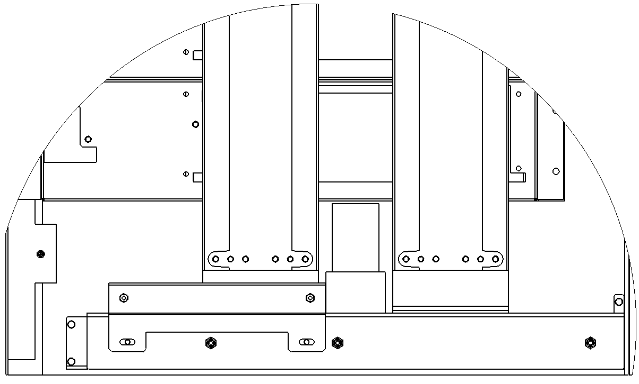

Problem: Calibration Errors
- Test LSP using Console screen

- Login to the RoboCrib software as a supervisor and select the Console button.
- Type the command RSA and press the enter button on the keyboard.
    - The controller will return a line for the LSP and SSP motors. Each will be followed by the letter ‘c’ and then the number 0 or 1.
    - If the c0 is displayed for the LSP platter, recalibrate the platter.
      - Type the command CAL L and press the enter button on the keyboard. The LSP will turn clockwise until the reference mark (the SSP motor body) passes the LSP reference sensor. When this occurs, the red LED next to the LSP switch on the controller will blink on and then off. The motor will slow and stop at this point.
      - Type the command TST L and press the enter button the keyboard. The LSP will turn counterclockwise briefly, passing the reference mark almost immediately. The LEDs on the sensor and the controller should blink on then off as the SSP motor passes the sensor.
    - Type the RSA command again and verify the LSP line reports c1.
      - If the line still reports c0, check the wiring from the LSP sensor to the LSP motor board and from the LSP motor board to the controller.
      - Troubleshoot this wiring until the red LED next to the LSP motor switch blinks on then off as the SSP motor passes the LSP sensor. The gap between the sensor and the motor body as its closest approach should be 1/16 of an inch. If the light on the sensor does not blink as the motor passes, the sensor should be replaced.

LSP ENCODER BOARD

LSP MOTOR WIRE CONNECTOR

GAP BETWEEN SENSOR & MOTOR IS 1/16”

SSP MOTOR WITH COVER

LSP PROXIMITY SENSOR

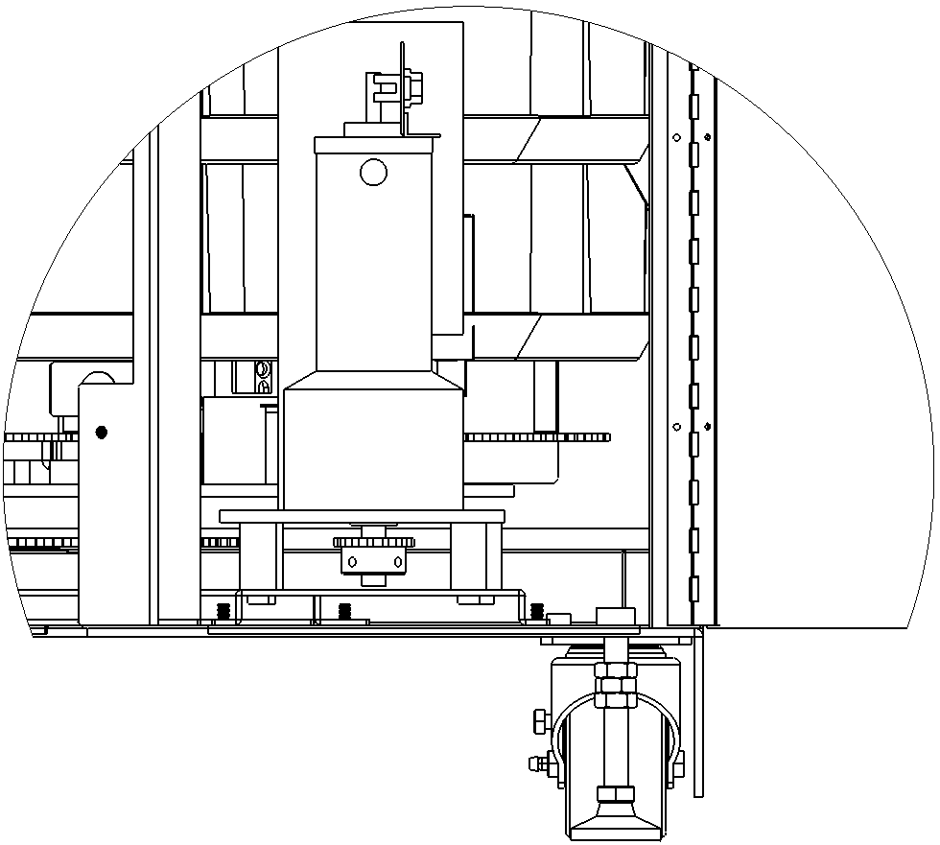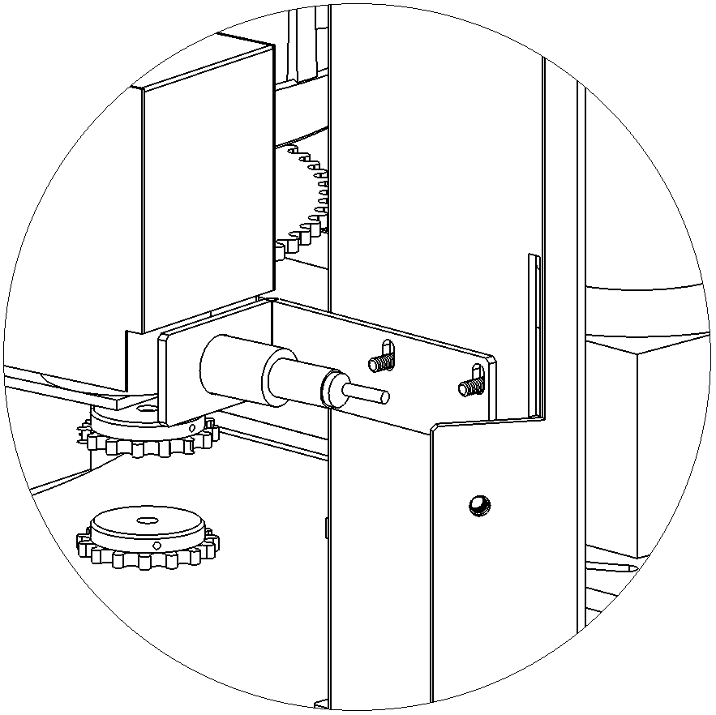

  - Test SSP using Console screen

        - If the c0 is displayed for the SSP platter, recalibrate the platter.
          - Type the command CAL S1 and press the enter button on the keyboard. The SSP will turn clockwise until the reference mark (a metal tab on the sprocket under the 11X stack) passes the SSP reference sensor. When this occurs, the red LED next to the SSP switch on the controller will blink off (the opposite of what the LSP LED does) and the motor will stop immediately.
          - No TST command is required to calibrate the SSP.
- Type the RSA command again and verify the S1 line reports c1.
    - If it still shows c0, check the wiring from the SSP sensor board to the controller.
    - Troubleshoot this wiring until the red LED next to the SSP motor switch blinks on then off as the tab passes the SSP sensor.
    - If the light on the sensor does not blink as the motor passes, the sensor board should be replaced.
- If replacing the sensors does not resolve the calibration error and the wiring is confirmed continuous, the controller should be replaced. Rarely, the slip ring in the top center of the post may be the cause of intermittent SSP calibration, sensor, reference or motor problems. Contact AutoCrib technical support for instructions on troubleshooting or replacing the slip ring assembly.

